

DELEGATED HOUSEHOLDER APPLICATION REPORT

Ward: Coley
App Ref: 220048/LBC
Address: 25 Arbour Close, Reading, RG1 6EW
Proposals: Replacement of all timber sash and casement windows and rear glazed door set with timber double glazed windows / doors to match existing style.
Case Officer: Chukwudi Onwudinanti
Applicant: Sanctuary Housing Association
Date received (valid from): 10 March 2022
Target Decision date: 11 November 2022 (EXT)

1. SITE DESCRIPTION
The proposal site is a detached Grade II listed terraced dwelling located on Arbour Close, Minster. The listing describes 25 Arbour Close as the Gardener’s Cottage at Coley Park Farm, Wensley Road. The dwelling is a 2 storey red brick construction with a slate roof and end chimney. The front door to the property is central, with three windows on the first floor and two windows on the ground floor. The dwelling is very symmetrical in appearance. To the rear of 25 Arbour Close, there are three windows on the first floor, two windows on the ground floor along with glazed panel French doors. The frames for the windows and French door are white (painted) timber.

25 Arbour Close is set further back from the highway than other dwellings on this road, assumedly to preserve the setting of the Grade II listed building. The proposal site backs on to Holy Brook and Coley Water Meadows.

2. PROPOSAL AND SUPPORTING INFORMATION

This proposal for replacement of all timber sash and casement windows and rear glazed
door set with timber double glazed windows / doors to match existing style.

Plans considered (Received on 13/01/2022):
Drawing No 1201-Existing Elevations
Drawing No 1001- Site and Block Plan
Drawing No: 1901: Windows/Door Schedule received 12th October 2022
Design and Access Statement
Heritage Statement
Photos

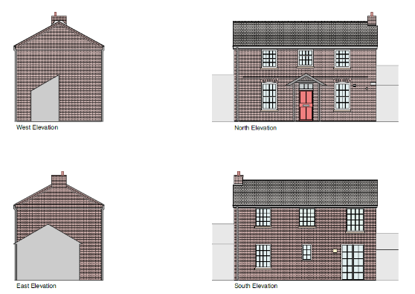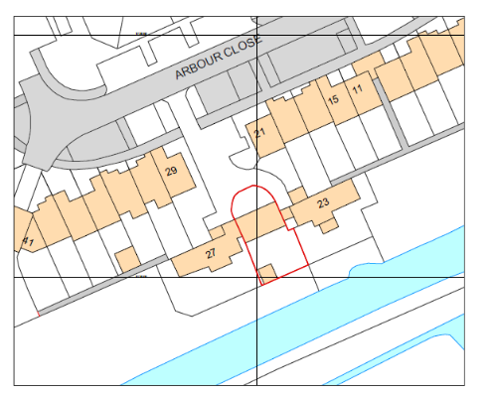
Elevations Location Plan

- RELEVANT PLANNING HISTORY
Application No 200234
Proposal: Replacement sliding sash window to Listed Building
Decision: Application Permitted
Decision Date: 9th April 2020

Application No 120219
Proposal: Replacement of existing timber frame vertical sliding sash single glazed windows and external doors, with new timber frame vertical sliding sash double-glazed windows and external doors fitted into unaltered building structural openings.
Decision: Application Permitted
Decision Date: 22nd August 2012

4. CONSULTATIONS

The following addresses were consulted by letter.

21 Arbour Close, Reading, RG1 6EW
23 Arbour Close, Reading, RG1 6EW
27 Arbour Close, Reading, RG1 6EW
29 Arbour Close, Reading, RG1 6EW

No letters of representation have been received.

Heritage Advice

A site visit was conducted on 30th August 2022 by the Planning Officer and the Heritage consultant and the subsequent windows schedule requested has been provided by the agent and is saved in I@W and cited in the conditions on the decision notice.

- Equality Act 2010:
In determining this application the Council is required to have regard to its obligations under the Equality Act 2010. However, there is no indication or evidence (including from consultation on the application) that the protected groups identified by the Act have or will have different needs, experiences, issues and priorities in relation to this particular planning application. Therefore in terms of the key equalities protected characteristics it is considered there would be no significant adverse impacts as a result of the development.

6. LEGAL AND PLANNING POLICY CONTEXT

Section 38(6) of the Planning and Compulsory Purchase Act 2004 requires that proposals be determined in accordance with the development plan unless material considerations indicate otherwise. Material considerations include relevant policies in the National Planning Policy framework (NPPF) - among them the 'presumption in favour of sustainable development'. The following local and national planning policy and guidance is relevant to this application:

Section 16(2) of the Planning (Listed Buildings and Conservation Areas) Act 1990 requires the local planning authority to have special regard to the desirability of preserving a listed building or its setting or any features of special interest which it possesses.

Section 72 (1) of the Planning (Listed Buildings and Conservation Areas) Act 1990 requires the local planning authority in the exercise of its functions to pay special attention to the desirability of preserving or enhancing the character or appearance of a conservation area.

The following local and national planning policy and guidance is relevant to this application:

National Policy
National Planning Policy Framework
National Planning Practice Guidance

Reading Borough Local Plan (Adopted November 2019)
EN1 Protection and Enhancement of the Historic Environment
CC8 Safeguarding Amenity

SPD
Relevant Conservation Area Appraisal

7. APPRAISAL

7.1 Protection and Enhancement of the Historic Environment

In accordance with Reading Borough Local Plan policy EN1: Protection and Enhancement of the Historic Environment, proposals affecting Listed Buildings are acceptable where it will not:

- Have an adverse impact on those elements which contribute to their special architectural or historic interest including, where appropriate, their setting.
- The proposed replacement of all timber sash and casement windows and rear glazed door set with timber double glazed windows / doors to match existing style is considered to contribute positively to the Grade II listed building.
- The elements of which contribute to the listing status of the property are considered intact as a result of this proposal.

In this instance the works as proposed would not lead to any harmful loss of significance to the Listed Building. The works are considered to result in the preservation, restoration and enhancement of the heritage asset for the public benefit. Specific conditions have been recommended to secure relevant material and joinery details. The proposal therefore complies with the requirements of Section 66 of the Town and Country (Listed Buildings and Conservation Areas) Act 1990 and the statutory duties of the Council in this regard have been discharged.

7.2 Safeguarding Amenity

This proposal has also been assessed against Reading Borough Local Plan policy CC8: Safeguarding Amenity, which states that proposals are acceptable where they will not cause a detrimental impact on the living environment of existing residential properties with regard to:
- Privacy and overlooking
- Access to sunlight and daylight
- Harm to outlook
- Crime and safety

This proposal is considered not to harm the amenity to neighbouring properties due to the size and scale of the proposal. The proposal is for the replacement of existing windows, as such there will be no material impact to amenity.

8. CONCLUSION

The proposed development has been assessed and the proposed works are considered to be in accordance with the above relevant policies and Listed Building Consent can be granted.

9. RECOMMENDATION
GRANT

10. CONDITIONS
LB1: Time Limit Listed Building (Works)
The works hereby permitted shall begin no later than three years from the date of this consent.
REASON: In accordance with Section 18 of the Planning (Listed Building and Conservation Areas) Act 1990 as amended by section 51 of the Planning and Compulsory Purchase Act 2004.

LB2: Listed Building (Works Specification)
The works to the Listed Building hereby permitted shall be carried out only in accordance with the following approved plans or specifications:

- Existing Elevations
- Location Plan and Block Plan
- Design and Access Statement
- Heritage Statement
- Photos

MLB: Listed Building Materials (To Match)
All new external and internal works and finishes, and any works of making good, shall match the existing original fabric in respect of using materials of a matching form, composition and consistency, detailed execution and finished appearance, except where indicated otherwise on the drawings hereby approved.

REASON: In order that the special architectural and historic interest of this Listed Building is safeguarded in accordance with Policy EN1 of the Reading Borough Local Plan 2019.

