

DELEGATED HOUSEHOLDER APPLICATION REPORT

Ward: Battle
App Ref: 230271/NMA
Address: 34 Prince Of Wales Avenue, Reading
Proposals: Non-Material Amendmenet to Application 220986 - Change the use of the proposed office into a bedroom
Case Officer: Chukwudi Onwudinanti
Applicant: Mr David Gilbert
Date received (valid from): 22 March 2023
Target Decision date: 19 May 2023 (EXT)

SITE DESCRIPTION
The proposal site is a mid-terrace dwelling unit on the northern side of Prince Wales Avenue, among long terraces on both sides of the road. It was converted to two one bedroom flats at least four years prior to 2004 and a Certificate of Lawfulness for Existing Use was granted in 2004. Therefore, the acceptability of the conversion at the time would not have been assessed, just the lawfulness of it. The property has been converted back to a single family dwelling.

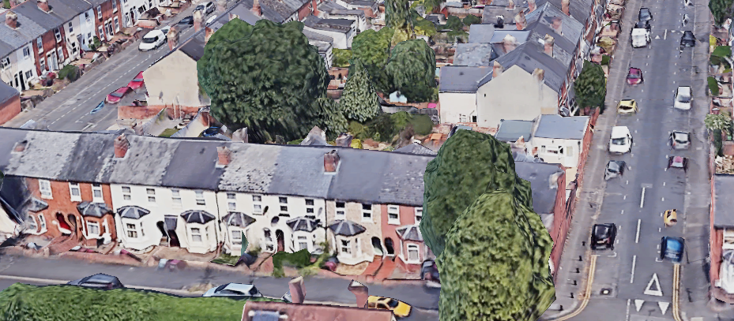

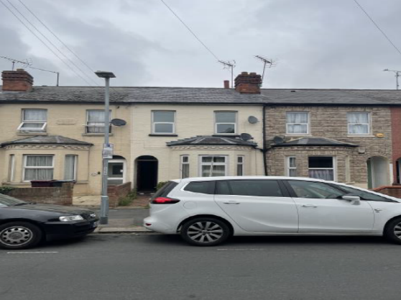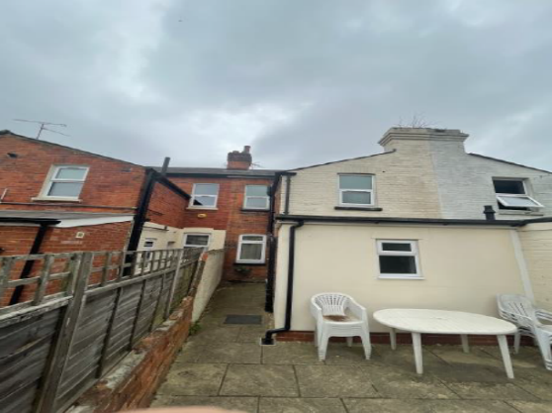

2. PROPOSAL AND SUPPORTING INFORMATION
Non-Material Amendment to Application 220986 - Change the use of the proposed office into a bedroom.

Originally Approved under 220986 Proposed under 230271
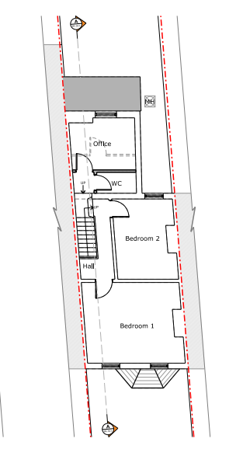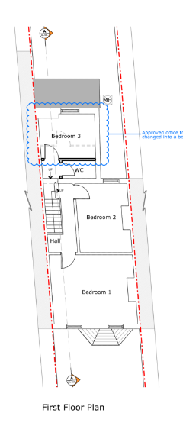

Original Ground Floor approved under 220986/FUL | Proposed Amended Ground Floor Plan under 230271/NMA

Drawing no: 127258 - PR – 101 dated July 2022, received 6 July 2022 | Drawing no: 127258 - PR – 101A dated Feb 2023, received 7 March 2023

Objections Received (Summary):
Applications under S96A are not applications for planning permission, so are not covered by the publicity requirements as set out in the DMPO.

- RELEVANT PLANNING HISTORY
App Ref: 220986/FUL
Proposals: Retrospective Change of use from 2 No. one-bedroom flats to 1 No. single 2 bedroom dwelling house and all associated works
Outcome: Application Permitted
Date of Decision: 17 October 2022

4. Plans Considered:
Drawing no: 127258 - PR – 101 dated Feb 2023, received 7 March 2023

5. Appraisal:
The proposed changes would have no material or detrimental effect on residential amenity. The change would in context remain acceptable in accordance with Policy CC7. There are no conditions on the permission restricting the number of bedrooms.

Conclusion:
The changes as proposed are considered to be acceptable non-material alterations to the previously approved application 220986.

Recommendation:
Approve non-material amendment subject to conditions. Although Section 96(A) of the Act does not allow for the original decision to be re-issued, it does allow the modification of, or imposition of, conditions. In this respect it is considered appropriate to impose an additional condition:

Condition:
The plans and statements put forward by the agent hereby approved by this Non-Material Amendment (under Section 96A of the Town and Country Planning Act 1990) are as follows:
Drawing no: 127258 - PR – 101A Rev A: Proposed Plans dated Feb 2023, received 7 March 2023
Drawing no: 127258 - PR – 101A Rev A: Proposed Plans dated Feb 2023, received 7 March 2023
Drawing No: 127258 - PR – 202A Rev A: Proposed Elevations dated Feb 2023, received 7 March 2023
Drawing No: 127258 - PR – 302A Rev A: Proposed Section dated Feb 2023, received 7 March 2023

