The Oracle

Sustainable Travel Plan

2022 – 2023

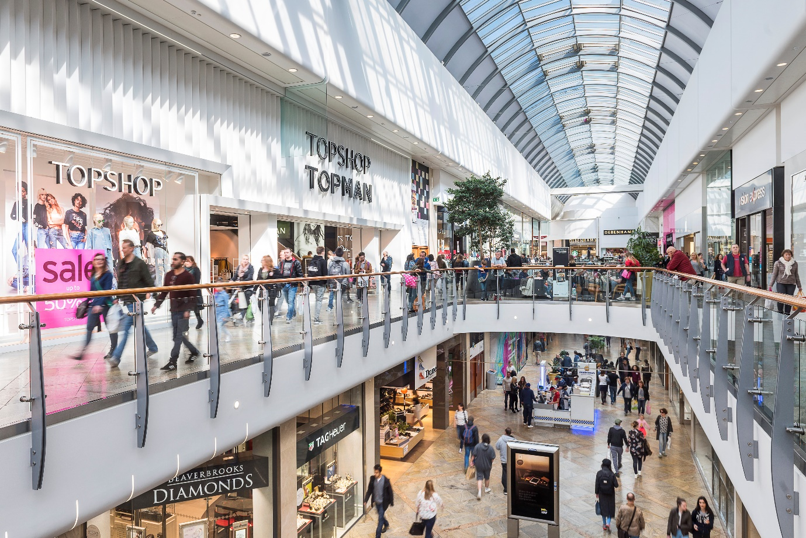

Contents
- Executive Summary
- Introduction
- Aims and Objectives
- 2019 Survey Results
- Conclusion and Recommendations
- Travel Plan Actions 2022 – 2023

- Executive Summary
The purpose of the Travel Plan is to minimise the negative impact of travel associated with The Oracle Shopping centre on the local environment, community and economy. The overall objective of the travel plan is as follows:
To implement measures within and around The Oracle Shopping centre so that the majority of employees and visitors have the option to travel by sustainable modes of transport. The aim is to encourage a better quality of life for visitors, employees and surrounding residents as well as improving the environment and enhancing the local economy. This will mean providing for and encouraging alternatives to using a car.
The plan will be updated with relevant new findings annually following each annual travel survey. The travel plan aims to positively contribute to:
- encouraging sustainable travel;
- lessening traffic generation and its detrimental impacts;
- reducing carbon emissions and climate impacts;
- creating accessible, connected, inclusive communities;
- improving health outcomes and quality of life;
- improving road safety; and
- reducing the need for new development to increase existing road capacity or provide new roads.

- Introduction

About the centre
The Oracle is Reading’s premier shopping destination, the centre hosts more than 90 retail units - combining chic boutiques with major department stores like Debenhams and House of Fraser. In addition, there is a 10 screen Vue cinema and a wide range of eateries. The Riverside restaurants, cafes and bars stretch along both sides of the River Kennet, providing an opulent dining experience for customers. Two bridges span the river - Cooks Bridge, a footbridge linking The Riverside Car Park to House of Fraser, and Delphi Bridge, which provides access to the Vue cinema and Debenhams.
The centre was opened in 1999, the site is spread over 22 acres and there is 778,000 sq.ft. of shopping and leisure on three levels. More than £250 million was invested in the development which created 3,500 jobs.
Location
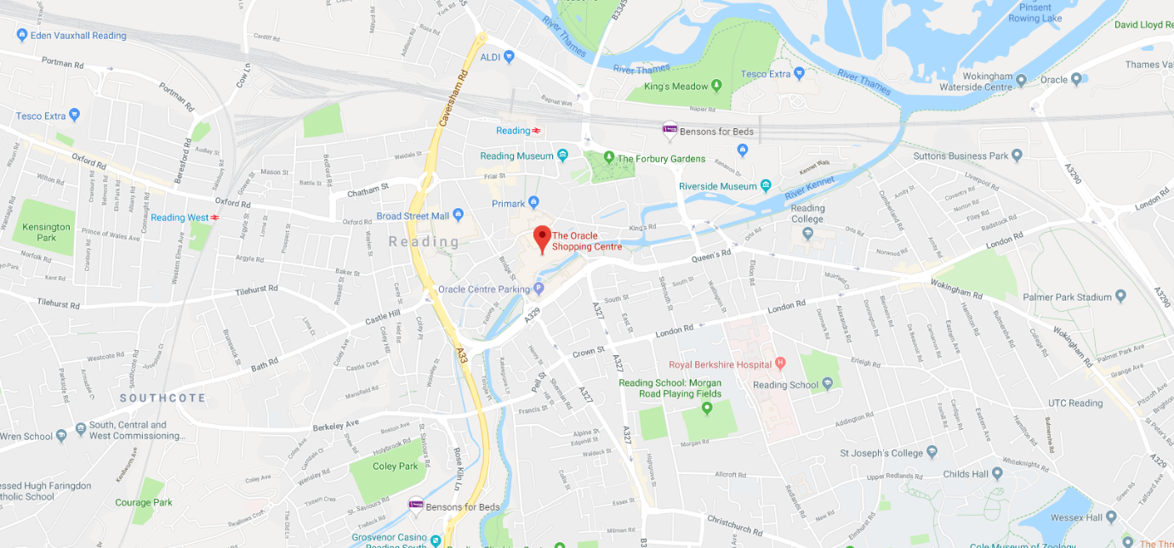
Walking
Reading town centre is highly walkable, a local pocket map guide is available to aid visitors around the town and The Oracle is signposted across the town.
Cycling
Reading has a bike hire scheme, 200 bikes are available for use at 29 docking stations throughout the town, including at Reading Station, key locations in the town centre such as Broad Street and Town Hall Square, Thames Valley Business Park, The University of Reading, Whitley, Green Park, and north of the Thames into Caversham. The scheme allows members and non-members to hire bikes at one docking station and deposit them back at any one of the docking stations, allowing for one-way journeys between the town centre and other points in Reading.
The Oracle has docking stations located outside the centre in various locations which customers can use, there is also secure bike storage facilities on site located in the Riverside.
Car
Reading is well located, and served by 3 junctions of the M4 motorway, which links Reading with the M25. Both the M40 and M3 are within easy reach. There are also two park and rides on the edge of Reading and a number of car parks in the town centre.

The Oracle has 2,300 car parking spaces across two car parks. The Oracle is committed to the effective management of car travel to and from the shopping centre and as well as promoting use of the two centre car parks The Oracle also encourages the use of alternative, more sustainable modes of transport. In addition, in 2018 twelve EV (Electric Vehicle) charging points have been installed, six in each car park.
As an alternative to owning a car is use of a car club, which provides access to a vehicle if and when needed. A local scheme, operated by ‘Co-Wheels’ has vehicles available in the centre of Reading.

Public Transport
The Oracle is a 5 minute walk away from Reading Train station. Reading is only 25 minutes non-stop from London by train. Over 200 trains a day link Reading’s new £800 million station with London, just 25 minutes away. There are direct links to hub airports - Heathrow (40 mins) and Gatwick (75 mins) and Reading is located on the M4 east /west motorway axis. Crossrail will link Reading directly to central London in 2021.
Reading boasts an award-winning bus company. Reading Buses has been named as Bus Operator of the Year at the National Bus Awards. Park and Ride schemes stop near The Oracle and most buses run late into the night. There are also a number of buses that runs 24 hours a day, 7 days a week.

- 2019 Travel Survey
Aims & Objectives
In 2019, the centre conducted a survey on transport for completion by the retail and centre operational staff. In 2018, a survey was also undertaken aimed at customers.
The aim of the survey is to understand how individuals travel to the centre and identify opportunities for improved sustainable travel methods.
The objectives of the survey are as follows:
- Find out what percentage of customers and centre staff travel by each transport method
- Find out the distance customers and centre staff travel to the centre
- Achieve an improved understanding of which, if any sustainable transport methods are used by centre staff and visitors
- Identify improvement opportunities for the centre to support sustainable transport methods

- 2019 Survey Results
The survey was sent to centre staff and retailers in spring 2019. Not all survey questions have been included in the findings, only questions that have provided findings of note.
Response rate per survey:
Centre Staff survey – 87 responses Retailer survey - 9 responses
Centre Staff survey:
Question 2.

Question 3.

Question 4.

Question 5.

Question 8.

Summary of centre staff travel survey findings
The majority of centre staff travel to work via car (46%), 64% of those who do drive to work have a petrol-powered car and 36% had a diesel powered vehicle. In 2018, there were participants who used electric powered vehicles, however in 2019 no participants used this type of vehicle. This could be due to a number of different reasons e.g. staff have since left, the 2018 participants did not participate in the 2019 survey etc. However, continuing work to promote e-vehicle charging points in the centre during 2020 will help to increase awareness of this facility and may encourage more to buy an electric powered vehicle.
Overall, 14% of staff walk to work compared to 27% who travel via public transport or bike/ motorbike, this is indicative of a shorter commuting distance and supported by the results, which show 71% of staff travel between 1-10 miles to work.
Of those that do use public transport, 82% use the bus compared to the train, and those that cycle park their bike somewhere other than the shopping centre cycle store (50%). Only 17% of staff travel more than 20 miles to work, these are more likely to use the car or train to commute to work due to the distance travelled. It would be beneficial to know of those centre staff that drive to work what is the distance that they travel to see if they can be encouraged to use alternative transport methods such as public transport, cycling or walking. The bike stores were noted to be popular at The Oracle as half parked their bikes at the shopping centre facilities. It would be good to review the condition of the facilities to encourage more staff to store their bikes here.

Retail staff survey:
Question 3.

Question 5.

Question 8.

Question 9.

Summary of retail staff travel survey findings
The results of the 2019 travel survey show that in comparison with 2018, there was an overall reduction in participants in the survey ( 2018- 85, 2019-9). This is believed to be because the retailer surveys were undertaken by individuals rather than by store. The use of this approach should be reviewed for 2020 given the low number of participant results.
The small number of retail staff who took part in the survey used more sustainable modes of transport than the centre staff e.g. 45% of retail staff use public transport, none of the participants travel via car. Where the travel time was slightly longer (30-45 minutes) as over a third of participants travel over 20 miles to work, you would expect to see the likelihood of commuters using cars increase, however it is good to see that public transport was the primary transport mode ( train more popular- 75%).
In 2018- there were 5 different modes of transport used, however in 2019, only 3 types (car, public transport, motorbike). This could be a reflection on the number of participants so as mentioned earlier this area needs to be reviewed in order to gain more representative results.
Customer survey:
Question 2.

Question 3.

Question 6.

Question 9.

Question 11.

Summary of customer travel survey findings
The customer survey was last undertaken in 2018 and had 447 responses, this area is to be reviewed in 2020. It was found that a majority of customers travel to the centre via car (46%) of this proportion 69% drive a petrol-powered vehicle compared to 3%, which drive a hybrid car. Of the 3%, none of these customers indicated that they used the EV charging points provided when visiting the centre.
32% of customers travel to the centre, with 73% of this group using the bus service compared to the train.
The results indicate that the majority of customers travel to the centre by themselves or with one other person, travelling between 2-5 miles to get to the centre. The survey shows that only 3% of customers travel more than 20 miles to the centre, the majority of customers are in a 1-10 mile radius of the centre.
Following the 2018 car park refurbishments and promotion of the twelve new EV car charging points it is anticipated that the use of EV charging will increase at the centre and will continue to be monitored. As the majority of customers travel within a 1-10 miles radius it is possible to increase the amount of public transport used, at this distance public transport and cycling are viable.

- Conclusions and Recommendations:
Following the results of the 2019 travel survey The Oracle has an improved understanding of how centre & retail staff travel to the centre, as a result opportunities for improvement can be drawn, this has therefore delivered the aim of the travel survey.
In addition, the objectives of the survey have also been answered and a list of recommendations provided for the centre to consider as part of the ongoing sustainable travel plan.
The recommendations following the 2019 survey are as follows:
- Review whether there are any opportunities for improvement on participation rates for retail staff surveys.
- Review the scope of local promotions and ways to encourage via communication channels.
- Continue to promote e-vehicle charging points to maximise use.
- Review centre bike park area to encourage more users of this and support cycling travel method.
- Promote local public transport routes to staff and customers to reduce the number of individuals travelling to the centre via car (important to note the use of car parks is a vital revenue stream to the business)
- Promote national sustainable transport weeks/days e.g. walk to work, cycle to work.

- The Oracle 2018 – 2020 Travel Plan Actions
Project/Action | Completion Date | Action status update
Review opportunities to improve participation rates in retail staff surveys. | Q1 2020 | Review in preparation for when questions released for 2020 surveys.
Engage with local public transport providers to offer promotion and/or enhance way finding | 2020/21 | This action area was reviewed with the 2019/2020 Positive Places Plan, it was noted that this area will be deferred to 2021. However the ECC will review the scope of local promotions and ways to encourage via communication channels. The ECC will plan ways to take areas forward and progress any quick win opportunities.
Promote e-vehicle charging points to maximise use | Q1-Q2 2020 | This has been added to the Oracles 2020 Positive Places Plan and work is to be undertaken with the Marketing team to plan promotions.
Update centre website with sustainable travel methods and promote local guide | 2019 | Closed- The Oracle website contains details on how to get to the centre via different transport methods etc. including sustainable methods.
Review centre cycle store and cycling user facilities | Q2 2020 | Review to be undertaken to look at condition of bike stores etc. by ECC.
Engage with local car club providers | Q3 2020/ ongoing | A review will be undertaken to review this action/ the value of outputs etc. Similar outputs to action 1.
Promote national sustainable transport weeks/days e.g. walk to work, cycle to work. | Ongoing in 2020 | Budget has been allocated in the 2020 Positive Places Plan for national days. The ECC will plan activations for relevant travel related national days to promote.
Engage with Reading Buses and review feasibility of bus stop on Bridge Street being named “The Oracle” bus stop. | 2020/21 | This action was reviewed as part of the 2019/ 2020 Positive Places Plan, it was noted that this action would be deferred to 2021.
Create Travel Plan guide for staff, retailers and customers to encourage sustainable travel. | Q3 2020 | The Travel Plan will be on Communications App to provide a guide and updated where required to make more user friendly as a guide.

Review date: August 2020.

