

DELEGATED HOUSEHOLDER APPLICATION REPORT

Ward: Coley
App Ref: 230430/CLP
Address: 33 Argyle Road, Reading, RG1 7YL
Proposals: Proposed Hip to Gable and rear dormer roof conversion with three rooflights to the front roofslope.
Case Officer: Chukwudi Onwudinanti
Applicant: Mr and Mr Callum and Samuel Lee and Schout
Date received (valid from): 3 April 2023
Target Decision date: 29 May 2023

INTRODUCTION
The application site is a two storey semi-detached dwelling. The application property has a staggered rear elevation with the existing outrigger recessed from the boundary on one side. The application site is not within a Conservation Area nor have PD rights been withdrawn or restricted by way of a direction made under Article 4 or condition attached to an express planning permission.
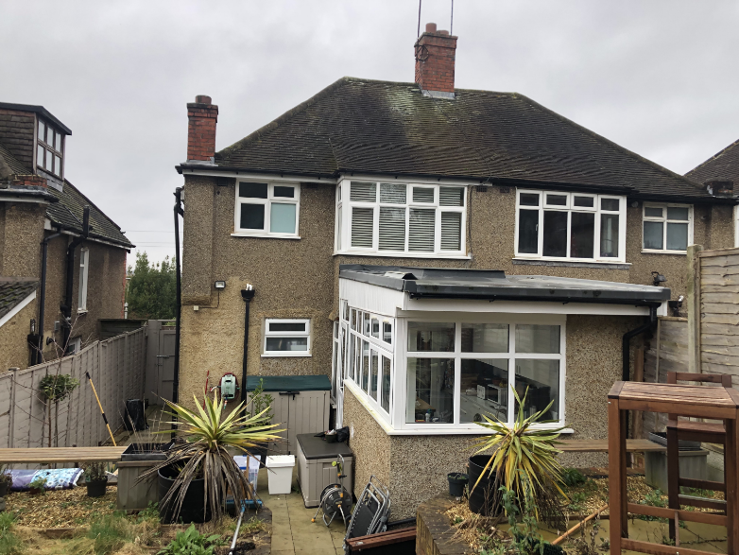

PROPOSAL AND SUPPORTING INFORMATION

This proposal is for a Certificate of Lawfulness for various works to the dwellinghouse. The proposals include:

- Hip to Gable
- Rear dormer roof conversion
- Three rooflights to the front roofslope.

This would involve the removal of chimneys.

Plans and Documents Considered dated March 2023 received 03/04/2023
Drawing No: BK 346594 – Site Location Plan
Drawing No: ST_MAR 23_33 ARG_001 – Existing Plans
Drawing No: ST_MAR 23_33 ARG_002 – Existing Elevations & Sections
Drawing No: ST_MAR 23_33 ARG_004 Rev E – Proposed Elevations
Drawing No: ST_MAR 23_33 ARG_005 Rev D – Proposed Section
Drawing No: ST_MAR 23_33 ARG_003 Rev D – Proposed Plans
Drawing No: ST_MAR 23_33 ARG_006 Rev E – Proposed Loft Plan

Site Photo of Rear of Property

RELEVANT PLANNING HISTORY

Application No: 190135/HPA
Proposal: Rear extension measuring 4.7m in depth, with a maximum height of 3.6m, and 3.6m in height to eaves level. Notification of the construction of an extension under class A Part 1 of Schedule 2 of the Town and Country Planning (General Permitted Development) (England) Order 2015.
Decision: Prior Approval Notification - Refused
Decision Date: 12/3/2019

CONSULTATIONS
No consultations required for this application.

No responses received.

Equality Act 2010:
In determining this application the Council is required to have regard to its obligations under the Equality Act 2010. However, there is no indication or evidence (including from consultation on the application) that the protected groups identified by the Act have or will have different needs, experiences, issues and priorities in relation to this particular planning application. Therefore in terms of the key equalities protected characteristics it is considered there would be no significant adverse impacts as a result of the development.

Relevant Planning Policy and Guidance
National Planning Practice Guidance
The Town and Country Planning (General Permitted Development) (England) Order 2015 (GPDO) (as amended)
Permitted development rights for householders – Technical Guidance September 2019

ASSESSMENT UNDER CLASS B , C and G
A Certificate of Lawfulness for a Proposed Development has been submitted as the applicant considers the proposal falls within the permitted development rights of the property.

The following elements of the proposals are considered under Class B:
- Hip to Gable
- Rear dormer roof conversion

The following elements of the proposals are considered under Class C:
- Three rooflights to the front roofslope.

The proposed hip to gable, loft conversion with rear dormer and front / rear rooflights must be assessed to ensure that they comply with the relevant conditions of Class B and Class C (as appropriate, as detailed above), Part 1, Schedule 2 of the Town and Country Planning (General Permitted Development) (England) Order 2015 (as amended), which relates to ‘additions etc to the roof of a dwellinghouse’ and ‘other alterations to the roof of a dwellinghouse’ respectively.
The relevant conditions of the GPDO for hip to gable and loft conversion with rear dormer which is not listed or in a conservation area, are as follows:
B.1 Development is not permitted by Class B if:
B.1 (a) permission to use the dwellinghouse as a dwellinghouse has been granted only by virtue of Class M, N, P or Q of Part 3 of this Schedule (changes of use); complies
B.1 (b) any part of the dwellinghouse would, as a result of the works, exceed the height of the highest part of the existing roof; complies
B.1 (c) any part of the dwellinghouse would, as a result of the works, extend beyond the plane of any existing roof slope which forms the principal elevation of the dwellinghouse and fronts a highway; complies
B.1 (d) the cubic content of the resulting roof space would exceed the cubic content of the original roof space by more than
(i) 40 cubic metres in the case of a terrace house:
(ii) 50 cubic metres in any other case
Complies, as the cubic content of the resulting roof space would exceed the cubic content of the original roof space by 38.94 cubic metres ( using the calculation for the volume of a roof dormer with H = 2.8m; Width = 5.3m; Depth = 3.4m and the volume of gable with H = 3.4m; Width = 7.4m ; Depth = 3.1m)
B.1 (e) it would consist of or include (i) the construction or provision of a veranda, balcony or raised platform, N/A / complies or
(ii) the installation, alteration or replacement of a chimney, flue or soil and vent pipe; Complies
B.1 (f) the dwellinghouse is on article 2(3) land. complies
Conditions
B.2 Development is permitted by Class B subject to the following conditions:
B.2 (a) the materials used in any exterior work must be of a similar appearance to those used in the construction of the exterior of the existing dwellinghouse; complies, as stated in Drawing No: ST_MAR 23_33 ARG_005 Rev D – Proposed Section

B.2 (b) the enlargement must be constructed so that (i) other than in the case of a hip-to-gable enlargement or an enlargement which joins the original roof to the roof of a rear or side extension (aa) the eaves of the original roof are maintained or reinstated; complies and (bb) the edge of the enlargement closest to the eaves of the original roof is, so far as practicable, not less than 0.2 metres from the eaves, measured along the roof slope from the outside edge of the eaves; complies and (ii) other than in the case of an enlargement which joins the original roof to the roof of a rear or side extension, no part of the enlargement extends beyond the outside face of any external wall of the original dwellinghouse; complies and
B.2 (c) any window inserted on a wall or roof slope forming a side elevation of the dwellinghouse must be (i) obscure-glazed, N/A / complies and (ii) non-opening unless the parts of the window which can be opened are more than 1.7 metres above the floor of the room in which the window is installed, N/A / complies
C.1 Development is not permitted by Class C if:
C.1 (a) permission to use the dwellinghouse as a dwellinghouse has been granted only by virtue of Class M, N, P or Q of Part 3 of this Schedule (changes of use); complies
C.1 (b) the alteration would protrude more than 0.15 metres beyond the plane of the slope of the original roof when measured from the perpendicular with the external surface of the original roof; complies (front roof lights are 0.10m)
C.1 (c) it would result in the highest part of the alteration being higher than the highest part of the original roof; complies or
C.1 (d) it would consist of or include (i) the installation, alteration, or replacement of a chimney, flue or soil and vent pipe, complies or (ii) the installation, alteration or replacement of solar photovoltaics or solar thermal equipment, complies
Conditions
C.2 Development is permitted by Class C subject to the condition that any window located on a roof slope forming a side elevation of the dwellinghouse must be:
C.2 (a) obscure-glazed; complies and
C.2 (b) non-opening unless the parts of the window which can be opened are more than 1.7 metres above the floor of the room in which the window is installed, complies

Development is not permitted by Class G if –

- permission to use the dwellinghouse as a dwellinghouse has been granted only by virtue of Class M, N, P, PA or Q of Part 3 of this Schedule (change of use) complies

(b) the height of the chimney, flue or soil and vent pipe would exceed the highest part of the roof by 1 metre or more; NA

(c) in the case of a dwellinghouse on article 2(3) land, the chimney, flue or soil and vent pipe would be installed on a wall or roof slope which- NA

- fronts a highway, NA and

(ii) forms either the principal elevation or a side elevation of the dwellinghouse. NA

OVERALL RECOMMENDATION
Sufficient evidence has been provided to demonstrate that a Certificate of Lawfulness should be granted for the proposed hip to gable, rear dormer roof extension and roof lights on front roof slope. The proposal has been assessed against the Town and Country Planning Act 1990 (as amended) Class B, Class C, and Class G, Part 1, Schedule 2 of the Town and Country Planning (General Permitted Development) (England) Order 2015 (as amended). It can be confirmed that the proposed operations would be lawful for planning purposes on the basis of the following:
Plans and Documents Considered dated March 2023 received 03/04/2023
Drawing No: BK 346594 – Site Location Plan
Drawing No: ST_MAR 23_33 ARG_001 – Existing Plans
Drawing No: ST_MAR 23_33 ARG_002 – Existing Elevations & Sections
Drawing No: ST_MAR 23_33 ARG_004 Rev E – Proposed Elevations
Drawing No: ST_MAR 23_33 ARG_005 Rev D – Proposed Section
Drawing No: ST_MAR 23_33 ARG_003 Rev D – Proposed Plans
Drawing No: ST_MAR 23_33 ARG_006 Rev E – Proposed Loft Plan
Therefore the Local Planning Authority can issue the applicant with a Certificate of Lawfulness for the proposed development.

Informatives
Building Regulations
Construction and Demolition
Encroachment and Party Wall Act

