

DELEGATED HOUSEHOLDER APPLICATION REPORT

Ward: Park
App Ref: 230404/HOU
Address: 40 Freshwater Road, Reading, RG1 3NA
Proposals: Rear and side single storey extensions with loft dormer.
Case Officer: Chukwudi Onwudinanti
Applicant: Mr & Mrs N Portnell
Date received (valid from): 4 April 2023
Target Decision date: 7 June 2023 (Ext)

1. SITE DESCRIPTION
The site is a mid-terrace dwelling unit on the southern side of Freshwater Road, among two lines of terraces on both sides of the road. The area is characterised by long lines of terraces forming a wide predominantly residential area.
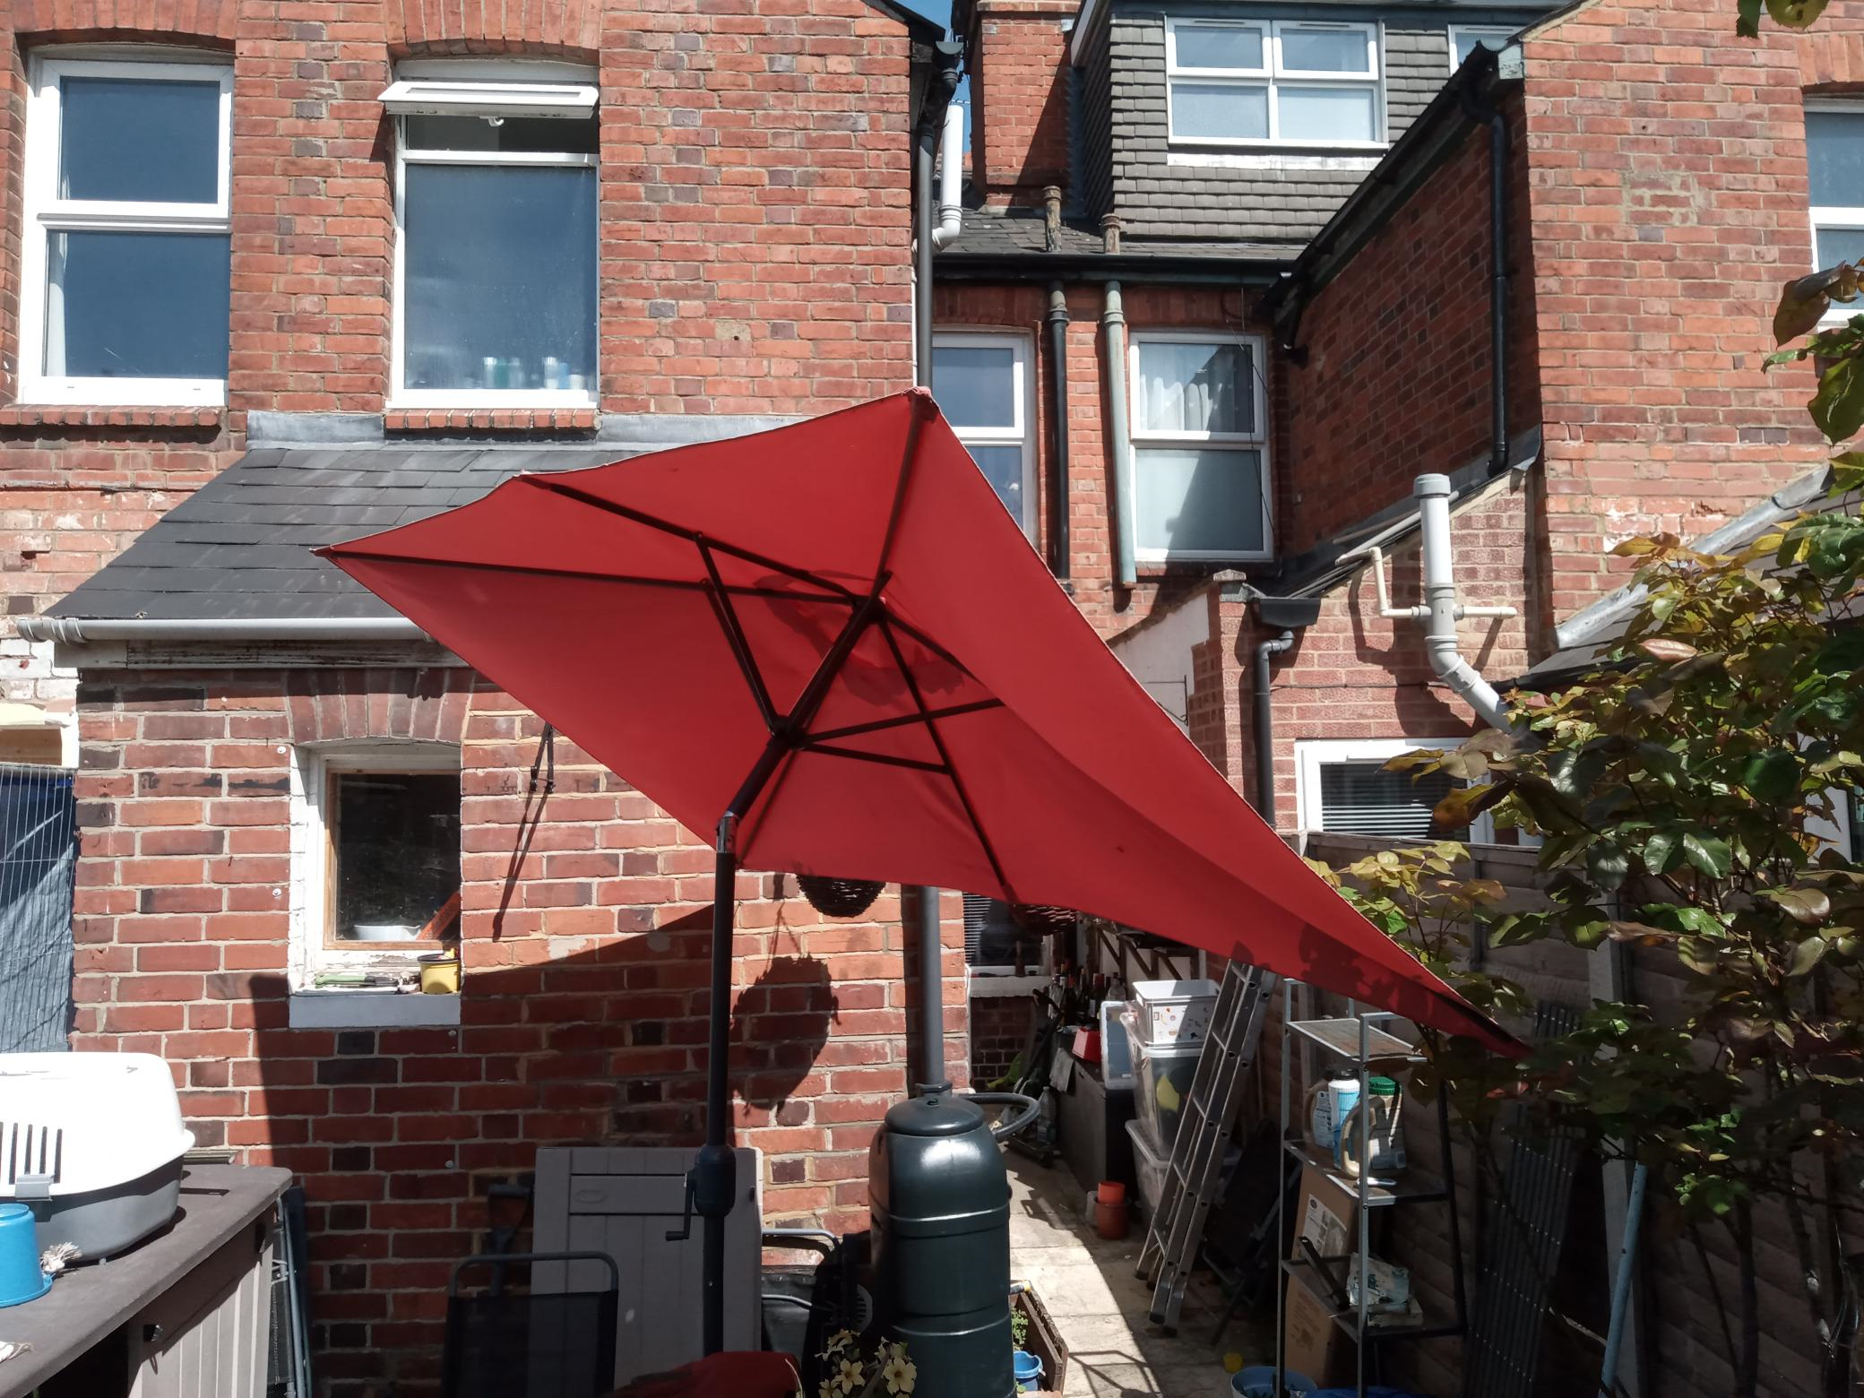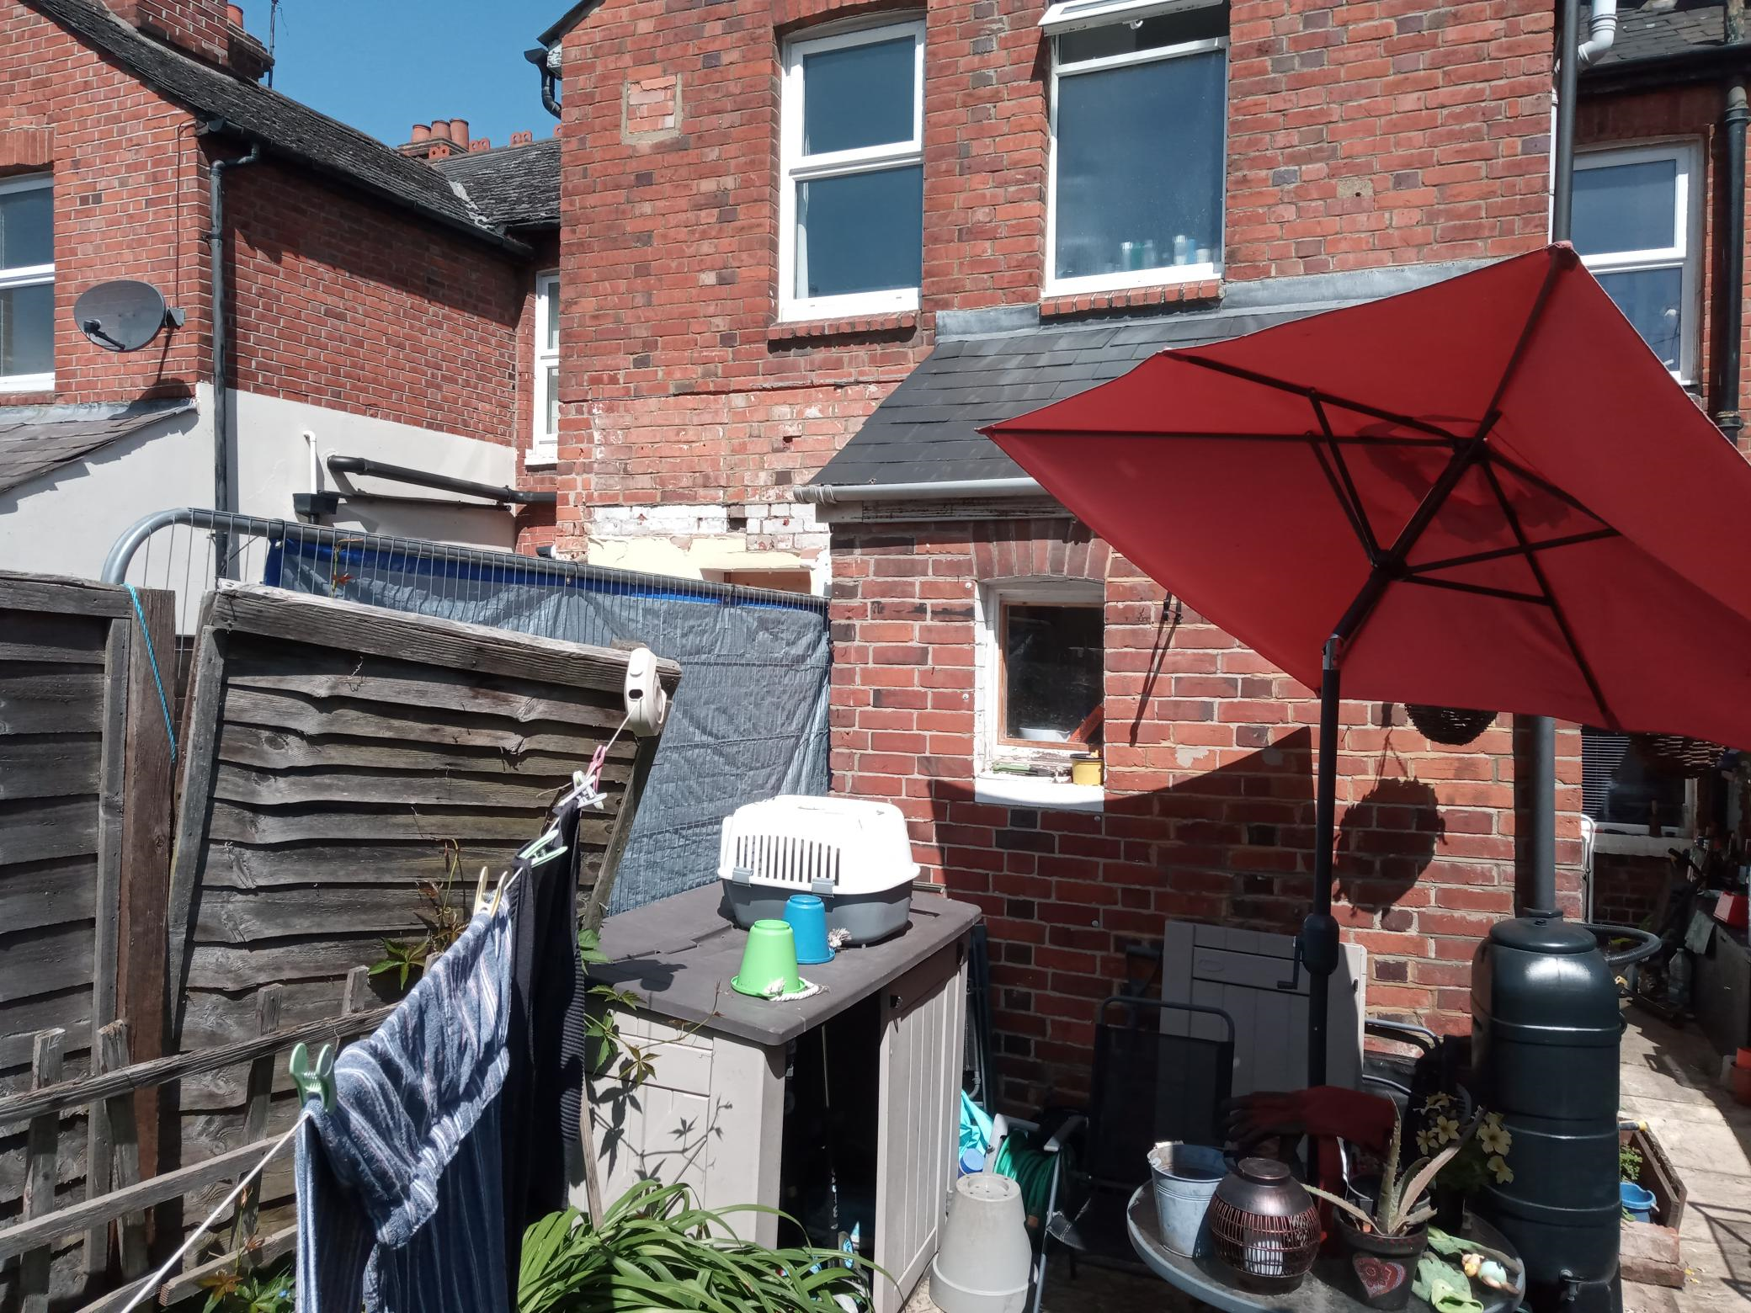

2. PROPOSAL AND SUPPORTING INFORMATION
The proposal presents a rear and side extension to the existing outrigger, effectively increasing the depth of the outrigger by 1.9m and 3.6m on the boundaries with Nos 38 and 42 respectively. It also introduces a loft dormer.

Plans considered dated February 2023 received 28/03/2023
Drawing No 131/100 : Existing Plans & Elevations
Drawing No 131/200 : Proposed Plans
Drawing No 131/201 : Proposed Elevations
Drawing No 131/202 : Proposed Site & Location Plans

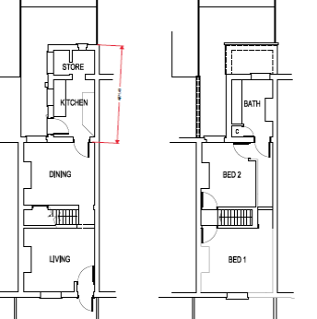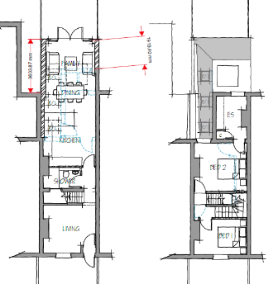
Existing Floor Plans Proposed Plans

- RELEVANT PLANNING HISTORY
Application Ref: 220166
Application Description: Demolition of existing single storey rear extension and erection of a replacement single storey rear extension.
Application Address: 38 Freshwater Road
Outcome: Permitted
Decision Date: 24/6/2022

4. CONSULTATIONS

The following addresses were consulted by letter.

42 Freshwater Road, Reading, Berkshire, RG1 3NA
38 Freshwater Road, Reading, Berkshire, RG1 3NA
35 Coventry Road, Reading, Berkshire, RG1 3ND
37 Coventry Road, Reading

No letters of representation have been received.

Equality Act 2010:
In determining this application the Council is required to have regard to its obligations under the Equality Act 2010. However, there is no indication or evidence (including from consultation on the application) that the protected groups identified by the Act have or will have different needs, experiences, issues and priorities in relation to this particular planning application. Therefore in terms of the key equalities protected characteristics it is considered there would be no significant adverse impacts as a result of the development.

- LEGAL AND PLANNING POLICY CONTEXT

Section 38(6) of the Planning and Compulsory Purchase Act 2004 requires that proposals be determined in accordance with the development plan unless material considerations indicate otherwise. Material considerations include relevant policies in the National Planning Policy framework (NPPF) - among them the 'presumption in favour of sustainable development'. The following local and national planning policy and guidance is relevant to this application:

National Policy
National Planning Policy Framework
National Planning Practice Guidance

Reading Borough Local Plan (2019)
CC7 (Design and the Public Realm)
CC8 (Safeguarding Amenity)
H9 (House Extensions and Ancillary Accommodation)

SPD
Design Guide to House Extensions 2021

6. APPRAISAL
Character and Appearance

Policy H9 states that an extension to a house will be acceptable where it respects the character of the house in terms of scale, location, materials and design and respects the character and pattern of neighbouring properties and the street as a whole in terms of scale, location, materials and design, and any important existing building line. Policy CC7 also sets out relevant considerations for design.

All aspects of this proposal is to the rear of the property. The extensions, limited to the ground floor are limited to 1.9m on one side and 3.6m on the other side of the boundaries with the properties on Nos 38 and 42. The height is limited to approximately 2.5m, maintaining the ground to eave height of the existing outrigger. Materials are to match existing for the roof and the external walls.

It is therefore considered that the proposed changes to the existing dwelling as proposed, respect the character of the house in terms of scale, location and external materials. The design is also deemed acceptable in terms of conformity with the character and pattern of neighbouring properties.

Residential Amenity

Policy H9 states that an extension will be acceptable where it does not result in an overbearing impact on neighbours. Policy H10 seeks to ensure that the amenity of gardens and other outdoor areas are not compromised. Policy CC8 states an extension to a house will be acceptable where it will not cause a significant detrimental impact to the living environment of existing or new residential properties.

The proposal presents no alterations above the ground floor level, and as stated above, all aspects are limited to a height of 2.5m, not higher than the existing roof over the outrigger. There are no side windows proposed and the increase to the depth of the original dwelling does not create any negative impacts on any habitable rooms on both sides. The new dormer to the rear is not observable from the street scene as it is within the height of the original ridge of the existing roof.

- CONCLUSION
The proposed development has been assessed as set out above and is considered to be acceptable on that basis, subject to the following conditions.

8. RECOMMENDATION
Recommended Conditions:
AP1: Approved Plans
TL1: Time Limit Standards
M1: Materials to Match Existing

