

DELEGATED HOUSEHOLDER APPLICATION REPORT

Ward: Emmer Green
App Ref: 221639/HOU
Address: 35 Kingsway, Caversham, Reading, RG4 6RA
Proposals: Retrospective conversion of the existing garage to habitable space (amended)
Case Officer: Chukwudi Onwudinanti
Applicant: Mr Darius Keeley
Date received (valid from): 2 November 2022
Target Decision date: 21 April 2023 (EXT)

1. SITE DESCRIPTION
The proposed site is a mid-terrace dwelling in a terrace of three dwellings. All dwellings on the terrace are of similar design. The dwelling to the right of this proposal has a similar extension to the front porch. The proposed scheme was completed in November 2022, just after the application was submitted.

2. PROPOSAL AND SUPPORTING INFORMATION
Conversion of the existing garage to habitable space

Plans considered dated October 2022
P90 Rev A: Location Plan received 02/11/2022
P80 Rev E: Proposed Site Plan received 18/04/2023
P100 Rev A: Existing Plans received 02/11/2022
P101 Rev A: Proposed Plans received 02/11/2022
P102 Rev A: Existing Elevations received 02/11/2022
P102 Rev A: Location Plan received 02/11/2022

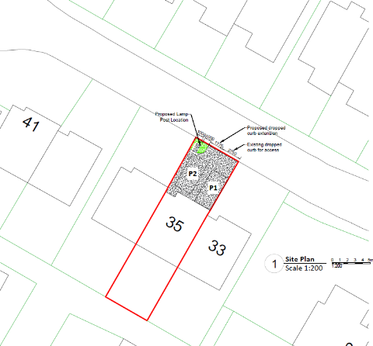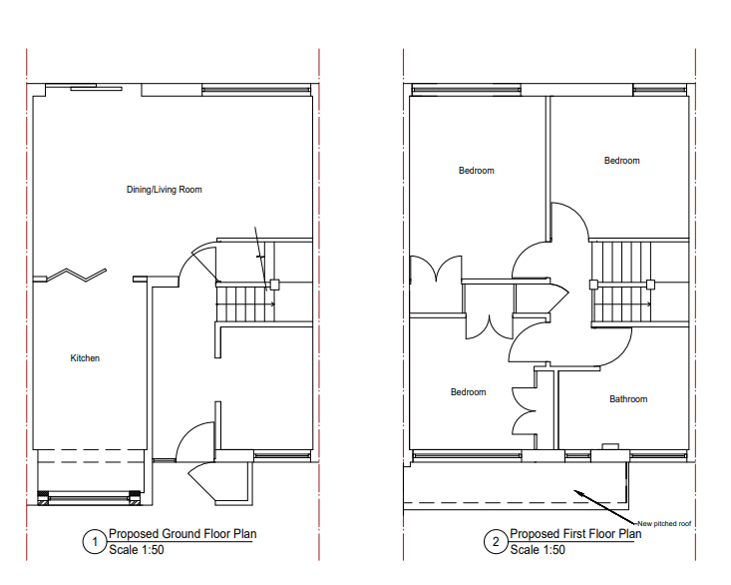

Proposed Site Plan Proposed Floor Plans

- RELEVANT PLANNING HISTORY

None

4. CONSULTATIONS

The following addresses were consulted by letter.

33 Kingsway, Caversham, Reading, RG4 6RA
37 Kingsway, Caversham, Reading, RG4 6RA

No letters of representation have been received.

Transport Comments.
The conversion of the garage will result in the loss of a parking space, an alternative parking layout has not been provided.

The Vehicle hard-standing area on property frontage should have minimum dimensions of at least 2.4m wide (along the boundary entry point) and a minimum 4.8m length (this is the minimum depth of property frontage. Note: This is a minimum requirement; a greater size may be required to accommodate more than one vehicle and to allow for property access/doorways etc. It is not permitted for vehicles to overhang the public highway as this can constitute an obstruction of the public highway under the Highways Act 1980.

iShare measurements indicate that the length of the drive is insufficient to allow for tandem parking, therefore an alternative layout will need to be provided. The lamp column located on the property boundary will also need to be illustrated to ensure there is no conflict of movement.

Water run-off from private property onto the public highway is not permitted. An appropriate method of drainage needs to be provided within the property curtilage including the use of suitable permeable surfacing materials.

Revised plans illustrating 2 off road parking spaces, access and the lamp column are required.

Equality Act 2010:
In determining this application the Council is required to have regard to its obligations under the Equality Act 2010. However, there is no indication or evidence (including from consultation on the application) that the protected groups identified by the Act have or will have different needs, experiences, issues and priorities in relation to this particular planning application. Therefore in terms of the key equalities protected characteristics it is considered there would be no significant adverse impacts as a result of the development.

- LEGAL AND PLANNING POLICY CONTEXT

Section 38(6) of the Planning and Compulsory Purchase Act 2004 requires that proposals be determined in accordance with the development plan unless material considerations indicate otherwise. Material considerations include relevant policies in the National Planning Policy framework (NPPF) - among them the 'presumption in favour of sustainable development'. The following local and national planning policy and guidance is relevant to this application:

National Policy
National Planning Policy Framework
National Planning Practice Guidance

Reading Borough Local Plan (2019)
CC7 (Design and the Public Realm)
CC8 (Safeguarding Amenity)
H9 (House Extensions and Ancillary Accommodation)
TR3 (Access Traffic and Highway-related Matters)
TR5 (Car and Cycle Parking)

SPD
Design Guide to House Extensions 2021
Revised Parking Standards and Design SPD 2011

6. APPRAISAL
Character and Appearance

Policy H9 states that an extension to a house will be acceptable where it respects the character of the house in terms of scale, location, materials and design and respects the character and pattern of neighbouring properties and the street as a whole in terms of scale, location, materials and design, and any important existing building line. Policy CC7 also sets out relevant considerations for design.

This proposal seeks to convert the existing garage into a habitable room, without increasing the footprint of the existing dwelling. The overhanging flat roof that covers part of the existing garage and the front porch is to be changed to a mono-pitch roof. All materials to be used externally are to match the existing materials and the new roof matches the existing extended roof on the adjoining property to the right of the dwelling on the terrace. The roof change is considered an enhancement of the original flat roof. While the replacement of the garage door with a kitchen window presents a change in appearance to the front façade, this change is not considered to be so negatively impactful as to be unacceptable, especially as there is an existing similar extension on the next terrace on the same side of the street.

It is therefore considered that this proposal does not present such an impact as it will be unacceptable in terms of scale, location, materials and design.

Residential Amenity

Policy H9 states that an extension will be acceptable where it does not result in an overbearing impact on neighbours. Policy H10 seeks to ensure that the amenity of gardens and other outdoor areas are not compromised. Policy CC8 states an extension to a house will be acceptable where it will not cause a significant detrimental impact to the living environment of existing or new residential properties.

The proposal does not detrimentally effect amenity.

Parking/ Access
As demonstrated above in this report, Transport had advised on the steps to mitigate the impact of this proposal on the parking and driveway access for the property. This advice has been taken on board and revised drawings provided to allay these concerns. These revised drawings have been accepted by Transport, while appropriate conditions and informative are to be attached to any decision to ensure compliance with Highway requirements.

In particular, since the accepted submission entails the relocation of the lamp post, Transport has advised that adequate conditions and informative be attached to the decision such that Highways would be consulted in all the processes.

There are no overbearing effects, Privacy and overlooking issues deemed to result from this proposal, hence the proposal is considered to be in keeping with preserving the Amenity of the existing dwelling and the adjoining properties.

- CONCLUSION
The proposed development has been assessed as set out above and is considered to be acceptable on that basis, subject to the following conditions.

8. RECOMMENDATION

Recommended Conditions:
AP1: Approved Plans
Materials
DC1: Vehicle Parking (As Specified)
DC3: Vehicular Access (As Specified)

Informative
Terms and Conditions
Building Regulations
IF1: Positive and Proactive
IF3: Highways

