MATERIALS

ET CLAY TAKELEY RED WIRECUT FACING BRICK PACK
The Takeley Red brick is a perforated, wirecut facing brick, imported from the EU. It is red in colour with a light texture.
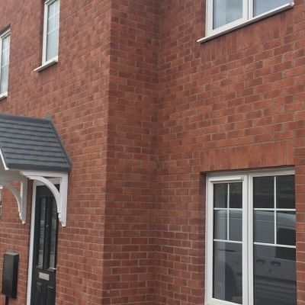

AluK 58BW
The attractive casement design of the AluK 58BW is perfect to replace both older windows in heritage properties, or to create a modern sleek look in a contemporary build. The frame offers clean lines and advanced functionality. Available in multiple configurations, with a range of customisable options.


Colour of windows and doors


Del Carmen: the slate that started it all
Del Carmen is the sensational natural slate that started it all. It was when our founder, Ahmed El-Helw, first found Del Carmen that the SSQ journey really began.
One of the finest quarries in the most renowned slate-producing region of North-West Spain, Del Carmen produces outstanding Spanish slate with a deep blue-black colour that will not fade in sunlight, characteristic longitudinal grain, and highly distinctive, faintly-rippled texture.
That’s why when architects, contractors and homeowners want to crown a property in style, they choose Del Carmen.
