

DELEGATED HOUSEHOLDER APPLICATION REPORT

Ward: Tilehurst
App Ref: 230794/HOU
Address: 16 Portland Gardens, Tilehurst, Reading, RG30 4QH
Proposals: Two storey side and rear extension with single storey orangery to rear.
Case Officer: Chukwudi Onwudinanti
Applicant: Mr & Mrs Simonds
Date received (valid from): 8 June 2023
Target Decision date: 3 August 2023

1. SITE DESCRIPTION
The site is on an end of terrace dwelling on the western side of the cul-de-sac that forms part of Portland Gardens. The Portland Gardens road empties into the Landsowne Road. Portland Gardens and the immediate areas on Landsdowne Road are characterised by residential dwellings of very similar styles and sizes.

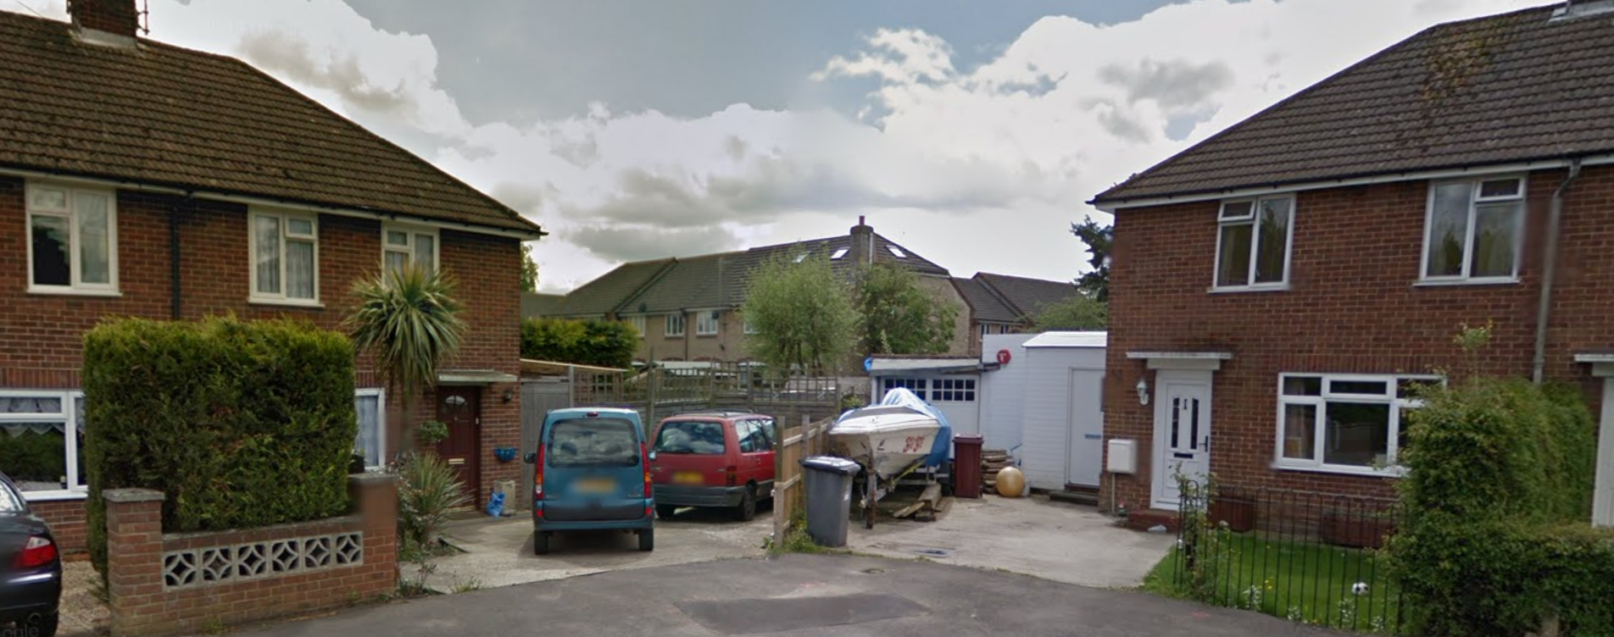

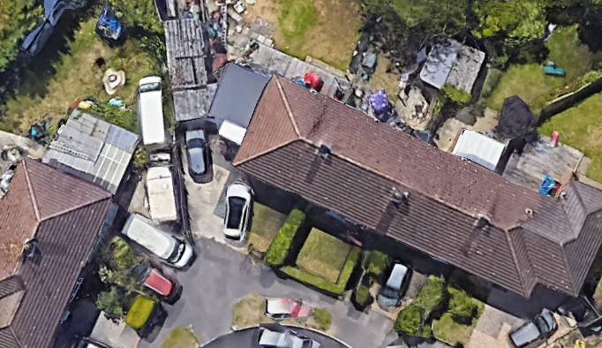
Google Photo
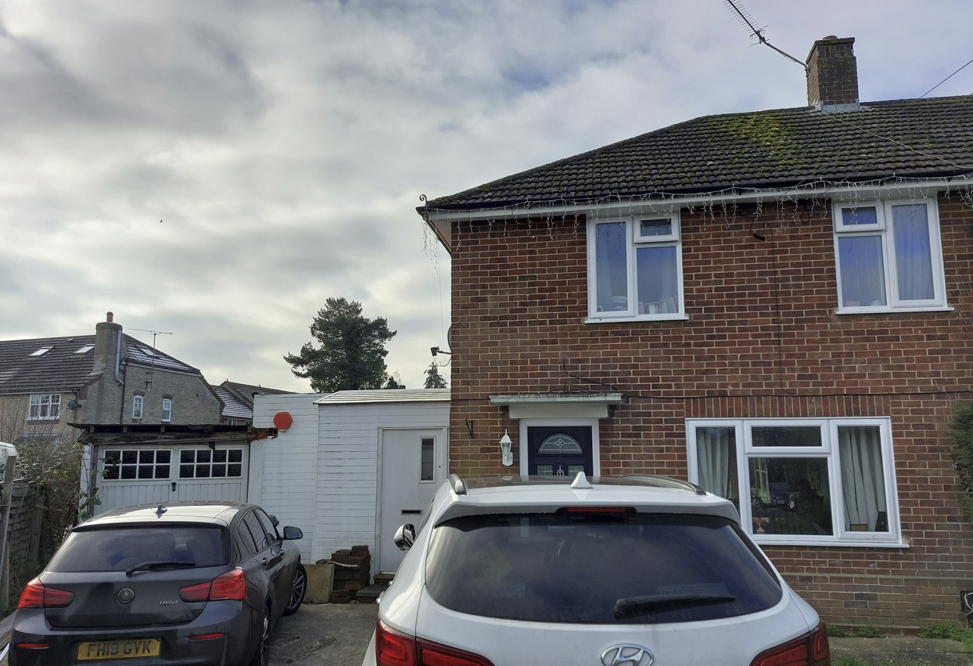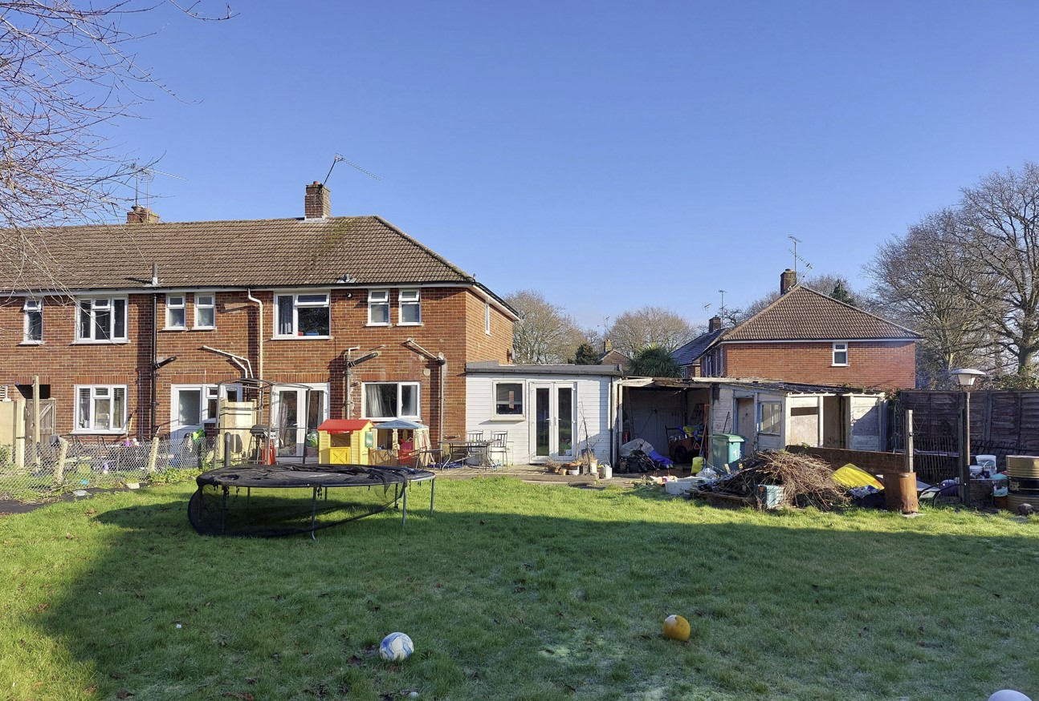
Site Photos Site Photos
2. PROPOSAL AND SUPPORTING INFORMATION
Proposed, is a part one storey, part two storey side extension, running the whole length of the side of the existing dwelling and a further rear extension of 3.5mwith single storey orangery to rear.

Plans and documents considered
Dated June ’23 and received 12/6/2023
Drawing No 001 Rev PL00: Location & Block Plan
Drawing No 002 Rev PL00: Existing Site Plan
Drawing No 010 PL00: Existing Ground Floor Plan
Drawing No 030 PL00: Existing Elevations
Drawing No 011 PL00: Existing First Floor & Roof Plan

Dated September 2023
Drawing No 003 Rev PL01: Proposed Site Plan received 05/09/2023
Drawing No 020 Rev PL02: Proposed Ground Floor Plan received 13/09/2023
Drawing No 021 Rev PL02: Proposed First Floor & Roof Plan received 13/09/2023
Drawing No 031 Rev PL02: Proposed Elevations received 13/09/2023
Preliminary Roost Assessment prepared by Arbtech Consulting Limited received 12/06/2023
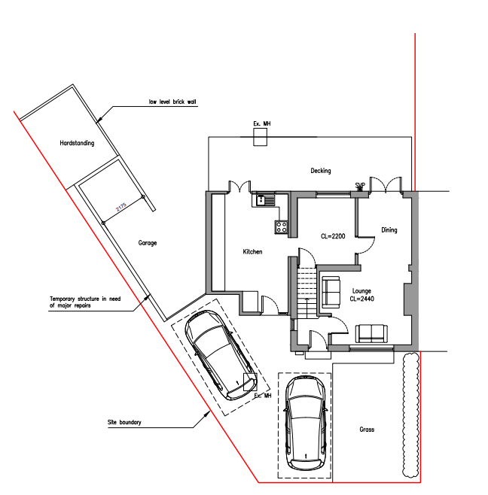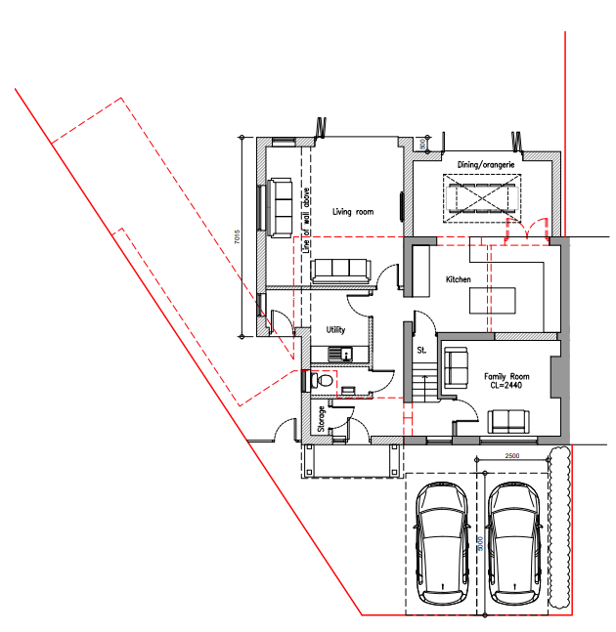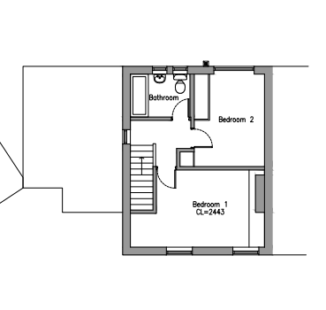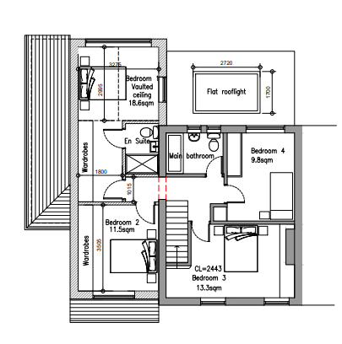
Existing GF Plan Proposed GF Plan Existing FF Plan Proposed FF Plan

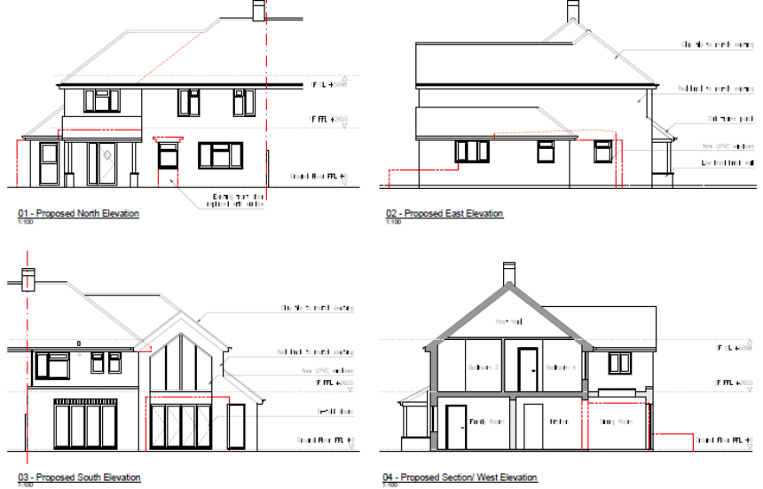
Proposed Elevations

- RELEVANT PLANNING HISTORY
None

4. CONSULTATIONS

The following addresses were consulted by letter.

15 Portland Gardens Tilehurst, Reading, Berkshire, RG3 4QH
16 Manor Park Close, Tilehurst, Reading, Berkshire, RG30 4PS
17 Manor Park Close, Tilehurst, Reading
17 Portland Gardens, Tilehurst, Reading, RG30 4QH
15 Manor Park Close, Reading, RG30 4PS

No letters of representation have been received.

Ecology
There are no objections to this application on ecological grounds. The submitted bat survey is deemed as adequate - Preliminary Roost Assessment prepared by Arbtech Consulting Limited.

Discussions with the agent
The agent was advised by the LPA to revise the original designs submitted. The advice was to bring the ridgeline of the proposed extension down from the level of the ridgeline of the existing dwelling and to step back the first floor aspect from the front line of the principal elevation. This advice was to ensure that the proposed extension would be adequately subservient to the existing dwelling. Amended drawings were received and are assessed in this report.

Equality Act 2010:
In determining this application the Council is required to have regard to its obligations under the Equality Act 2010. However, there is no indication or evidence (including from consultation on the application) that the protected groups identified by the Act have or will have different needs, experiences, issues and priorities in relation to this particular planning application. Therefore in terms of the key equalities protected characteristics it is considered there would be no significant adverse impacts as a result of the development.

- LEGAL AND PLANNING POLICY CONTEXT

Section 38(6) of the Planning and Compulsory Purchase Act 2004 requires that proposals be determined in accordance with the development plan unless material considerations indicate otherwise. Material considerations include relevant policies in the National Planning Policy framework (NPPF) - among them the 'presumption in favour of sustainable development'. The following local and national planning policy and guidance is relevant to this application:

National Policy
National Planning Policy Framework
National Planning Practice Guidance

Reading Borough Local Plan (2019)
CC7 (Design and the Public Realm)
CC8 (Safeguarding Amenity)
H9 (House Extensions and Ancillary Accommodation)

SPD
Design Guide to House Extensions 2021

6. APPRAISAL
Character and Appearance

Policy H9 states that an extension to a house will be acceptable where it respects the character of the house in terms of scale, location, materials and design and respects the character and pattern of neighbouring properties and the street as a whole in terms of scale, location, materials and design, and any important existing building line. Policy CC7 also sets out relevant considerations for design.

This proposal would be to replace the existing single storey side kitchen extension with a part 2 storey and part single storey side extension, the latter set well back from the front building line. The extensions would project beyond the rear building line.The side extension proposed effectively increases the existing built form by 1.6m width and 1.6m to the front, while increasing the depth to the rear of the existing dwelling by approximately 3.5m. Adjacent to the two storey element would be a flat roofed single storey extension (orangery) which would create a rear extension spanning the full width of the existing dwelling. New bifold doors are proposed to the rear. There are side windows proposed to the side for the living room, utility room and a toilet.

The two storey element would be ca 3.5m in width and stepped away from neighbouring properties on both sides. The ridge of the proposed roof is to be stepped down from the existing ridgeline and the front line is stepped back approximately 0.3m from the principal elevation line. New full height UPVC windows are proposed to the rear.

Materials to be used are to match the existing materials on the original dwelling and the porch proposed would be a system of columns and beams, with a roof over.

The site is on a cul-de-sac with similarly styled buildings. The proposal is on the side of the dwelling with a considerable distance between the proposed extension and the next dwelling on that side. The rear garden is also of considerably large size, with the next dwelling on that side much more than 20m. The dwellings on both sides of the site have had two storey side extensions of similar scales to that proposed in this application.

A combination of these factors of size of the gaps in between the dwellings, the existing extensions on the neighbouring properties and the sympathetic design, ensures that the overall effects of the developments proposed would not be harmful to the street and the existing dwelling in terms of character, design and scale as proportionality and outlook would be maintained and preserved.

Residential Amenity

Policy H9 states that an extension will be acceptable where it does not result in an overbearing impact on neighbours. Policy H10 seeks to ensure that the amenity of gardens and other outdoor areas are not compromised. Policy CC8 states an extension to a house will be acceptable where it will not cause a significant detrimental impact to the living environment of existing or new residential properties.

As highlighted above, there is a considerable gap between the dwelling and the neighbouring dwelling on the side of the two storey extension. The rear extension is retrained to the ground floor level on the side of the neighbouring property that shares a party wall with the site. This ground floor level extension to the rear is limited to a depth of 3.5m and a ground to eave height of 3m, with a flat roof over.

There are no proposed first floor side facing windows and a condition is included removing the permitted development rights for such to maintain privacy to the neighbour’s rear amenity space.

The combination of the limited depth and height of the rear extension and the separation from the adjoining properties on the side of the first floor extension aspect is considered to be of adequate mitigation to any privacy and overlooking issues as well as any overbearing effects. There are no existing windows to habitable rooms that are deemed to be affected adversely by the extensions proposed as a result of the separations mentioned above and the limited scale of the rear extensions.

- CONCLUSION
The proposed development has been assessed as set out above and is considered to be acceptable on that basis, subject to the following conditions.

8. RECOMMENDATION: Grant
Recommended Conditions:
AP1: Approved Plans
TL1: Time Limit Standards
M1: Materials to Match Existing
PD rights windows/ openings

