

DELEGATED HOUSEHOLDER APPLICATION REPORT

Ward: Redlands
App Ref: 230621/LBC
Address: Flat 3, 7 Eldon Square, Reading, RG1 4DR
Proposals: New boiler
Case Officer: Chukwudi Onwudinanti
Applicant: Joseph Parr
Date received (valid from): 9 August 2023
Target Decision date: 10 October 2023(EXT)

1. SITE DESCRIPTION
The proposed site is a flat within a Grade II listed building with the following listing description:

ELDON SQUARE 1. 5128 No 7 SU 7273 7/468 II GV 2. Circa 1840. 2 and 3 storey Bath ashlar 'pair' to No 5 (qv). Italianate style. Basement. 2 bays, the right hand bay a 3 storey gabled break with one range of glazing bar sash windows (plate glass with marginal glazing on ground floor). Raised surround on 1st floor, bracketed segmental pediment on ground floor with corbelled balcony. One window to left over recessed modern door in plain doorway. Slate roofs with projecting eaves.

The property is within the Eldon Square Conservation Area.

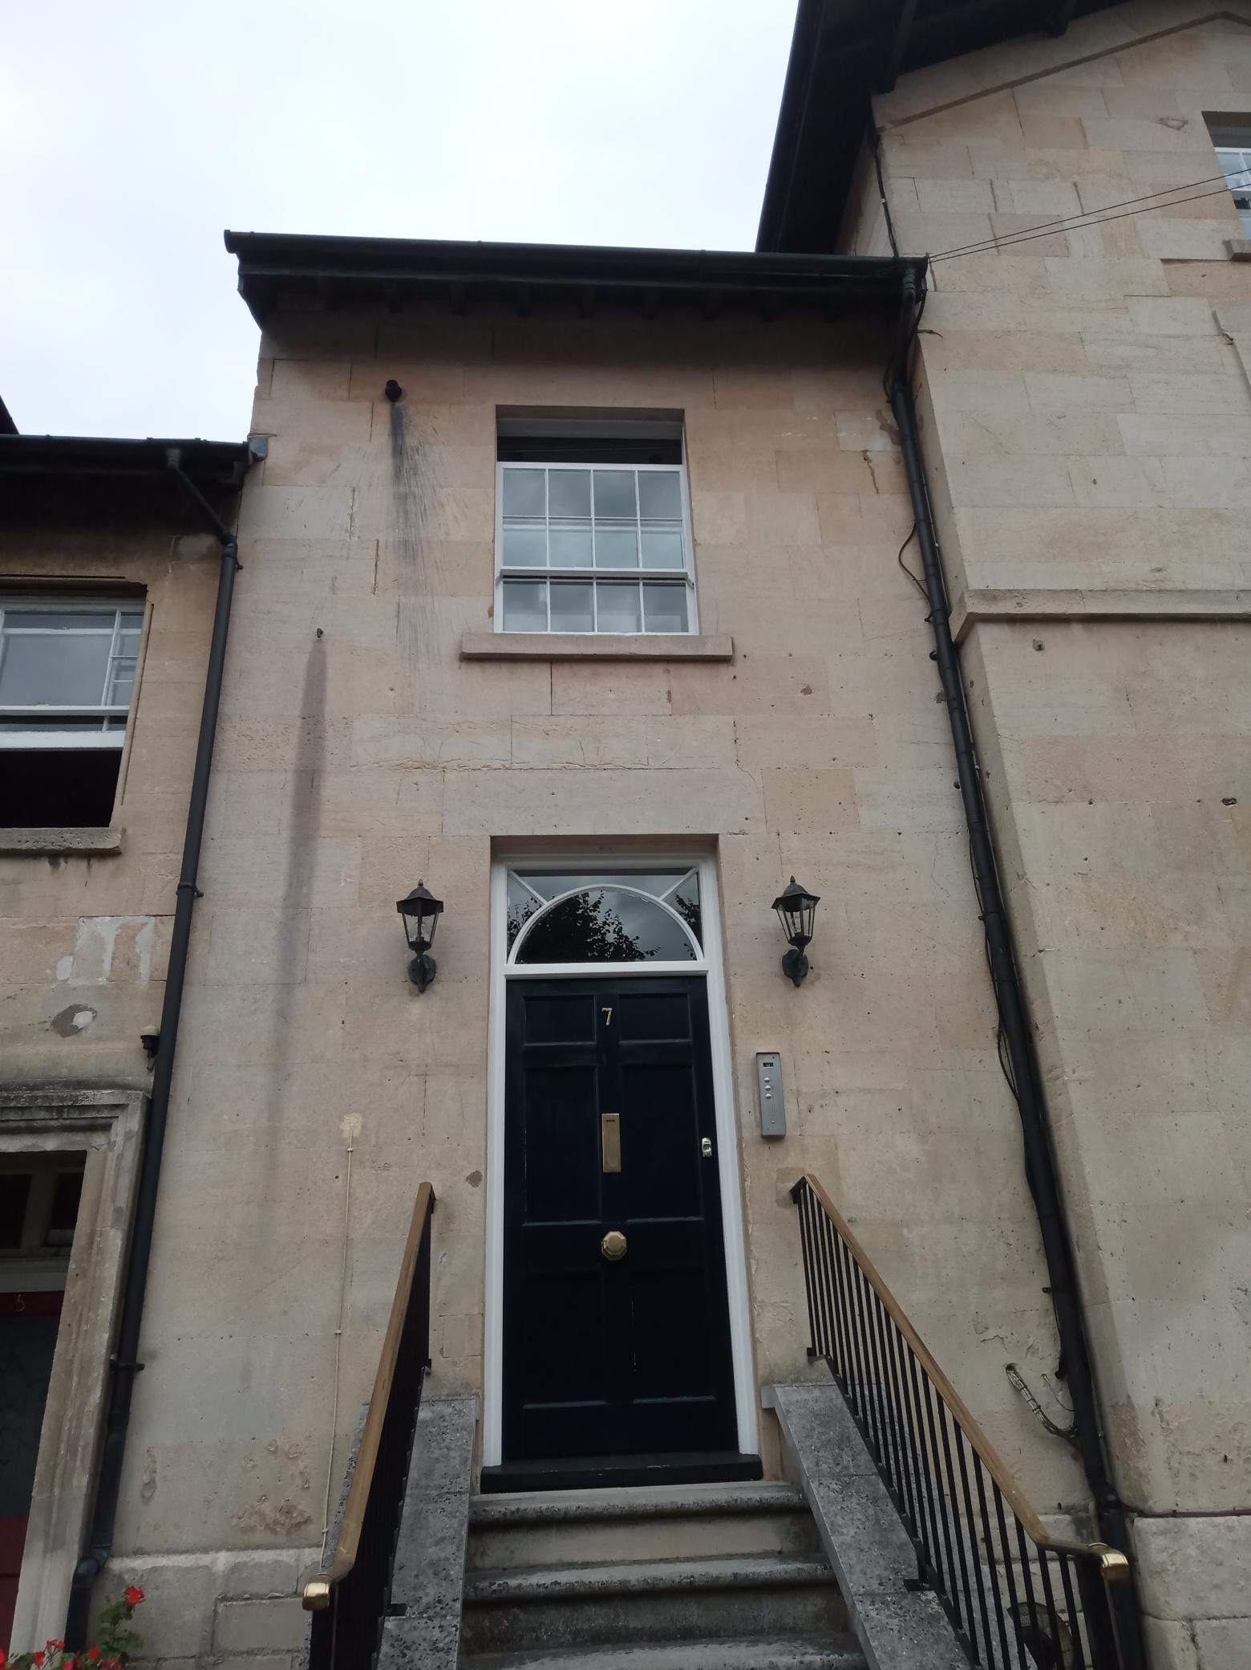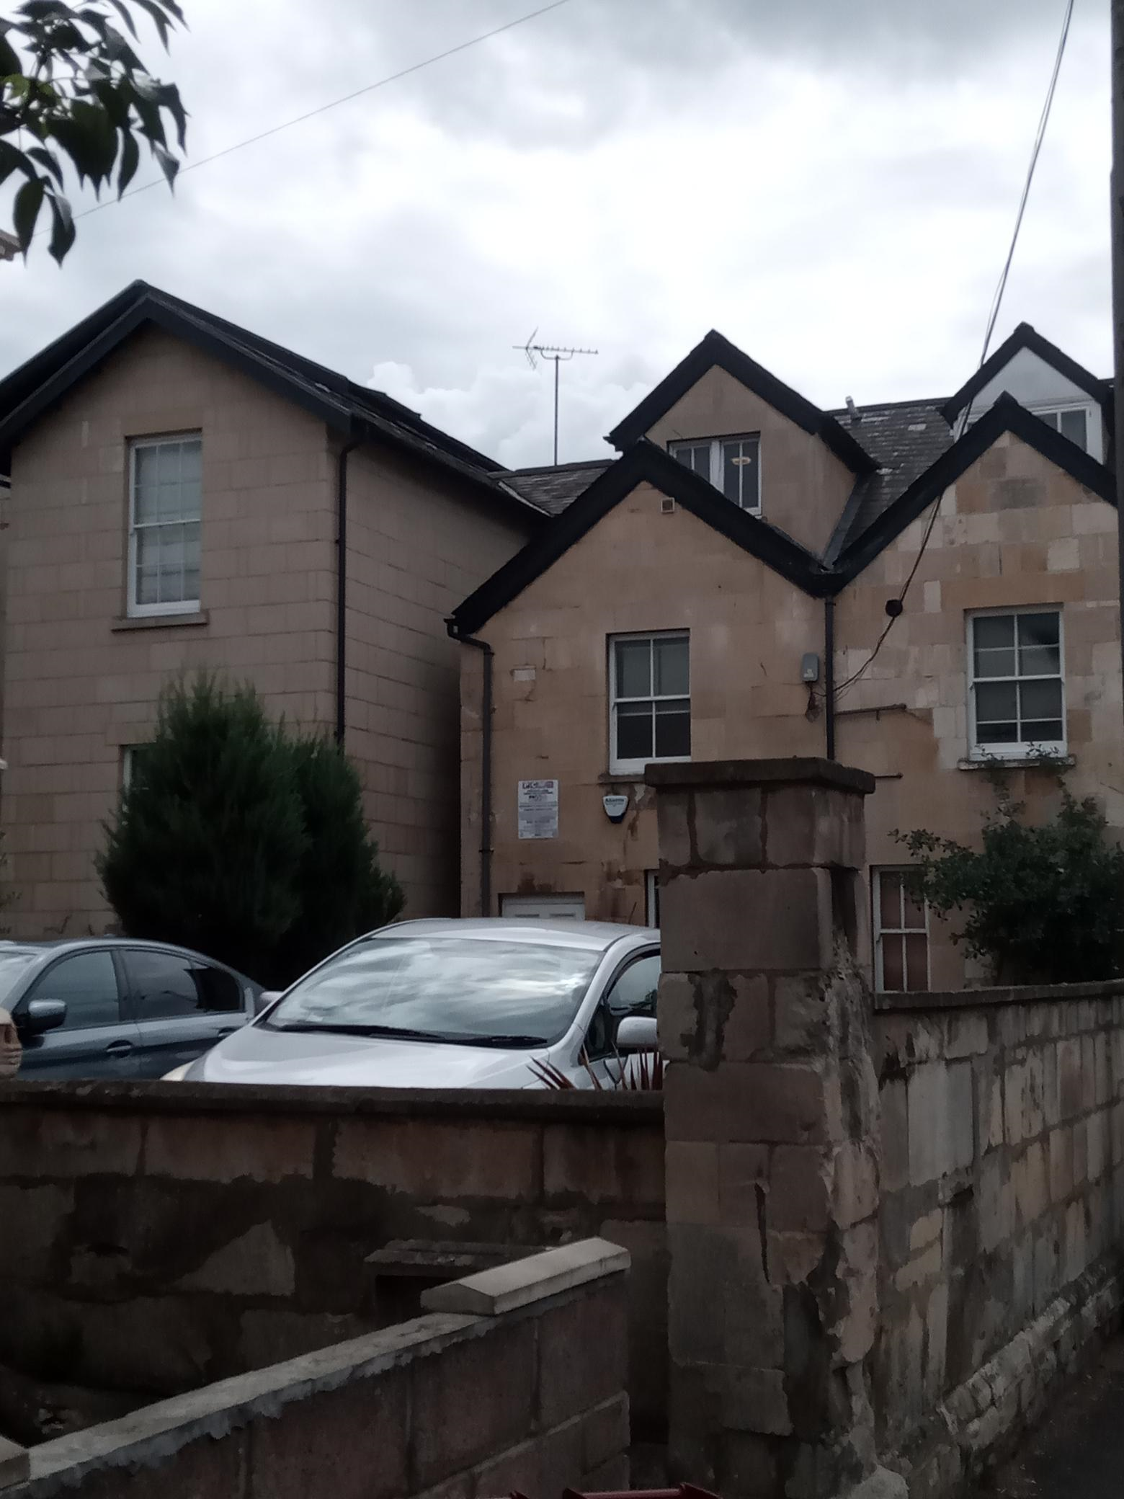

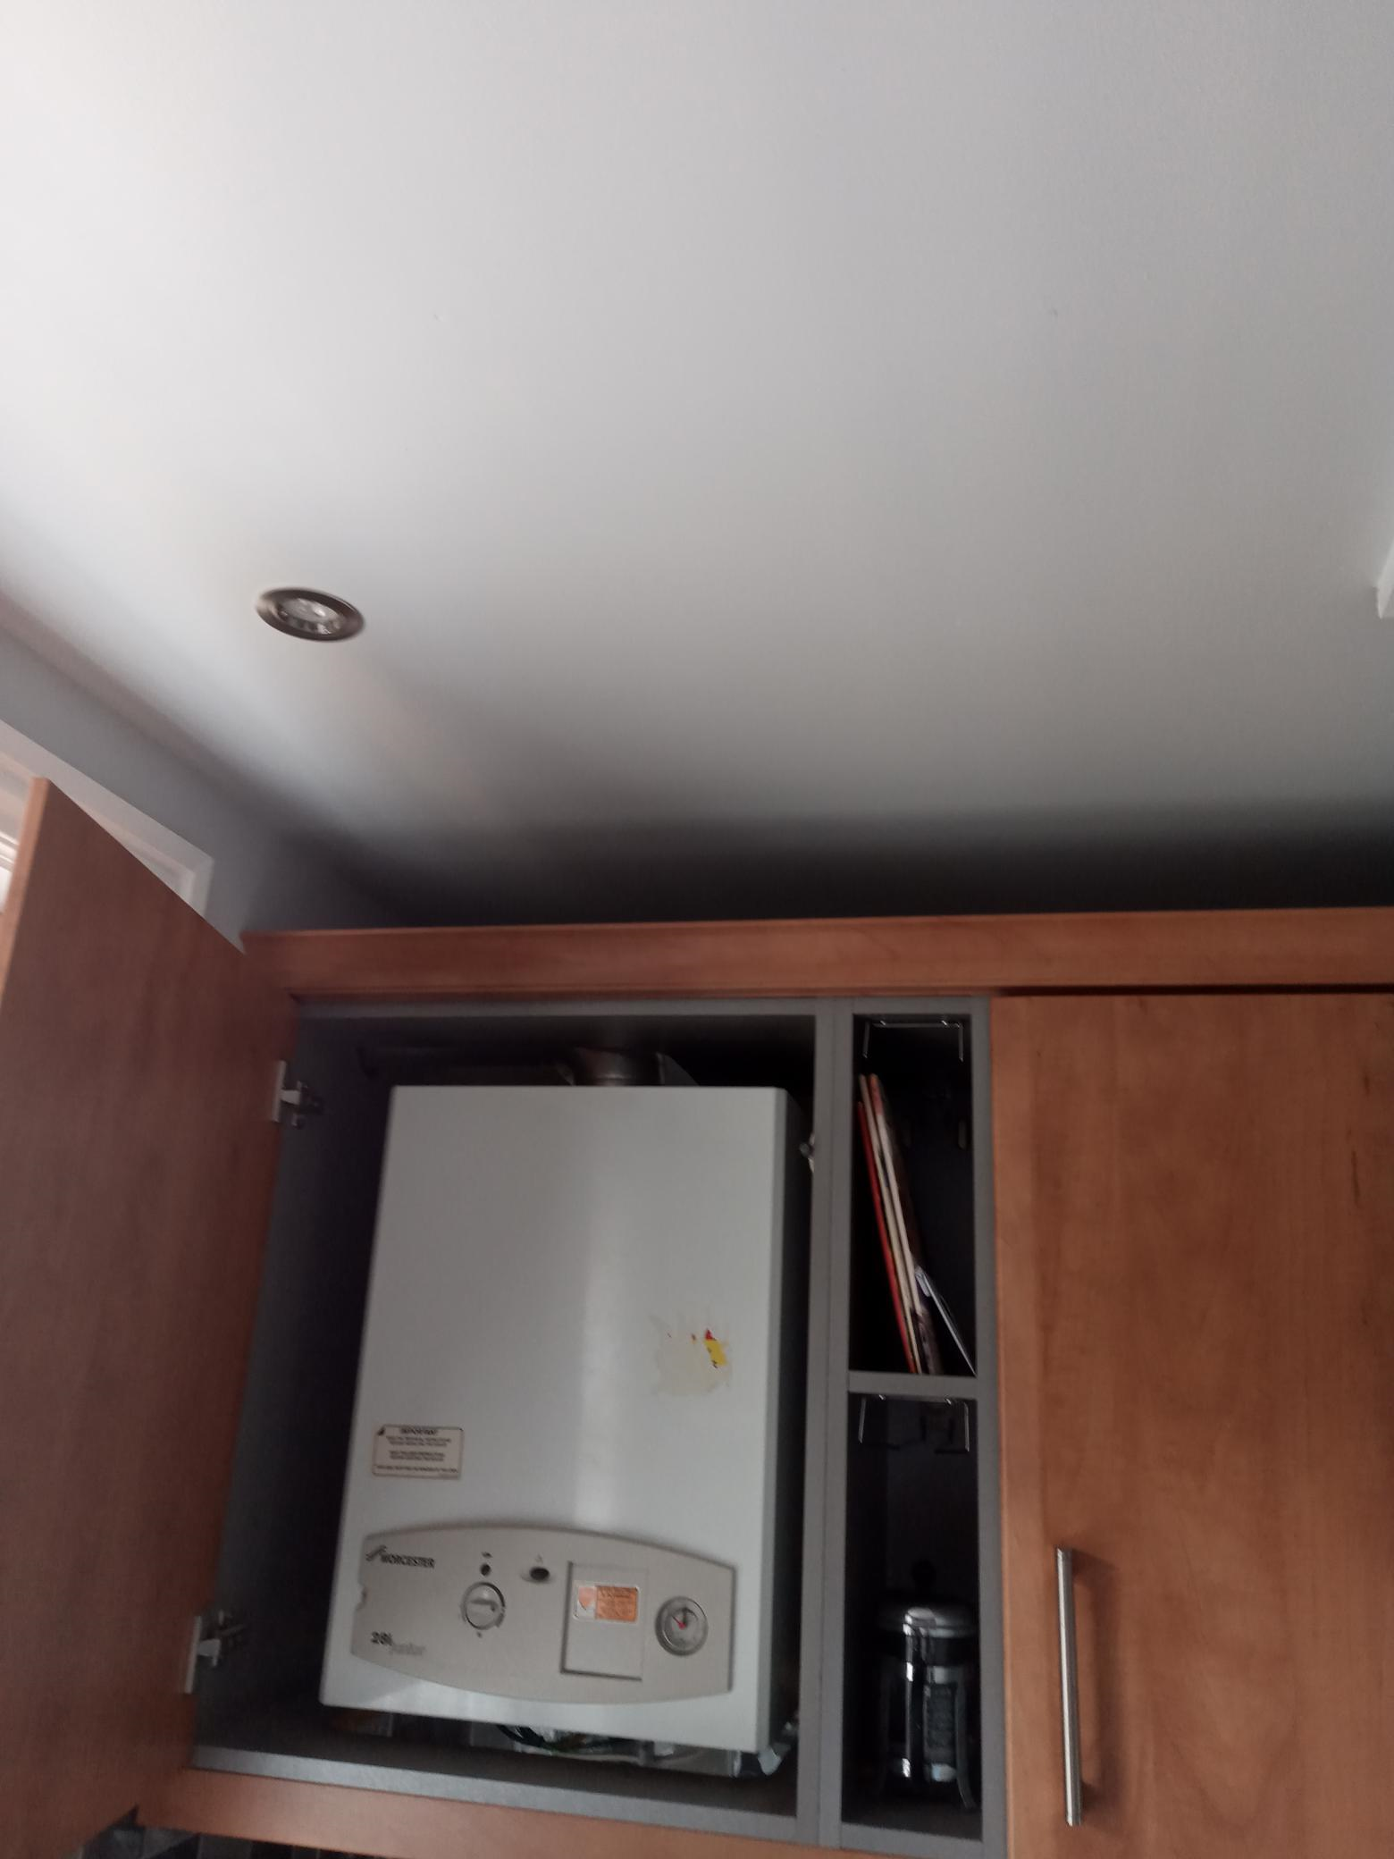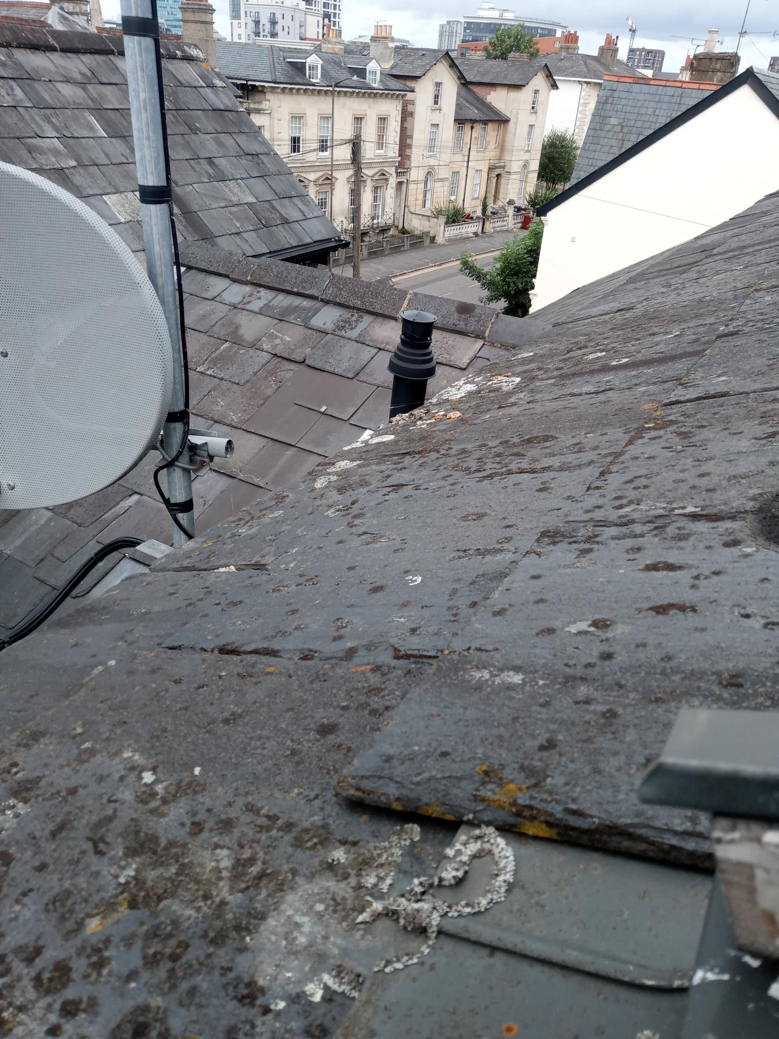

2. PROPOSAL AND SUPPORTING INFORMATION
The proposal is for the installation of a replacement boiler within the kitchen in Flat 3, re-channelling the vent pipe from the front façade, to the rear part of the roof, through the ceiling void.

Plans and documents considered
Proposed Boiler–F3 received 17/09/2023
Existing Boiler–F3 received 17/09/2023
Location Plan received 09/05/2023
Proposed Boiler Installation (Schematics) received 09/05/2023
Design and Access Statement received 09/05/2023
Façade Repairs & Cleaning Details prepared by A F Jones Stonemasons received 17/09/2023

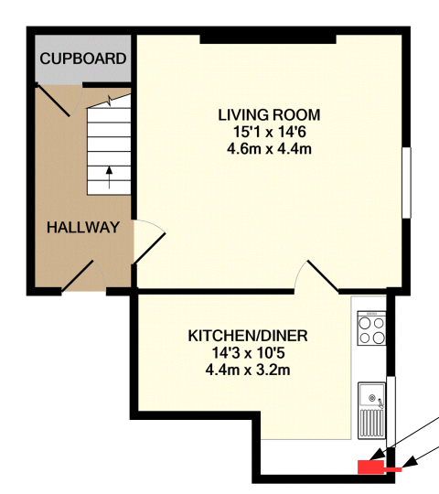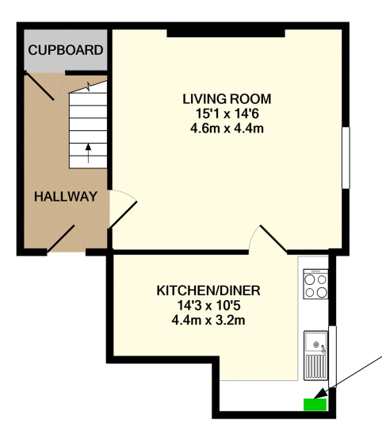

Existing Boiler Proposed Boiler

- RELEVANT PLANNING HISTORY
Application Ref: 020288
Description: Demolition of rear extensions, conversion to six flats for residential use.
Outcome: Application Refused
Decision Date: 15/4/2002

Application Ref: 030175
Description: Demolition of rear extensions - conversion and extension to form 4 flats for residential use.
Outcome: Application Permitted
Decision Date: 16/9/2003

4. CONSULTATIONS
Site notice was displayed on site.

Conservation
The Conservation Officer’s advice was sought with regard to the proposed repair to the stone work on the façade, caused by the existing boiler vent, now proposed to be removed.

No objections were raised subject to conditions.

Equality Act 2010:
In determining this application the Council is required to have regard to its obligations under the Equality Act 2010. However, there is no indication or evidence (including from consultation on the application) that the protected groups identified by the Act have or will have different needs, experiences, issues and priorities in relation to this particular planning application. Therefore in terms of the key equalities protected characteristics it is considered there would be no significant adverse impacts as a result of the development.

- LEGAL AND PLANNING POLICY CONTEXT
Section 38(6) of the Planning and Compulsory Purchase Act 2004 requires that proposals be determined in accordance with the development plan unless material considerations indicate otherwise. Material considerations include relevant policies in the National Planning Policy framework (NPPF) - among them the 'presumption in favour of sustainable development'. The following local and national planning policy and guidance is relevant to this application:

Section 16(2) of the Planning (Listed Buildings and Conservation Areas) Act 1990 requires the local planning authority to have special regard to the desirability of preserving a listed building or its setting or any features of special interest which it possesses.

Section 72 (1) of the Planning (Listed Buildings and Conservation Areas) Act 1990 requires the local planning authority in the exercise of its functions to pay special attention to the desirability of preserving or enhancing the character or appearance of a conservation area.

National Policy
National Planning Policy Framework
National Planning Practice Guidance

Reading Borough Local Plan (2019)
CC7 (Design and the Public Realm)
CC8 (Safeguarding Amenity)
EN1 (Protection and Enhancement of the Historic Environment)
EN3 (Enhancement of Conservation Areas)

SPD
Eldon Square Conservation Area Appraisal

6. APPRAISAL

Design and Heritage Impact
The NPPF details in Paragraph 199: “When considering the impact of a proposed development on the significance of a designated heritage asset, great weight should be given to the asset’s conservation (and the more important the asset, the greater the weight should be). This is irrespective of whether any potential harm amounts to substantial harm, total loss or less than substantial harm to its significance.” Paragraph 200 goes on to state: “Any harm to, or loss of, the significance of a designated heritage asset (from its alteration or destruction, or from development within its setting), should require clear and convincing justification.”

Paragraph 202 states:
“Where a development proposal will lead to less than substantial harm to the significance of a designated heritage asset, this harm should be weighed against the public benefits of the proposal including, where appropriate, securing its optimum viable use.”

Policy EN1 (Protection and Enhancement of the Historic Environment) states that “Historic features, areas of historic importance and other elements of the historic environment, including their settings will be protected and where possible enhanced. This will include:
- Listed Buildings;
- Conservation Areas;
All proposals will be expected to protect and where possible enhance the significance of heritage assets and their settings, the historic character and local distinctiveness of the area in which they are located.”

Policy EN3 (Enhancement of Conservation Areas) states that “The special interest, character and architecture of Conservation Areas will be conserved and enhanced. Development proposals within Conservation Areas must make a positive contribution to local character and distinctiveness. Positive consideration will be given to proposals which take opportunities to enhance the character of conservation areas. These may include:
- Restoring original building features;
- Removing inappropriate additions or alterations to buildings;”

The application seeks to replace the existing boiler with a new boiler of almost the same size. Therefore, the physical space to be taken up by the new boiler would not exceed the space taken by the existing boiler. Therefore, there would be no alterations to the walls of the existing dwelling nor the fabric around the enclosure housing the boiler.

It has also been considered whether the installation of the new boiler would have an adverse impact on those elements which contribute to the special architectural or historic interest including the settings around No 7 Eldon Square. The new boiler would be piped through the void of the ceiling, with the vent pipe let out through the roof to the rear of the property. On the site visit, it was noted that the vent pipe would not be visible from any point either to the rear of the property or in front of it. It was also noted, as is evident from the interior photos taken on the visit, that the ceiling does not retain the original architectural features, presumably lost in parts during previous developments converting No 7 Eldon Square into 4 flats.

The applicant is seeking to remove the existing vent pipe that protrudes through the front façade, which has caused some damage to the stone masonry work on the front façade. They are seeking to restore the stone work to its original form and has submitted the document “Façade Repairs & Cleaning Details prepared by A F Jones Stonemasons” to demonstrate how they could achieve this. The conservation consultee has accepted the repair details but also advised that conditions (included above) be included in the consent.

It is therefore considered that the works proposed in this application would cause less than substantial harm to the significance of the listed building. In accordance with National Policy (Para. 202) this less than significant harm has been weighed against the public benefits of the remedial works proposed to the front façade, which would in effect, restore to a good degree, the original features of the building and remove inappropriate additions or alterations to the building. There would also be no harm to the Conservation Area. Overall, therefore, the proposal is considered to accord with Policies EN1 and EN3 of the Reading Borough Local Plan (2019) and the NPPF.

- CONCLUSION
There would be some limited harm to the original fabric of the Listed Building, however, this has been weighed against the public benefits of stone work repair, and therefore, it is considered that the proposed works would be acceptable.

The proposed development has been assessed and the proposed works are considered to be in accordance with the above relevant policies and Listed Building Consent can be granted subject to the following conditions.

8. RECOMMENDATION: Grant
Recommended Conditions:
LB1: TIME LIMIT LISTED BUILDING (WORKS)
AP1: APPROVED PLANS
LB2: LISTED BUILDING CONSENT (WORKS SPECIFICATION)
ROOF MATERIAL PRESERVATION/RE-USE

