

DELEGATED HOUSEHOLDER APPLICATION REPORT

Ward: Tilehurst
App Ref: 230352/HOU
Address: 27 Westwood Road, Tilehurst, Reading, RG31 5PL
Proposals: Single storey extension for front entrance porch and toilet.
Case Officer: Chukwudi Onwudinanti
Applicant: Mr Richard Neale
Date received (valid from): 20 March 2023
Target Decision date: 14 June 2023 (Ext)

1. SITE DESCRIPTION
The proposal site is a semi-detached, two storey dwelling on the western side of Westwood Road, within a predominantly residential area comprising of a mix of semi-detached and detached dwellings of similar as well as varied styles.

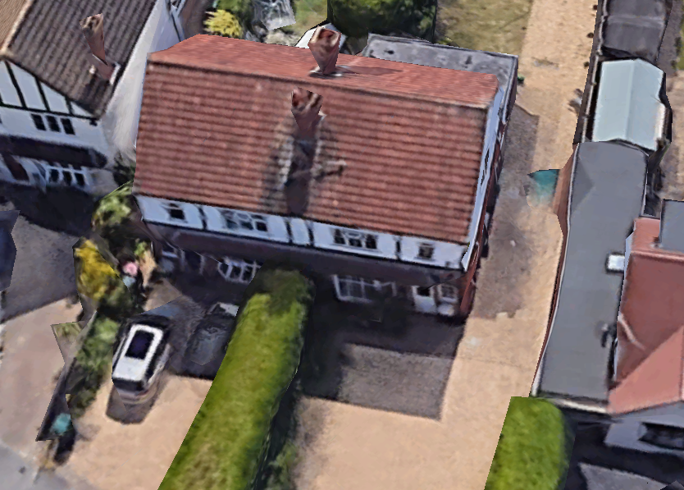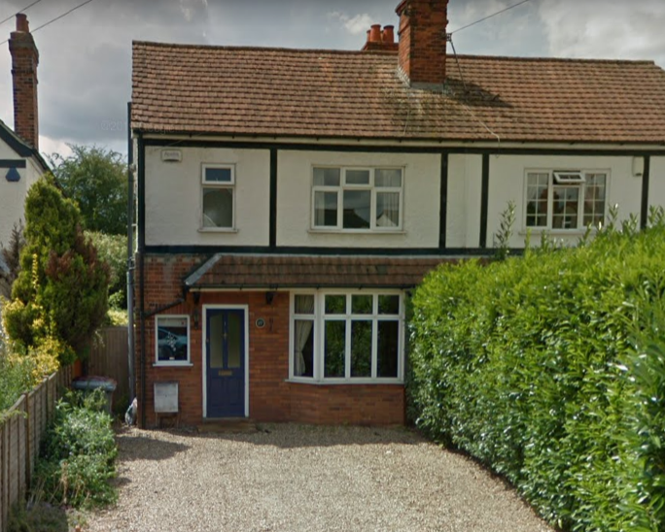

2. PROPOSAL AND SUPPORTING INFORMATION
Single storey extension for front entrance porch and toilet measuring 2.2m deep, 2.7m wide (as amended) and 3.4m to the pitched roof ridge. A toilet is to be installed within the shell of the new porch.

Plans considered dated March 2023
Drawing No 360-01 Rev A: Existing & Proposed Ground Floor Plan and Proposed Elevations received 02/06/2023
Drawing No 360-02 Rev A: Block Plan received12/06/2023
Drawing No 360-03: Location Plan received 17/03/2023

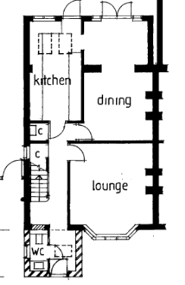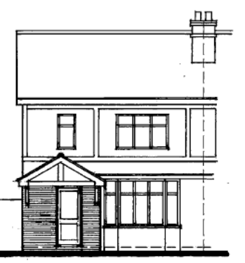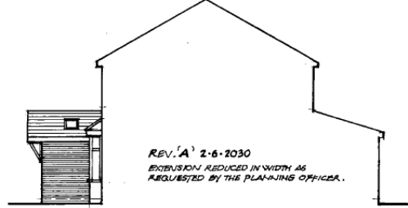
Ground Floor Plan, Proposed Front Elevation, Proposed Side Elevation

- RELEVANT PLANNING HISTORY
None

4. CONSULTATIONS

The following addresses were consulted by letter.

28 Westwood Road, Tilehurst, Reading, Berks
24 Westwood Road, Tilehurst, Reading, Berkshire, RG31 5PW
26 Westwood Road, Tilehurst, Reading, RG31 5PW
29 Westwood Road, Tilehurst, Reading, RG31 5PL
25 Westwood Road, Tilehurst, Reading, RG31 5PL

No letters of representation have been received.

Equality Act 2010:
In determining this application the Council is required to have regard to its obligations under the Equality Act 2010. However, there is no indication or evidence (including from consultation on the application) that the protected groups identified by the Act have or will have different needs, experiences, issues and priorities in relation to this particular planning application. Therefore in terms of the key equalities protected characteristics it is considered there would be no significant adverse impacts as a result of the development.

- LEGAL AND PLANNING POLICY CONTEXT

Section 38(6) of the Planning and Compulsory Purchase Act 2004 requires that proposals be determined in accordance with the development plan unless material considerations indicate otherwise. Material considerations include relevant policies in the National Planning Policy framework (NPPF) - among them the 'presumption in favour of sustainable development'. The following local and national planning policy and guidance is relevant to this application:

National Policy
National Planning Policy Framework
National Planning Practice Guidance

Reading Borough Local Plan (2019)
CC7 (Design and the Public Realm)
CC8 (Safeguarding Amenity)
H9 (House Extensions and Ancillary Accommodation)

SPD
Design Guide to House Extensions 2021

6. APPRAISAL
Character and Appearance

Policy H9 states that an extension to a house will be acceptable where it respects the character of the house in terms of scale, location, materials and design and respects the character and pattern of neighbouring properties and the street as a whole in terms of scale, location, materials and design, and any important existing building line. Policy CC7 also sets out relevant considerations for design.

The proposed front porch extension as originally proposed, would have extended beyond the side wall of the existing dwelling. This was considered to be unsympathetic to the existing lines of the dwelling, considering that the porch is also extending beyond the front line of the existing dwelling. On the advice of the LPA, the agent has sent in amendments, bringing the side of the porch in line with the existing side wall. Although relatively large there is a considerable gap between the proposed porch and the next building on No 25 and there are other similar examples in the road. It is not considered that this addition would have a significant detrimental effect on the character and appearance of the property or the street.

Residential Amenity

Policy H9 states that an extension will be acceptable where it does not result in an overbearing impact on neighbours. Policy H10 seeks to ensure that the amenity of gardens and other outdoor areas are not compromised. Policy CC8 states an extension to a house will be acceptable where it will not cause a significant detrimental impact to the living environment of existing or new residential properties.

There are no aspects of this proposal that would cause any negative privacy, overlooking, overbearing effects, or loss of sunlight and daylight to any of the neighbouring properties on both sides, and there is considerable gap between the porch and the nearest property to it at No 25.

- CONCLUSION
The proposed development has been assessed as set out above and is considered to be acceptable on that basis, subject to the following conditions.

8. RECOMMENDATION
Recommended Conditions:
AP1: Approved Plans
M1: Materials to Match Existing
TL1: Time Limit Standards

