

DELEGATED HOUSEHOLDER APPLICATION REPORT

Ward: Abbey
App Ref: 230091/HOU
Address: 20 Cambridge Street, Reading, RG1 7PA
Proposals: First floor rear extension, plus internal alterations
Case Officer: Chukwudi Onwudinanti
Applicant: Mr Smith
Date received (valid from): 25 January 2023
Target Decision date: 3 May 2023 (EXT)

1. SITE DESCRIPTION
The proposal site is a mid-terrace dwelling on the northern side of Cambridge Street. It is one of a cluster of terraces on both sides of the street, in a predominantly residential area.

2. PROPOSAL AND SUPPORTING INFORMATION

The proposal presents a first floor rear extension over the existing ground floor outrigger, measuring approximately 3m in depth and extending across the whole width of the outrigger. The development is being proposed at the same time as for No 22.

Plans considered dated December 2022 and received 25/01/2023
Drawing No -19131PP-01: Existing Ground Floor Plans
Drawing No -19131PP -02: Existing First Floor Plans
Drawing No -19131PP -03: Existing Second Floor Plan
Drawing No -19131PP -04: Existing Elevations
Drawing No -19131PP -05: Proposed Ground Floor Plans
Drawing No -19131PP -06: Proposed First Floor Plans
Drawing No -19131PP -07: Proposed Elevations
Drawing No –19131PP-08: Location Plan
Drawing No -19131PP -09: Block Plans

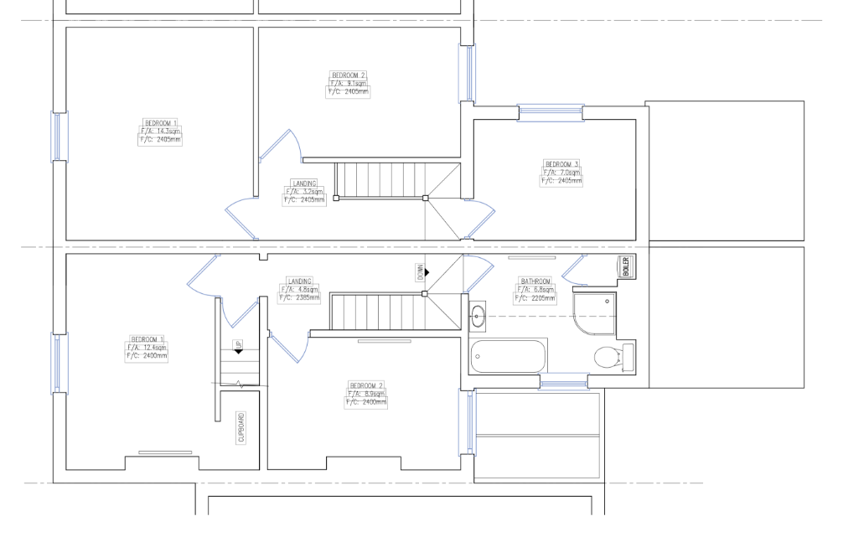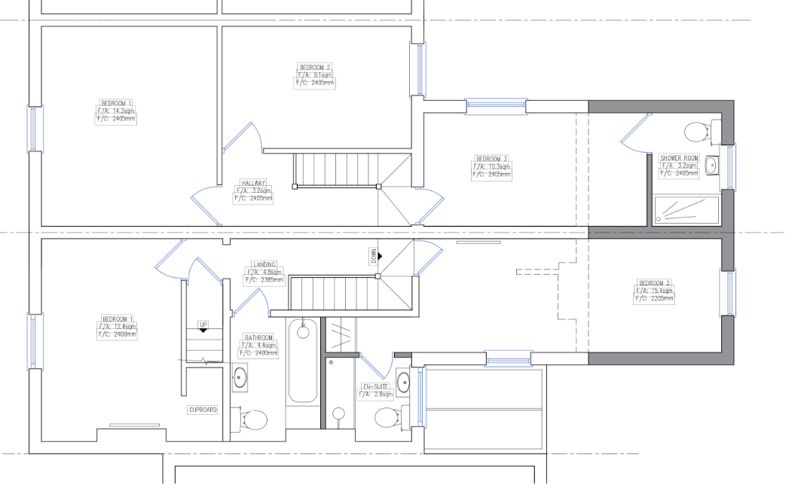
Existing First Floor Plan Proposed First Floor Plan

- RELEVANT PLANNING HISTORY

Application Reference: 191869/HOU
Description: Proposed first floor extension plus internal alterations
Outcome: Permitted 28/1/2020

22 Cambridge Street
Application Reference: 191870/HOU
Description: First floor rear extension plus internal alterations
Outcome: Permitted 28/1/2020

Application Reference: 230092
Address: 22 Cambridge Street
Description: First floor rear extension, plus internal alterations.
Outcome: Pending (with this application)

4. CONSULTATIONS

The following addresses were consulted by letter.

22 Cambridge Street, Reading, RG1 7PA
24 Cambridge Street, Reading, RG1 7PA

No letters of representation have been received.

Equality Act 2010:
In determining this application the Council is required to have regard to its obligations under the Equality Act 2010. However, there is no indication or evidence (including from consultation on the application) that the protected groups identified by the Act have or will have different needs, experiences, issues and priorities in relation to this particular planning application. Therefore in terms of the key equalities protected characteristics it is considered there would be no significant adverse impacts as a result of the development.

- LEGAL AND PLANNING POLICY CONTEXT

Section 38(6) of the Planning and Compulsory Purchase Act 2004 requires that proposals be determined in accordance with the development plan unless material considerations indicate otherwise. Material considerations include relevant policies in the National Planning Policy framework (NPPF) - among them the 'presumption in favour of sustainable development'. The following local and national planning policy and guidance is relevant to this application:

National Policy
National Planning Policy Framework
National Planning Practice Guidance

Reading Borough Local Plan (2019)
CC7 (Design and the Public Realm)
CC8 (Safeguarding Amenity)
H9 (House Extensions and Ancillary Accommodation)

SPD
Design Guide to House Extensions 2021

6. APPRAISAL
Character and Appearance

Policy H9 states that an extension to a house will be acceptable where it respects the character of the house in terms of scale, location, materials and design and respects the character and pattern of neighbouring properties and the street as a whole in terms of scale, location, materials and design, and any important existing building line. Policy CC7 also sets out relevant considerations for design.

The first floor rear above the existing outrigger extension is modest at 3m deep. There are no side windows proposed and the roof is to be tied with the extension to No 22, being developed at the same time with this proposal, with the ridge extended, well below the level of the main existing roof to the front. It is not considered that there would be a detrimental impact on the overall character and pattern of the dwelling. The original materials are to be matched in the extensions. The proposal will be alongside an identical scheme at no. 22 under ref 230092.

It is therefore considered that the proposal is sympathetic in scale and design to the existing dwelling, neighbouring properties and the street scene as a whole.

Residential Amenity

Policy H9 states that an extension will be acceptable where it does not result in an overbearing impact on neighbours. Policy H10 seeks to ensure that the amenity of gardens and other outdoor areas are not compromised. Policy CC8 states an extension to a house will be acceptable where it will not cause a significant detrimental impact to the living environment of existing or new residential properties.

As stated above in this report, all aspects of this proposal are done on both sides of the adjoining dwellings on the terrace. There are therefore no privacy and overlooking issues and no overbearing effects as the upward developments are to be done on both sides of the adjoining properties. Grampian (Phased Development) conditions will be used to ensure that both developments are carried out in such a way as to prevent adverse impact of one over the other.

- CONCLUSION
The proposed development has been assessed as set out above and is considered to be acceptable on that basis, subject to the following conditions.

8. RECOMMENDATION: Grant

Recommended Conditions:
AP1: Approved Plans
TL1: Time Limit Standards
M1: Materials to Match
C00: Tandem Development

