HARD AND SOFT LANDSCAPING
CONDITION 8

DEVELOPMENT AT

Land Adjacent to
114 – 116 School Road
Tilehurst
Reading
RG31 5AX

DEVELOPER

Chesters Place Limited

PREPARED By

C Thorpe

Date

10th January 2023

V1

Portuguese Laurel Planting

As already agreed under condition 9
Biodiversity enhancements

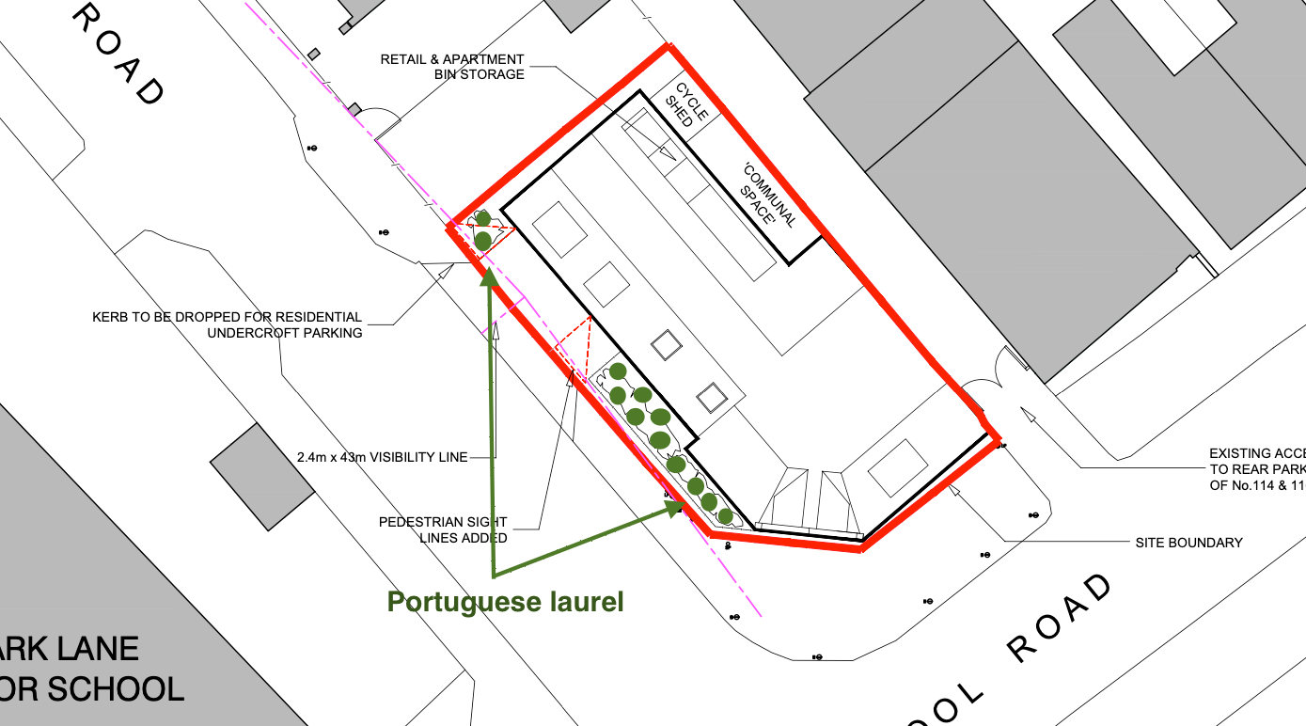

Means of enclosure facing - Downing Road

1.2m in height

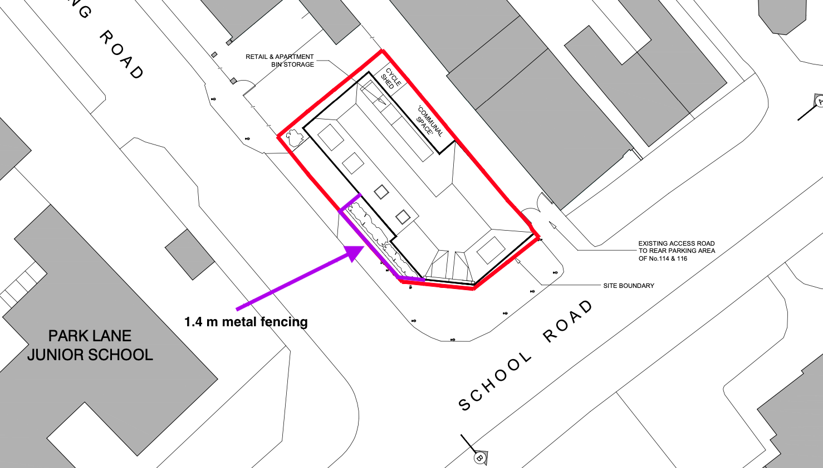

DRIVEWAY
&
REAR COURTYARD MATERIALS

Marshalls Drivesett Argent

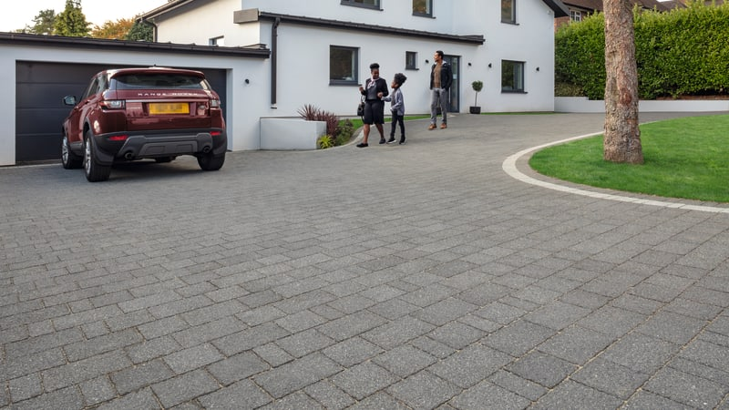

Side and rear boundaries have been retained or replaced like for like.
These are 1.8m high arris rail fencing

