

DELEGATED HOUSEHOLDER APPLICATION REPORT

Ward: Church
App Ref: 230786/CLP
Address: 228 Shinfield Road, Reading, RG2 7DU
Proposals: Garage conversion
Case Officer: Chukwudi Onwudinanti
Applicant: Raymond Duong
Date received (valid from): 8 June 2023
Target Decision date: 23 October 2023 (EXT)

INTRODUCTION
The proposal site is a semi-detached two storey dwelling on the western side of Shinfield Road, in a predominantly residential area. It is set at an angle to Shinfield Road and faces the junction with Elm Road. Its detached garage, which is part of an ‘l-shaped’ structure is roughly at right angles to the dwelling. It is among buildings of varying styles and sizes on both sides of the street.

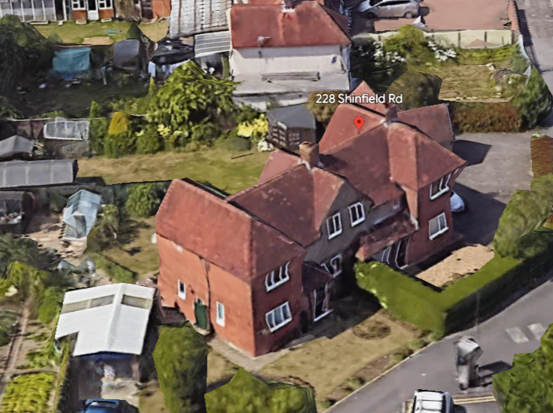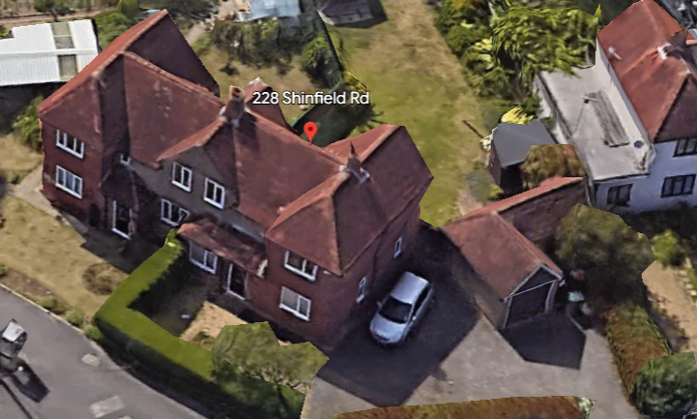

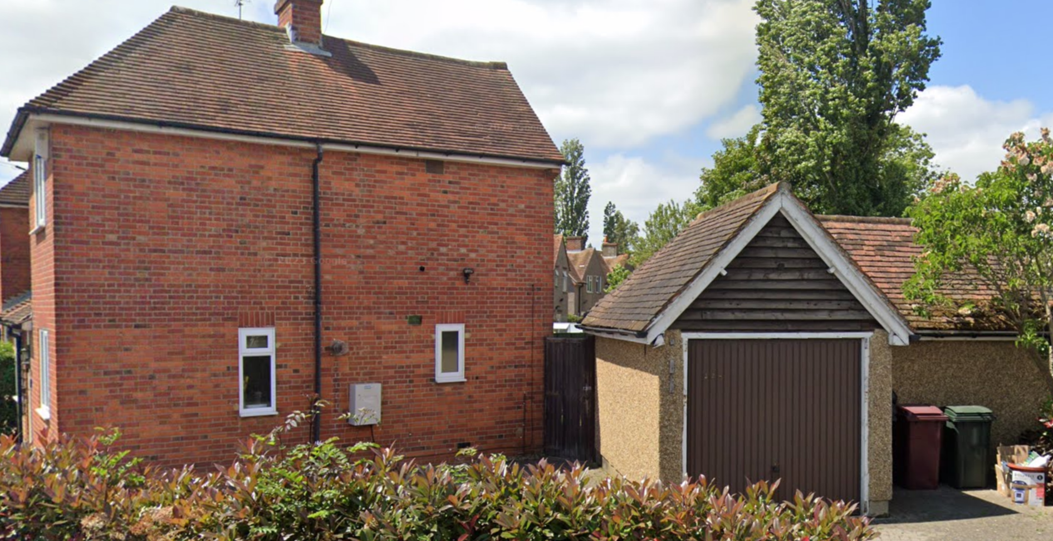

The application site is not a listed building or located in a conservation area. It is not in an area subject to any Article 4 restrictions.

PROPOSAL AND SUPPORTING INFORMATION
This proposal is for a Certificate of Lawfulness for the following works:
- Convert the garage to habitable room.
- Addition of two new windows
- Rooflight to front slope
- Two rooflights to left side slope
- Rooflight to right side slope
- Two rooflights to rear slope

Plans and Documents Considered

Drawing No: 2023-1129-201 Existing and Proposed Site Plans dated 07/06/2023
Drawing No: 2023-1129-102 C Proposed Plans and Elevations dated 08/05/2023
Drawing No: 2023-1129-101 Existing Plans and Elevations dated 08/05/2023
Drawing No: 2023-1129-202 Existing and Proposed Block Plans dated 08/05/2023
Drawing No: 2023-1129-203 Location Plan dated 07/06/2023

RELEVANT PLANNING HISTORY

None

CONSULTATIONS

No consultations required for this application.

Equality Act 2010:

In determining this application the Council is required to have regard to its obligations under the Equality Act 2010. However, there is no indication or evidence (including from consultation on the application) that the protected groups identified by the Act have or will have different needs, experiences, issues and priorities in relation to this particular planning application. Therefore in terms of the key equalities protected characteristics it is considered there would be no significant adverse impacts as a result of the development.

Relevant Planning Policy and Guidance
National Planning Practice Guidance
The Town and Country Planning (General Permitted Development) (England) Order 2015 (GPDO)
Permitted development rights for householders – Technical Guidance September 2019

ASSESSMENT UNDER CLASS A
A Certificate of Lawfulness for a Proposed Development has been submitted as the applicant considers the proposal falls within the permitted development rights of the property.

The following elements of the proposals are considered under Class A:

- alter a door to a window on the rear elevation at ground floor level
- addition of a new window on the left side elevation at ground floor level

The proposal must be assessed to ensure that it complies with the conditions Class A, Part 1, Schedule 2 of the Town and Country Planning (General Permitted Development) (England) Order 2015 (as amended), which relates to ‘The enlargement, improvement or other alteration of a dwellinghouse’.

A.1 Development is not permitted by Class A if:

A.1 (a) permission to use the dwellinghouse as a dwellinghouse has been granted only by virtue of Class M, N, P or Q of Part 3 of this Schedule (changes of use) Complies
A.1 (b) as a result of the works, the total area of ground covered by buildings within the curtilage of the dwellinghouse (other than the original dwellinghouse) would exceed 50% of the total area of the curtilage (excluding the ground area of the original dwellinghouse) NA
A.1 (c) the height of the part of the dwellinghouse enlarged, improved or altered would exceed the height of the highest part of the roof of the existing dwellinghouse NA
A.1 (d) the height of the eaves of the part of the dwellinghouse enlarged, improved or altered would exceed the height of the eaves of the existing dwellinghouse NA –
A.1 (e) the enlarged part of the dwellinghouse would extend beyond a wall which (i) forms the principal elevation of the original dwellinghouse; or (ii) fronts a highway and forms a side elevation of the original dwellinghouse NA
A.1 (f) subject to paragraph (g), the enlarged part of the dwellinghouse would have a single storey and – (i) extend beyond the rear wall of the original dwellinghouse by more than 4 metres in the case of a detached dwellinghouse, or 3 metres in the case of any other dwellinghouse, (ii) exceed 4 metres in height NA
A.1 (g) for a dwellinghouse not on article 2(3) land nor on a site of special scientific interest, the enlarged part of the dwellinghouse would have a single storey and – (i) extend beyond the rear wall of the original dwellinghouse by more than 8 metres in the case of a detached dwellinghouse, or 6 metres in the case of any other dwellinghouse, or (ii) exceed 4 metres in height NA
A.1 (h) the enlarged part of the dwellinghouse would have more than a single storey and – (i) extend beyond the rear wall of the original dwellinghouse by more than 3 metres, or (ii) be within 7 metres of any boundary of the curtilage of the dwellinghouse opposite the rear wall of the dwellinghouse NA
A.1 (i) the enlarged part of the dwellinghouse would be within 2 metres of the boundary of the curtilage of the dwellinghouse, and the height of the eaves of the enlarged part would exceed 3 metres N/A / NA as already exists
A.1 (j) the enlarged part of the dwellinghouse would extend beyond a wall forming a side elevation of the original dwellinghouse, and would – (i) exceed 4 metres in height, (ii) have more than a single storey, or (iii) have a width greater than half the width of the original dwellinghouse N/A
A.1 (k) it would consist of or include – (i) the construction or provision of a verandah, balcony or raised platform (ii) the installation, alteration or replacement of a microwave antenna, (iii) the installation, alteration or replacement of a chimney, flue or soil and vent pipe, or (iv) an alteration to any part of the roof of the dwellinghouse N/A
A.2 In the case of a dwellinghouse on article 2(3) land, development is not permitted by Class A if:
A.2 (a) it would consist of or include the cladding of any part of the exterior of the dwellinghouse with stone, artificial stone, pebble dash, render, timber, plastic or tiles N/A as not on article 2 (3) land
A.2 (b) the enlarged part of the dwellinghouse would extend beyond a wall forming a side elevation of the original dwellinghouse N/A as not on article 2 (3) land
A.2 (c) the enlarged part of the dwellinghouse would have more than a single storey and extend beyond the rear wall of the original dwellinghouse N/A as not on article 2 (3) land

CONDITIONS UNDER CLASS A
Development is permitted by Class A subject to the following conditions:

A.3 (a) the materials used in any exterior work (other than materials used in the construction of a conservatory) must be of a similar appearance to those used in the construction of the exterior of the dwellinghouse Complies

A.3 (b) any upper-floor window located in a wall or roof slope forming a side elevation of the dwellinghouse must be (i) obscure-glazed, and (ii) non-opening unless the parts of the window which can be opened are more than 1.7 metres above the floor of the room in which the window is installed NA/Complies

A.3 (c) where the enlarged part of the dwellinghouse has more than a single storey, or forms an upper storey on an existing enlargement of the original dwellinghouse, the roof pitch of the enlarged part must, so far as practicable, be the same as the roof pitch of the original dwellinghouse NA

ASSESSMENT UNDER CLASSE C

The following elements of the proposals are considered under Class C:

- one rooflight on the front roofslope, two rooflight on the rear roofslope , two rooflights to left side and one rooflight to the rear side.

C.1 Development is not permitted by Class C if:
C.1 (a) permission to use the dwellinghouse as a dwellinghouse has been granted only by virtue of Class M, N, P or Q of Part 3 of this Schedule (changes of use); complies
C.1 (b) the alteration would protrude more than 0.15 metres beyond the plane of the slope of the original roof when measured from the perpendicular with the external surface of the original roof; complies (Rear, side and front rooflights are 0.10m)

C.1 (c) it would result in the highest part of the alteration being higher than the highest part of the original roof; complies or
C.1 (d) it would consist of or include (i) the installation, alteration, or replacement of a chimney, flue or soil and vent pipe, complies or (ii) the installation, alteration or replacement of solar photovoltaics or solar thermal equipment, N/A / complies
Conditions
C.2 Development is permitted by Class C subject to the condition that any window located on a roof slope forming a side elevation of the dwellinghouse must be:
C.2 (a) obscure-glazed; complies and
C.2 (b) non-opening unless the parts of the window which can be opened are more than 1.7 metres above the floor of the room in which the window is installed, complies

ASSESSMENT UNDER CLASS E

A Certificate of Lawfulness for a Proposed Development has been submitted as the applicant considers the proposal falls within the permitted development rights of the property.

The following elements of the proposals are considered under Class E:

- Garage conversion to a habitable living area and shower room.

The proposal must be assessed to ensure that it complies with the conditions Class E, Part 1, Schedule 2 of the Town and Country Planning (General Permitted Development) (England) Order 2015 (as amended), which relates to ‘The enlargement, improvement or other alteration of a dwellinghouse’.

Class E – buildings etc
This provides permitted development rights within the curtilage of a house for:

(a) any building or enclosure, swimming or other pool required for a purpose incidental to the enjoyment of the dwellinghouse as such, or the maintenance, improvement or other alteration of such a building or enclosure; or

(b) a container used for domestic heating purposes for the storage of oil or liquid petroleum gas

Under Class E, the following limits and conditions apply:
E.1 Development is not permitted by Class E if –
a) permission to use the dwellinghouse as a dwellinghouse has been granted only by virtue of Class M, N, P, PA or Q of Part 3 of this Schedule (change of use) Complies

(b) the total area of ground covered by buildings, enclosures and containers within the curtilage (other than the original dwellinghouse) would exceed 50% of the total area of the curtilage (excluding the ground area of the original dwellinghouse) Complies

(c) any part of the building, enclosure, pool or container would be situated on land forward of a wall forming the principal elevation of the original dwellinghouse Complies

(d) the building would have more than a single storey Complies

(e) the height of the building, enclosure or container would exceed -
(i) 4 metres in the case of a building with a dual-pitched roof, Complies

(ii) 2.5 metres in the case of a building, enclosure or container within 2 metres of the boundary of the curtilage of the dwellinghouse, or N/A as already existing

(iii) 3 metres in any other case

(f) the height of the eaves of the building would exceed 2.5 metres N/A as already existing

(g) the building, enclosure, pool or container would be situated within the curtilage of a listed building Complies

(h) it would include the construction or provision of a verandah, balcony or raised platform N/A

(i) it relates to a dwelling or a microwave antenna N/A

(j) the capacity of the container would exceed 3,500 litres. N/A

E.2 In the case of any land within the curtilage of the dwellinghouse which is within -
(a) a World Heritage Site,
(b) a National Park,
(c) an area of outstanding natural beauty or
(d) the Broads,
development is not permitted by Class E if the total area of ground covered by buildings, enclosures, pools and containers situated more than 20 metres from any wall of the dwellinghouse would exceed 10 square metres N/A

E.3 In the case of any land within the curtilage of the dwellinghouse which is article 2(3) land, development is not permitted by Class E if any part of the building, enclosure, pool or container would be situated on land between a wall forming a side elevation of the dwellinghouse and the boundary of the curtilage of the dwellinghouse N/A

E.4 For the purposes of Class E, “purpose incidental to the enjoyment of the dwellinghouse as such” includes the keeping of poultry, bees, pet animals, birds or other livestock for the domestic needs or personal enjoyment of the occupants of the dwellinghouse Complies as supported by Legal advice

OVERALL RECOMMENDATION
Sufficient evidence has been provided to demonstrate that a Certificate of Lawfulness should be granted for the proposed garage conversion to a habitable room.
The proposal has been assessed against the Town and Country Planning Act 1990 (as amended) and Class A, Class C and Class E, , Part 1, Schedule 2 of the Town and Country Planning (General Permitted Development) (England) Order 2015 (as amended). It can be confirmed that the proposed operations would be lawful for planning purposes on the basis of the following:
Drawing No: 2023-1129-201 Existing and Proposed Site Plans dated 07/06/2023
Drawing No: 2023-1129-102 C Proposed Plans and Elevations dated 08/05/2023
Drawing No: 2023-1129-101 Existing Plans and Elevations dated 08/05/2023
Drawing No: 2023-1129-202 Existing and Proposed Block Plans dated 08/05/2023
Drawing No: 2023-1129-203 Location Plan dated 07/06/2023

Therefore the Local Planning Authority can issue the applicant with a Certificate of Lawfulness for the proposed development.
Informatives
Building Regulations
Construction and Demolition
Encroachment and Party Wall Act

