

DELEGATED HOUSEHOLDER APPLICATION REPORT

Ward: Caversham Heights
App Ref: 231013/HOU
Address: 5 Gravel Hill, Emmer Green, Reading, RG4 8QN
Proposals: Single storey rear extension
Case Officer: Chukwudi Onwudinanti
Applicant: Ms Faye Hamilton-Martin and Mr John Angerson
Date received (valid from): 20 July 2023
Target Decision date: 26 October 2023(EXT)

1. SITE DESCRIPTION
The site is a semi-detached two storey dwelling on the northern side of Gravel Hill. The area is predominantly residential with buildings of various styles and sizes. The site has an existing rear box dormer extension sitting side by side with a similar extension on No 7, however there are no records of this development. According to Google Map Images, the rear ground outrigger existed in April 2009 but not the dormer to the rear, nor the hip to gable conversion.

There is an existing ground floor rear projection and the neighbouring property has a slightly deeper extension (as can be seen in the site visit photo below).

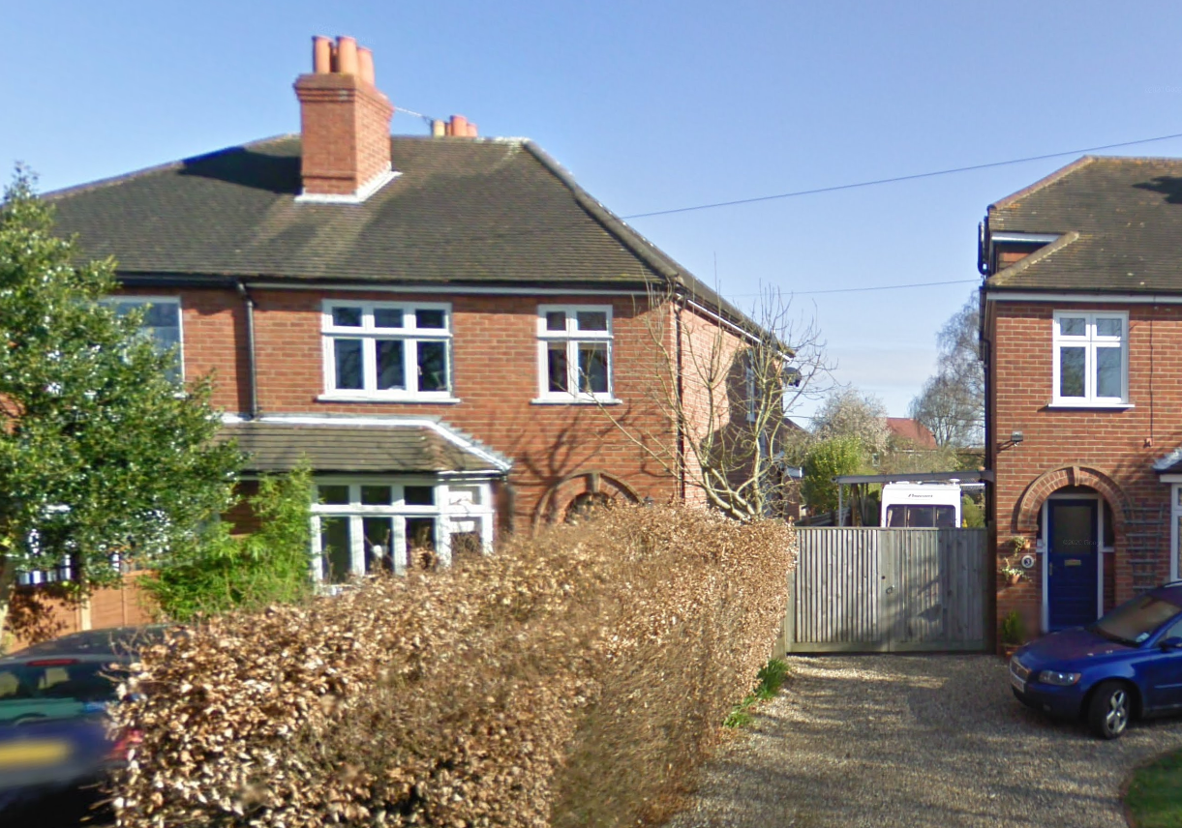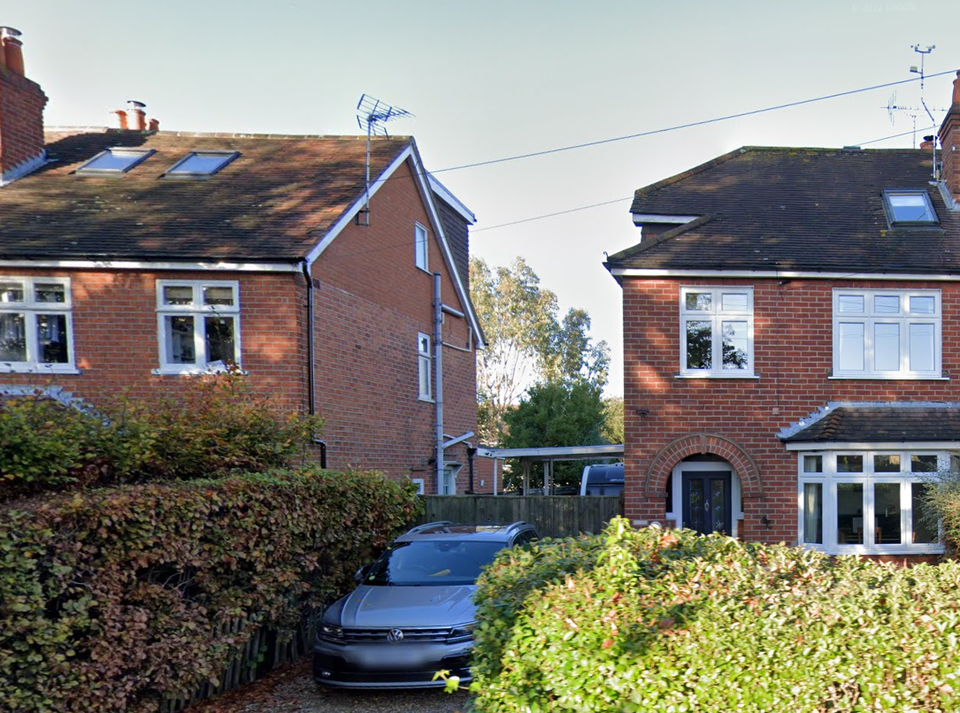
Google Maps ( April 2009) Google Maps (2022)

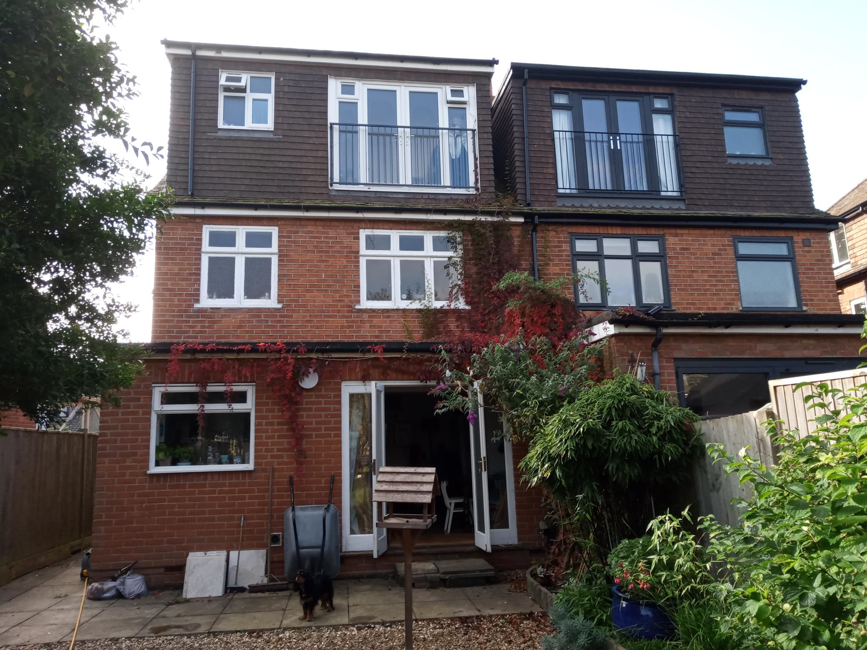
Site Photo (October 2023)

2. PROPOSAL AND SUPPORTING INFORMATION
The proposal is to replace the existing 2m deep single storey rear extension with one measuring 6m in depth and 5.6m in width. The extension therefore increases the footprint of the existing rear outrigger (measuring 2m deep to the rear) by 4m. The height of the extension is 2.9m and a new side window and door are proposed to side elevation, facing number 3 (i.e. not the adjoined property)

Plans considered dated 2/6/2023
Drawing No HM.006 Location Plan received 20/07/2023
Drawing No HM.005 Site Block Plan received 20/07/2023
Drawing No HM.002: Proposed Elevations received 20/07/2023
Drawing No HM.004: Proposed Ground Floor Plan received 20/07/2023
Drawing No HM.001: Existing Elevations received 20/07/2023
Drawing No HM.003: Existing Ground Floor Plan received 20/07/2023

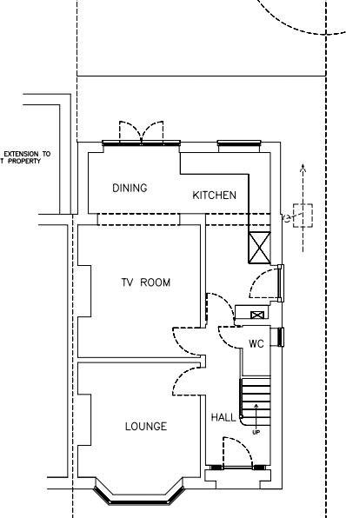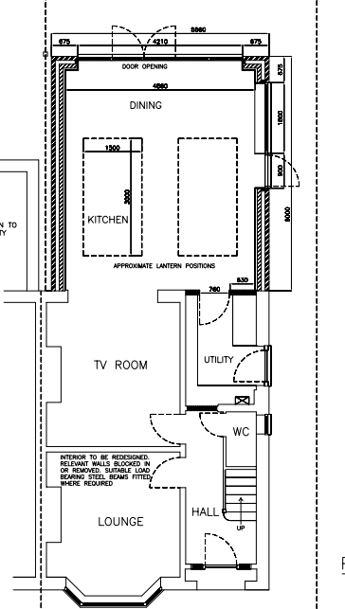
Exisning Ground Floor Plan Proposed Ground Floor Plan

- RELEVANT PLANNING HISTORY
None

4. CONSULTATIONS

The following addresses were consulted by letter.

7 Gravel Hill, Emmer Green, Reading, Berkshire, RG4 8QN
3 Gravel Hill, Caversham
1 Albany Gardens, Emmer Green, Reading, RG4 8PZ
2 Albany Gardens, Emmer Green, Reading, RG4 8PZ

No letters of representation have been received.

Equality Act 2010:
In determining this application the Council is required to have regard to its obligations under the Equality Act 2010. However, there is no indication or evidence (including from consultation on the application) that the protected groups identified by the Act have or will have different needs, experiences, issues and priorities in relation to this particular planning application. Therefore in terms of the key equalities protected characteristics it is considered there would be no significant adverse impacts as a result of the development.

- LEGAL AND PLANNING POLICY CONTEXT

Section 38(6) of the Planning and Compulsory Purchase Act 2004 requires that proposals be determined in accordance with the development plan unless material considerations indicate otherwise. Material considerations include relevant policies in the National Planning Policy framework (NPPF) - among them the 'presumption in favour of sustainable development'. The following local and national planning policy and guidance is relevant to this application:

National Policy
National Planning Policy Framework
National Planning Practice Guidance

Reading Borough Local Plan (2019)
CC7 (Design and the Public Realm)
CC8 (Safeguarding Amenity)
H9 (House Extensions and Ancillary Accommodation)

SPD
Design Guide to House Extensions 2021

6. APPRAISAL
Character and Appearance

Policy H9 states that an extension to a house will be acceptable where it respects the character of the house in terms of scale, location, materials and design and respects the character and pattern of neighbouring properties and the street as a whole in terms of scale, location, materials and design, and any important existing building line. Policy CC7 also sets out relevant considerations for design.

All aspects of the extension proposed in this application are to the rear and limited to maximum height of 2.9m. All materials to be used on the external walls are to match the existing brick work, while all the external timber are to be clad with white UPVC. The roof proposed is a flat roof with the introduction of a roof lantern.

The particulars of the proposal as stated would respect the character of the existing dwelling in terms of location, materials and design, as it constrained to the rear and not visible from the street scene. The depth of 6m proposed is considerably large, however, this is in effect an increase of 4m to the existing outrigger which is proportionate to the overall scale of the existing dwelling.

Residential Amenity

Policy H9 states that an extension will be acceptable where it does not result in an overbearing impact on neighbours. Policy H10 seeks to ensure that the amenity of gardens and other outdoor areas are not compromised. Policy CC8 states an extension to a house will be acceptable where it will not cause a significant detrimental impact to the living environment of existing or new residential properties.

As stated above in this report, the extension proposed is limited to the rear, increases the existing outrigger by 4m, and of maximum height of 2.9m. The neighbouring property at No 7 has an existing ground floor outrigger to the rear which extends 1.36m deeper than the existing outrigger on the proposal site, therefore the extension proposed would be approximately 2.6m deeper than no. 7’s. It is not considered that there would be a detrimental impact on the daylight and sunlight accessible to No. 7.

The combination of the limited height and the ample separation of the extension line with the boundary with No 3 ensures that there also would not be any detrimental impact on the daylight and sunlight accessible to them. The side windows proposed are of a lintel height of approximately 2.3m, so would be barely above the boundary fence, and so is not considered to present any overlooking effects on No 3. There are no side facing windows on No.3 that are in direct line of the proposed windows.

The size of the extension is within 3m height, with a flat roof over it. It is also amply separated from No 3, the closest distance from the extension to the wall of the dwelling on No 3 being approximately 6.77m.

- CONCLUSION
The proposed development has been assessed as set out above and with the combination of all the factors put forward, is considered to be acceptable on that basis, subject to the following conditions.

8. RECOMMENDATION: Grant
Recommended Conditions:
AP1: Approved Plans
TL1: Time Limit Standards
M1: Materials to Match Existing

