DELEGATED HOUSEHOLDER APPLICATION REPORT

Ward: Caversham Heights
App Ref: 220779/HOU
Address: 2 Albert Road, Caversham, Reading, RG4 7PE
Proposals: Demolition of a shed, Demolition of single storey side extension, porch remodel, Double storey side extension, Single storey rear extension
Case Officer: Chukwudi Onwudinanti
Applicant: Mr Keyvan Nasehi
Date received (valid from): 26 May 2022
Target Decision date: 14 September 2022 (EXT)

1. SITE DESCRIPTION
The proposal site is a detached two storey dwelling on the eastern side of Albert Road, in a predominantly residential area, among buildings of varied styles and sizes. It is neither in an Article 4 Area nor in a Conservation area.

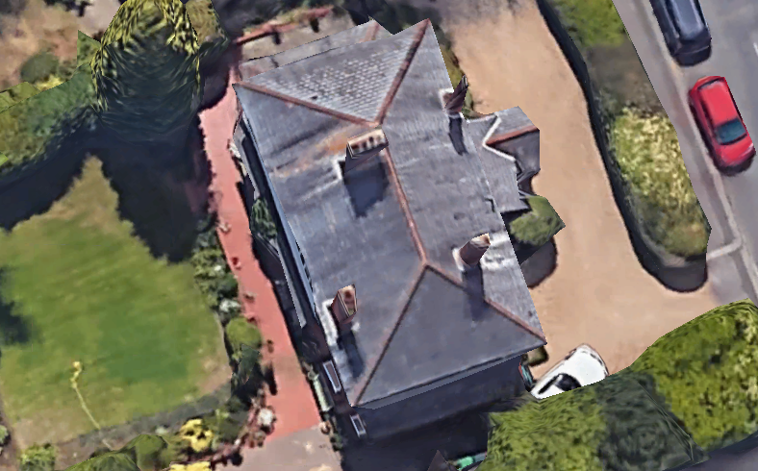

2. PROPOSAL AND SUPPORTING INFORMATION
The application proposes a two storey extension to one side of the building by 3.8m and a one storey aspect extending to the rear by approximately 4m. The existing single storey side extension is to be demolished and the front porch remodelled.

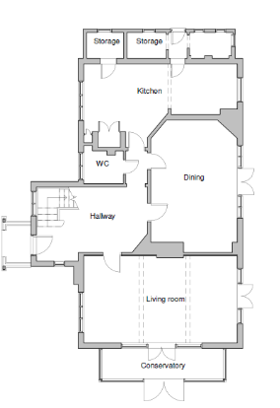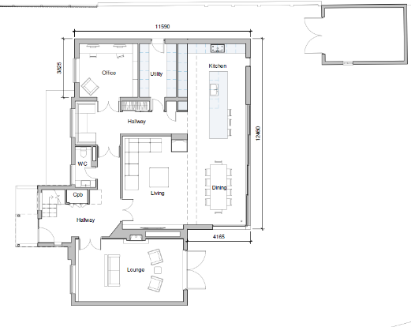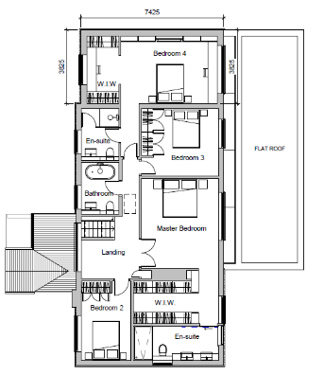
Ex. Ground Fl. Plan Proposed Ground Fl. Plan Proposed 1st Floor Plan

Plans considered
Received 25th May 2022:
Drawing No 101: Location Plan
Drawing No 102: Block Plan
Drawing No 103: Existing Site Plan
Drawing No 104: Proposed Site Plan
Drawing No 201: Existing Ground Floor Plan
Drawing No 202: Existing First Floor Plan
Drawing No 203: Existing Roof Plan
Drawing No 401: Existing Elevations –West and East
Drawing No 402: Existing Elevations –North and South
Drawing No 204: Proposed Ground Floor Plan

Received 8th June 2022:
Drawing No 205 Rev A: Proposed First Floor Plan
Drawing No 206 Rev A: Proposed Roof Plan
Drawing No 403 Rev A: Proposed Elevations –West and East
Drawing No 404 Rev A: Proposed Elevations –North and South

- RELEVANT PLANNING HISTORY

None

4. CONSULTATIONS

The following addresses were consulted by letter.

2A Albert Road, Caversham, Reading, RG4 7PE
4 Albert Road, Caversham, Reading, RG4 7PE

No letters of representation have been received.

Equality Act 2010:
In determining this application the Council is required to have regard to its obligations under the Equality Act 2010. However, there is no indication or evidence (including from consultation on the application) that the protected groups identified by the Act have or will have different needs, experiences, issues and priorities in relation to this particular planning application. Therefore in terms of the key equalities protected characteristics it is considered there would be no significant adverse impacts as a result of the development.

- LEGAL AND PLANNING POLICY CONTEXT

Section 38(6) of the Planning and Compulsory Purchase Act 2004 requires that proposals be determined in accordance with the development plan unless material considerations indicate otherwise. Material considerations include relevant policies in the National Planning Policy framework (NPPF) - among them the 'presumption in favour of sustainable development'. The following local and national planning policy and guidance is relevant to this application:

National Policy
National Planning Policy Framework
National Planning Practice Guidance

Reading Borough Local Plan (2019)
CC7 (Design and the Public Realm)
CC8 (Safeguarding Amenity)
H9 (House Extensions and Ancillary Accommodation)
EN14 (Trees, Hedges and Woodlands)

SPD
Design Guide to House Extensions (2021)

6. APPRAISAL

Character and Appearance
Policy H9 states that an extension to a house will be acceptable where it respects the character of the house in terms of scale, location, materials and design and respects the character and pattern of neighbouring properties and the street as a whole in terms of scale, location, materials and design, and any important existing building line. Policy CC7 also sets out relevant considerations for design.

While this proposal increases the existing building by approximately 3.8m to the side and 4m to the rear, the design has been stepped back from the frontline of the principal elevation and the ridge of the extension stepped down from the existing ridge, mimicking the shape and form of the existing elevation. Materials are to match existing materials used externally.

Therefore, it is considered that the extension has been made subservient to and respects the character of the original building and the street scene.

Residential Amenity
Policy H9 states that an extension will be acceptable where it does not result in an overbearing impact on neighbours. Policy H10 seeks to ensure that the amenity of gardens and other outdoor areas are not compromised. Policy CC8 states an extension to a house will be acceptable where it will not cause a significant detrimental impact to the living environment of existing or new residential properties.

This has been evaluated under the following considerations:
- Privacy and overlooking: The proposed two storey side extension is stepped away from the boundaries by at least 2m and presents no side windows or balconies.
- Overbearing effects; As a result of the setback from the boundary, and with a distance of at least 7m between the proposed development and the nearest property on the side of the extension, the proposal presents no additional impact to the adjoining property, if any.
- Sunlight and daylight; All aspects of the extension to the existing building do not take the resultant new dwelling beyond the line of the buildings on the adjoining plots, therefore the 45 degree rule is well respected and no loss of sunlight will be caused to any property by this development.

- CONCLUSION
The proposed development has been assessed as set out above and is considered to be acceptable on that basis, subject to the following conditions.
PD5, PD2, as well as the standard conditions of Approved Drawings, Time Limits and Materials to Match Existing.
8. RECOMMENDATION
Grant

