COLLINS AND LANE BUILDERS LTD
45 Crisp Road
Henley-on-Thames
Oxfordshire
RG9 2EN
Tel: 01491574576
18/06/2023

Method Statement

Following the comments from RBC, the following section of the Method statement details the specific requirements as requested in detail for condition 6 of approval 221291. This additional section is to be used in conjunction with the Method statement and risk assessment as previously provided by Collins and Lane Builders Ltd dated 25/05/23.
The purpose of this document is to address the condition 6 specifics.

Section 5.13

a) Space on site where vehicles of site operatives and visitors can be parked with details of how site operatives and visitors will be required to make use of the parking area provided;
Site Parking;
The Collins and Lane Builders Ltd team will use the existing parking area within 21 Derby road premises as highlighted on site plan, 5 car parking spaces (designated parking area and plant storage). Additional parking will be available for deliveries on the entrance to property location. The frontage of the property as highlighted on site plan in pink is not to be used for off road parking. Additional parking can be available for contractors on Moss close if needed.

There will be a dedicated site foreman appointment to guide construction vehicles and traffic. Where multiple delivery vehicles and construction vehicles are expected on the same day, foreman will create timed slots to avoid construction traffic on public road. Times will be planned in advance.
There are currently no plan for any road closures, all vehicles will be expected to use site allocated parking and offloading positions.
Collins and Lane Builders Ltd will have details of traffic management as required during the construction, this will be reviewed throughout each stage of the project. The footway management will be managed during construction.

Collins and Lane Ltd will be committed to avoidance of unnecessary parking of site related vehicles (i.e. construction workers’ vehicles), areas in proximity to the site that can be used for these vehicles are identified; additional parking on Moss close. The times for construction traffic and delivery vehicles will be monitored so deliveries can be managed within designated offloading parking area.

All on-site construction vehicles will enter and exit the site in the designate site entrance. Site foreman has the appointed responsibility to assist in the guidance of heavy and large construction vehicles into the dedicated offloading bay and to supervise unloading. The foreman will indicate to heavy and large construction vehicles when it is appropriate for them to enter and leave the site. Deliveries by large or heavy vehicles will be advised to ring ahead and will be advised to enter via Henley road when entering Derby road; The foreman will await the vehicle at the site access to assist the vehicle into the site designated offloading/ parking area. The foreman will also assist with exiting the site by indicating to the driver of the large or heavy vehicle when it is appropriate for them to enter and leave the site.

b) Location on site for storage of plant and materials used in constructing the development;
Unused construction plants are stored away from work areas and designated traffic routes in agreement with the foreman and construction plants will be promptly removed from site on completion of use. All requirements for additional plants will be discussed with the foreman in advance, prior to delivery on site. Parking of up to 5 car spaces is within the site location. The site does not anticipate more than 5 people on site at its peak. Site plan:

21 Derby road Construction parking and storage site plan
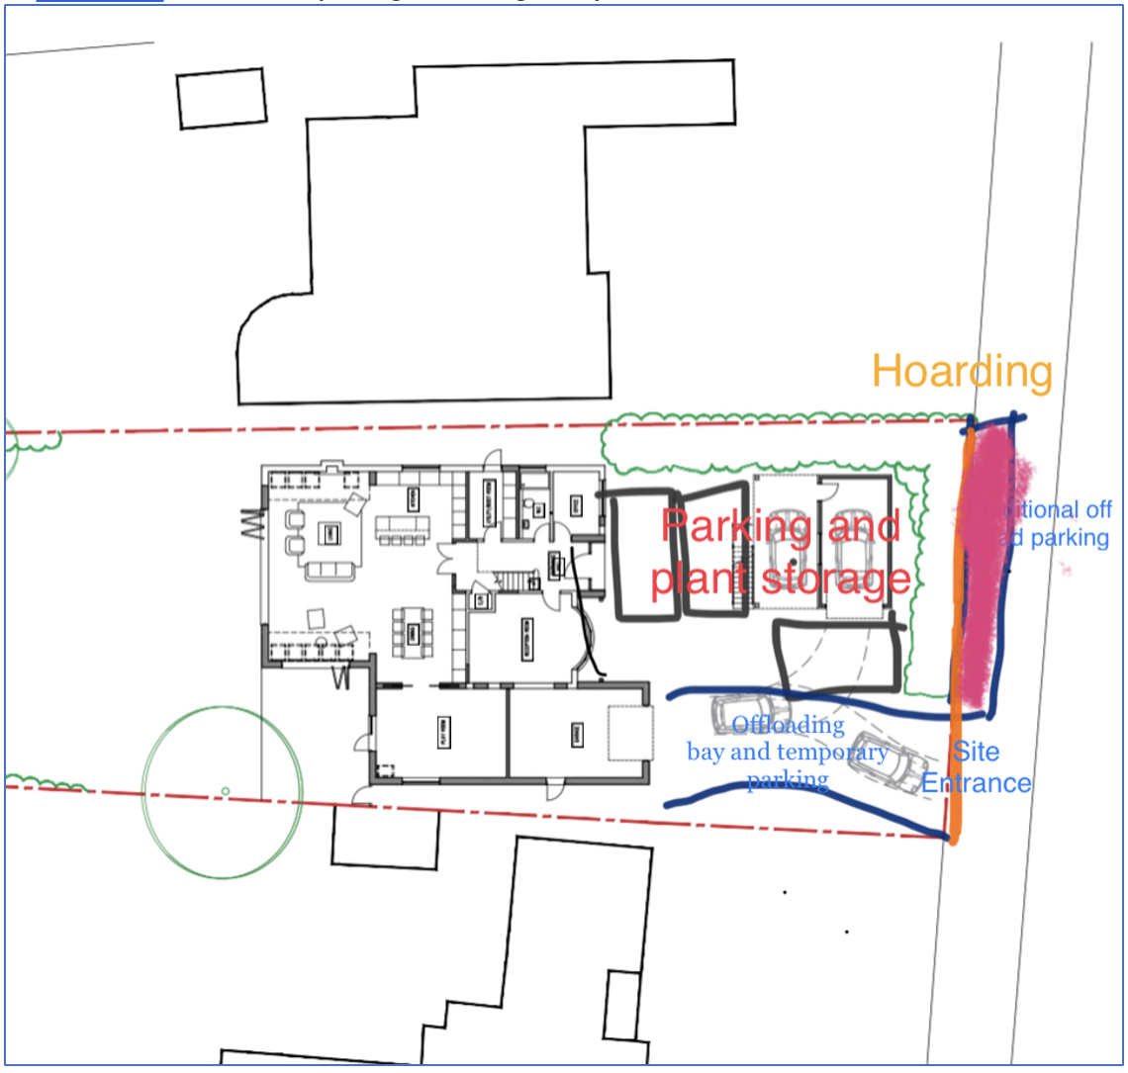
Shaded pink area is exclusion zone for parking due to tree protection.

c) The erection and maintenance (including removal of any graffiti or fly posters) of security hoarding around the site;
Collins and Lane builders Ltd will erect 2m hoarding to the front of the property as other 3 sides of property are securely fenced off with closed board fence and closed off to the public.

d) closures or road closures needed during construction;
Collins and Lane Builders Ltd do not foresee that any road closures will be required during the construction of the development. Temporary delay in traffic as large vehicles drive in and out of the site may be expected, however not complete closure of the full width of the road.
Due to the size of the development, it is unlikely that road traffic closure management measures will need to be put into place for any significant length of time.
Footway Management as some offloading may occur from directly in front of the site at the entrance to site, there is potential for temporary disruption to the footway as vehicles are offloading. Collins and Lane Builders ltd will arrange for deliveries to take place outside of school peak hours so the impact of deliveries on the adjacent footways will be minimised.
Priority will be given to pedestrians and foreman will coordinate all vehicle entry and egress from site. Though not foreseen, if however necessary, Pedestrian barriers will be erected at the site access to control the interface between members of the public and site traffic. A crossing point for pedestrians over the site access will be established and clearly demarcated and signed. The foreman will ensure that the pedestrian and vehicle interface is safely controlled.

e) Required wheel washing facilities on site;
Wheel-washing facilities will be provided on-site at the access point, therefore construction vehicles exiting the site will not take mud or debris onto the local road. Given the temporary, short-term nature of the construction phase, wheel-washing facilities will be provided in the form of a portable automated high-pressure wheel washer.

Collins and Lane Builders Ltd will ensure wheel wash facilities will be provided when necessary to minimise the spread of material from the site and the risk of road contamination. In addition the site roads will be regularly cleaned. These steps will ensure that material will not be transferred to the public highway. Dust suppression measures will be implemented in site to minimise the risk of dust spread.

f) A scheme for recycling waste resulting from the construction works.
Collins and Lane builders ltd shall be undertaking the demolition with removal and disposal, of the current building and obsolete utility lines. The work includes the demolition of existing superstructures, substructures, supporting bents and columns, surrounding material, and the removal of foundations. It also includes salvaging and storing designated material and backfilling resulting trenches, holes and pits.
Roof tiles will be set aside for reuse on new house
Wood will be salvaged from the roof for reuse on new house
Unsalvageable wood will be collected separately
Glass that will create a hazard if fragmented shall be removed and collected separately for recycling
Metal and copper pipes will be identified and separated for recycling
All spoil generated on site will be transported away using a combination of skips and grab lorry depending on volume and stage of the works.
Other wastes will be disposed of using skips

g) Measures for controlling the use of site lighting whether required for safe working or for security purposes;
No additional site lighting installation planned. Collins and Lanes Builders ltd plan to complete structure works during daylight hours with no expectations for works to delay into the winter period.

h) Required measures to control the emission of dust, dirt and other airborne pollutants during demolition and construction;
Collins and Lane Builders Ltd will adopt the following measures to minimise noise, vibration and dust pollution:
- All engines to be switched off when not in use
- Spraying of areas with water as and when conditions dictate
- A road sweeper will be made available whenever operations dictate. The road sweeper will be used outside of the peak school hours
- Vehicles carrying waste material off-site will be sheeted

i) Provisions to be made for the control of noise coming from the site during demolition and construction;
Collins and Lane Builders ltd will work to reduce hours of noisy equipment use. Noisy construction and demolition activities will only be carried out during the following times:
8am - 5pm Monday to Friday
8am - 1pm on Saturdays
No work on Sundays or Bank Holidays

j) Full details of pest control measures following any demolition required. Where necessary, capping of drains/sewers and baiting arrangements.
Collins and lane builders ltd will ensure all telephone, cable, electric, gas, water, and any other service shall be shut off at the street and capped, or otherwise made safe and controlled, outside the building or off the structure before the general demolition work is started.
All severed sewer lines or drains emanating from the building or structure shall be capped or otherwise tightly sealed to prevent the entry of foreign materials into the main sewer or drain or pests. Once drains are capped off and sealed. Collins and lane builder ltd will monitor sealed drains regularly during construction until connection to new drainage is completed. Excess debris will be cleared from site and waste will be stored in suitably located, pest resistant, closable containers and removed frequently. If pests identified, Collins and Lane builders Ltd will inform home owner to arrange for pest control treatment.

