

DELEGATED HOUSEHOLDER APPLICATION REPORT

Ward: Southcote
App Ref: 221086/HOU
Address: 80 Hatford Road, Reading, RG30 3HP
Proposals: Proposed rear extension following removal of existing conservatory (amended)
Case Officer: Chukwudi Onwudinanti
Applicant: Mr Khalid
Date received (valid from): 22 July 2022
Target Decision date: 2nd February 2023 (EXT)

1. SITE DESCRIPTION
The proposal site is a dwelling house at the end of a three-house terrace property on the southern side of Hatford Road. It is among buildings of similar style and sizes on both with the site close to the junction with Brunel Road. The original dwellings in this street are characterised by open entrances with a flat self-projecting covering over the front doors. There have been several extensions on the street to create enclosed front porches.

Site visit date: 31/10/2022
Site Photos taken

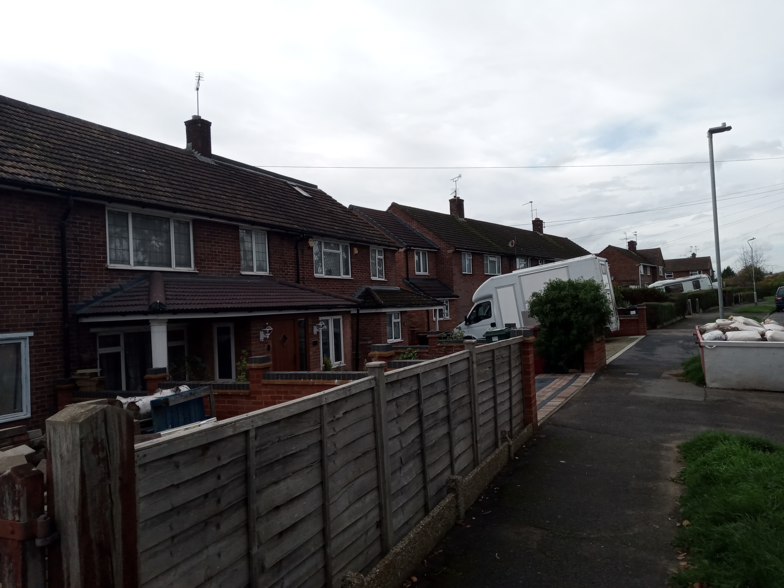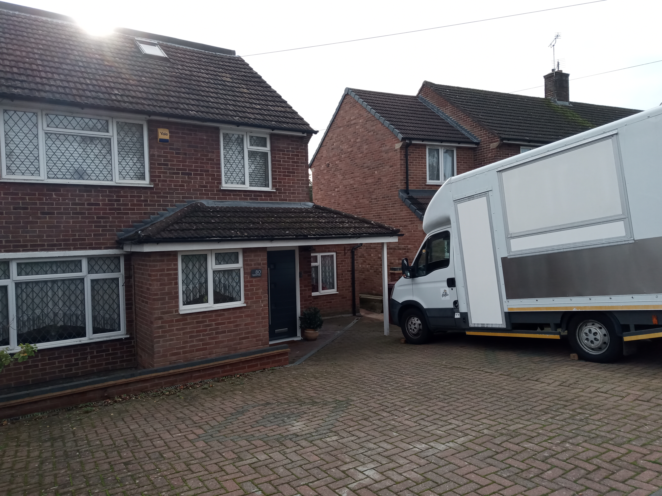

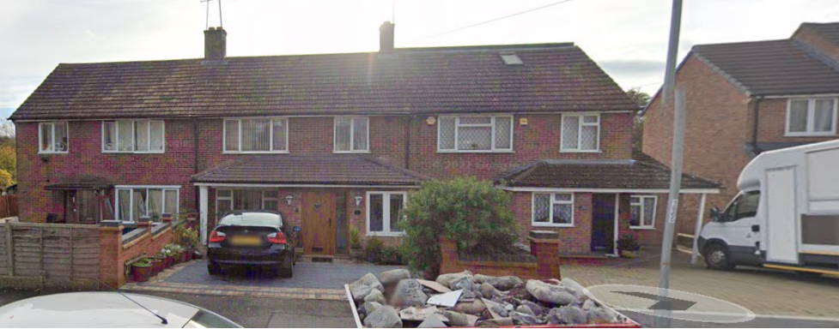
No. 80 to the far right
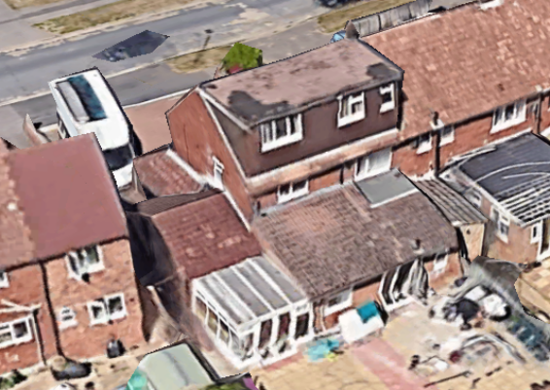

2. PROPOSAL AND SUPPORTING INFORMATION
The amended proposal includes a proposed rear extension following removal of the existing conservatory with a mono-pitched roofscape compared to the existing flat roof

Plans considered
A-L-001 Rev A: Proposed Plans & Elevations dated May 2022 and received 9th January 2023
E-X-001 Rev A: Existing Plans & Elevations dated May 2022 and received 22nd July 2022

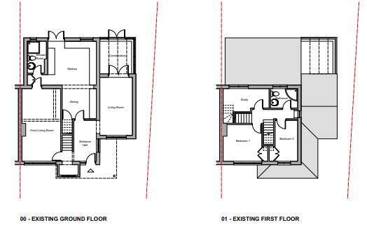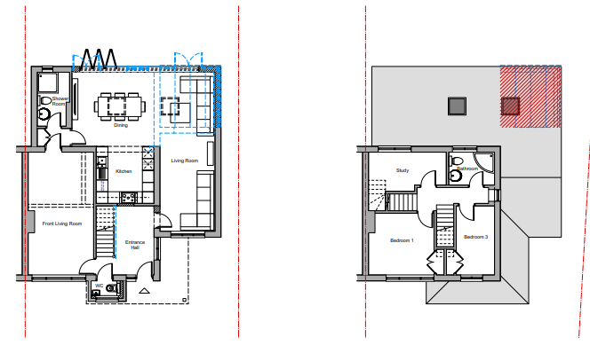

Existing Ground and First Floor Plans Proposed Ground and First Floor Plans

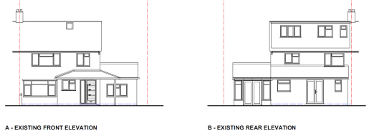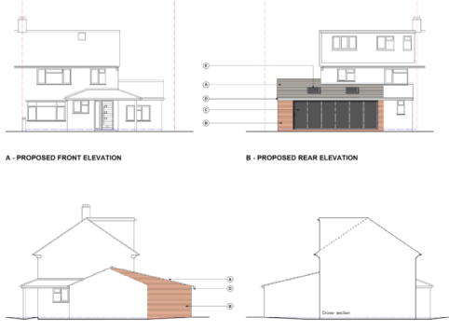

Proposed Elevations

- RELEVANT PLANNING HISTORY

Application Ref: 911105
Description: Erection of two storey side extension
Outcome: Refused
Date: 10/3/1992

Application Ref: 920267
Description: Erection of porch and single storey side extension
Outcome: Permitted
Date: 12/10/1992

Application Ref: 991220
Description: Erection of extension at 1st and 2nd storey level above existing single storey extension to dwelling
Outcome: Refused
Date: 2/6/2000

Application Ref: 071213
Description: Single Storey Rear Extension
Outcome: Permitted
Date: 17/9/2007

4. CONSULTATIONS

The following addresses were consulted by letter.

78 Hatford Road, Reading, RG30 3HP
82 Hatford Road, Reading, RG30 3HP

No letters of representation have been received.

The originally submitted plans included an extension across the front adjacent to the existing front projection. Following officer advice this element of the proposal was removed and the amended proposal includes the rear extension (in place of the rear conservatory) only.

Equality Act 2010:
In determining this application the Council is required to have regard to its obligations under the Equality Act 2010. However, there is no indication or evidence (including from consultation on the application) that the protected groups identified by the Act have or will have different needs, experiences, issues and priorities in relation to this particular planning application. Therefore in terms of the key equalities protected characteristics it is considered there would be no significant adverse impacts as a result of the development.

- LEGAL AND PLANNING POLICY CONTEXT

Section 38(6) of the Planning and Compulsory Purchase Act 2004 requires that proposals be determined in accordance with the development plan unless material considerations indicate otherwise. Material considerations include relevant policies in the National Planning Policy framework (NPPF) - among them the 'presumption in favour of sustainable development'. The following local and national planning policy and guidance is relevant to this application:

National Policy
National Planning Policy Framework
National Planning Practice Guidance

Reading Borough Local Plan (2019)
CC7 (Design and the Public Realm)
CC8 (Safeguarding Amenity)
H9 (House Extensions and Ancillary Accommodation)

SPD
Design Guide to House Extensions 2021

6. APPRAISAL
Character and Appearance

Policy H9 states that an extension to a house will be acceptable where it respects the character of the house in terms of scale, location, materials and design and respects the character and pattern of neighbouring properties and the street as a whole in terms of scale, location, materials and design, and any important existing building line. Policy CC7 also sets out relevant considerations for design.

The original design submitted with this application sough to extend the existing front porch extension to the whole width of the principal elevation. It was noted by the LPA that the extension would be an extension of the front room beyond the original building line of the principal elevation. As can be viewed above from the history of this building, there have been extensive levels of extension over the years. Therefore, it was considered by the LPA that the initial scheme as submitted would have constituted cumulative over-development and would have had a significant detrimental impact on the character of the original dwelling. It was considered that taking the series of existing extensions, the character of the original dwelling would be lost. The agent was duly informed.

Consequently, a revised drawing was submitted and the extension to the front porch removed. The rear extension would be limited to the footprint of the existing conservatory, within the envelope of the existing dwelling, albeit the roofscape has changed from a flat roof to a mono pitch to join to the rear of the roof pitch of the existing side extension and to wrap round above the existing adjacent rear extension. This is considered to create a more cohesive appearance than the existing roofs of the extensions.

It is therefore considered that this application, as revised, respects the character and pattern of neighbouring properties and also respects the character of the house in terms of scale, location, materials and design.

Residential Amenity

Policy H9 states that an extension will be acceptable where it does not result in an overbearing impact on neighbours. Policy H10 seeks to ensure that the amenity of gardens and other outdoor areas are not compromised. Policy CC8 states an extension to a house will be acceptable where it will not cause a significant detrimental impact to the living environment of existing or new residential properties.

The rear extension aspect of this application is limited to the ground floor level, with an approximate measurement of 2m ground to eve. There are no side windows presented and like noted above, sits within the existing envelope of the conservatory.

It is therefore considered that the proposal does not present any privacy and overlooking issues. The limited height of the extension, which would be only marginally taller overall than the existing flat roof, but pitched, would ensure that there would beno additional overbearing effects and no sunlight or daylight presently available to the adjoining property would be impeded.

- CONCLUSION
The proposed development has been assessed as set out above and is considered to be acceptable on that basis, subject to the following conditions.

8. RECOMMENDATION
Recommended Conditions:
AP1: Approved Plans
TL1: Time Limit Standards
M1: Materials to Match Existing

