

DELEGATED HOUSEHOLDER APPLICATION REPORT

Ward: Whitley
App Ref: 231113/HOU
Address: 26 Wincanton Road, Reading, RG2 8PB
Proposals: Part First Floor Rear Extension
Case Officer: Chukwudi Onwudinanti
Applicant: Mr Mohammed Sikedar
Date received (valid from): 7 August 2023
Target Decision date: 22 November 2023 (EXT)

- SITE DESCRIPTION
The site is a semi-detached two storey dwelling on the west side of Wincanton Road, in a predominantly residential area. There is an existing ground floor extension attached to the side of the dwelling. The area is characterised by similarly styled dwellings with considerable setbacks from the road and sizeable rear gardens. The site has had a Housholder Prior Approval for a ground floor 6m deep rear extension approved.

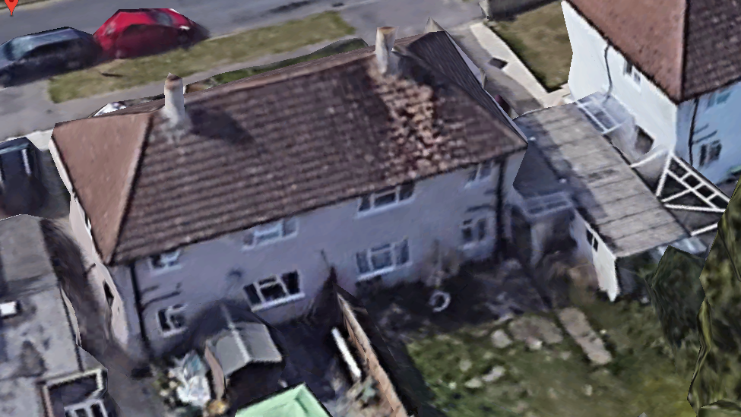

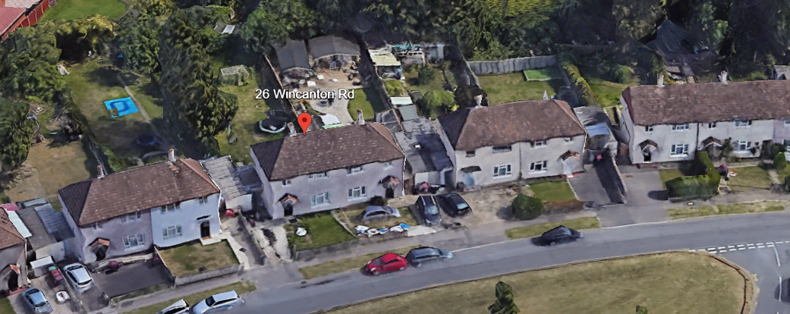
Google Aerial Photos

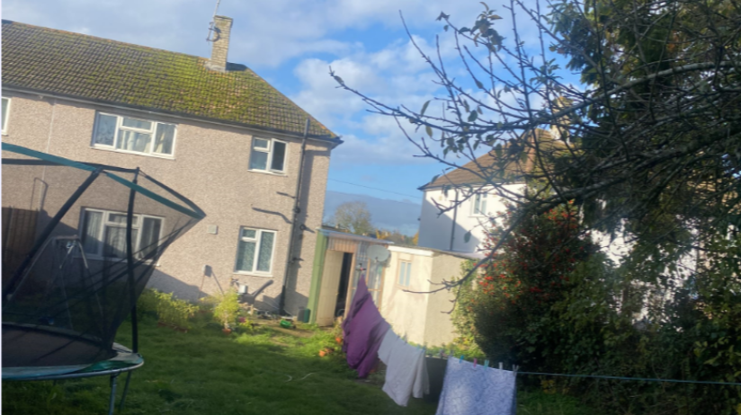
Site Photo

2. PROPOSAL AND SUPPORTING INFORMATION
The proposal is part first floor rear extension measuring 4m deep and 3.5m wide, stepped back from the boundary with No 26 Wincanton Road.

Plans considered dated July 2023 received 07/08/2023
Drawing No PA/A623/01: Existing & Proposed Ground Floor Plans
Drawing No PA/A623/02: Existing & Proposed First Floor Plans
Drawing No PA/A623/03: Existing Elevations
Drawing No PA/A623/04: Proposed Elevations
Drawing No PA/A623/05: Location and Site Plan

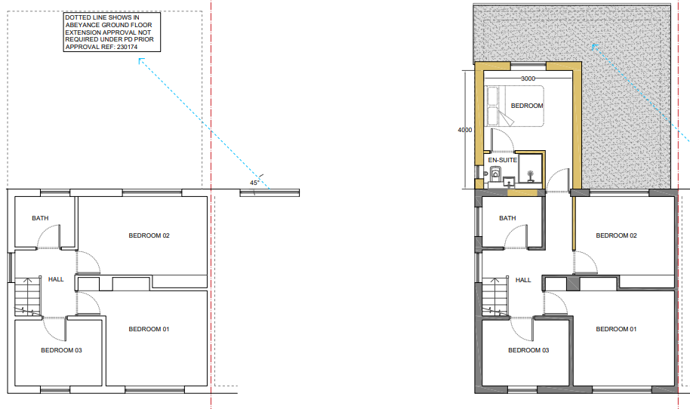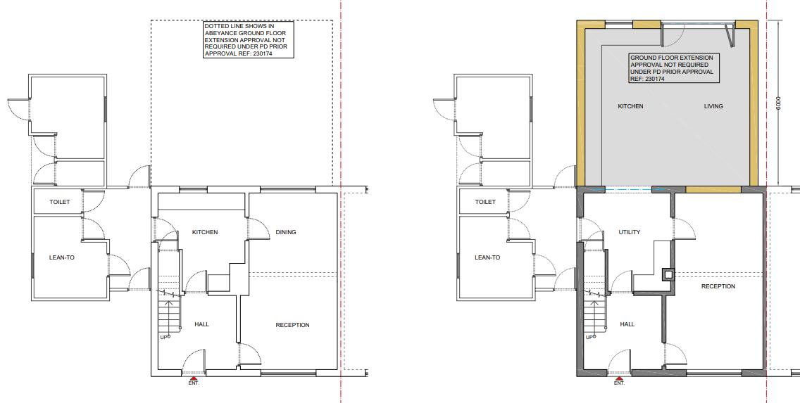
Existing & Proposed Ground Floor Plan Existing & Proposed First Floor Plan

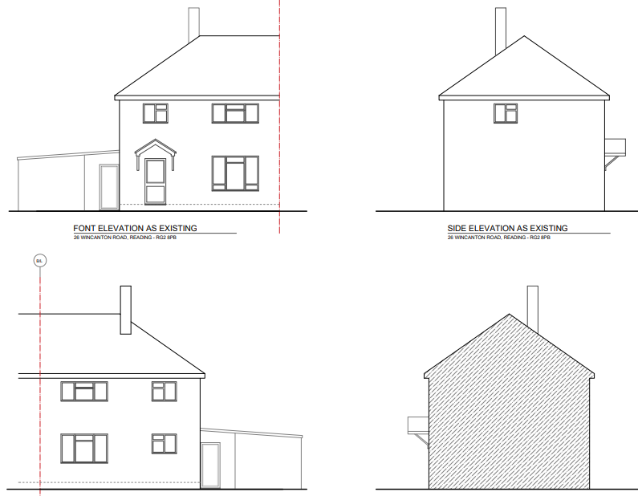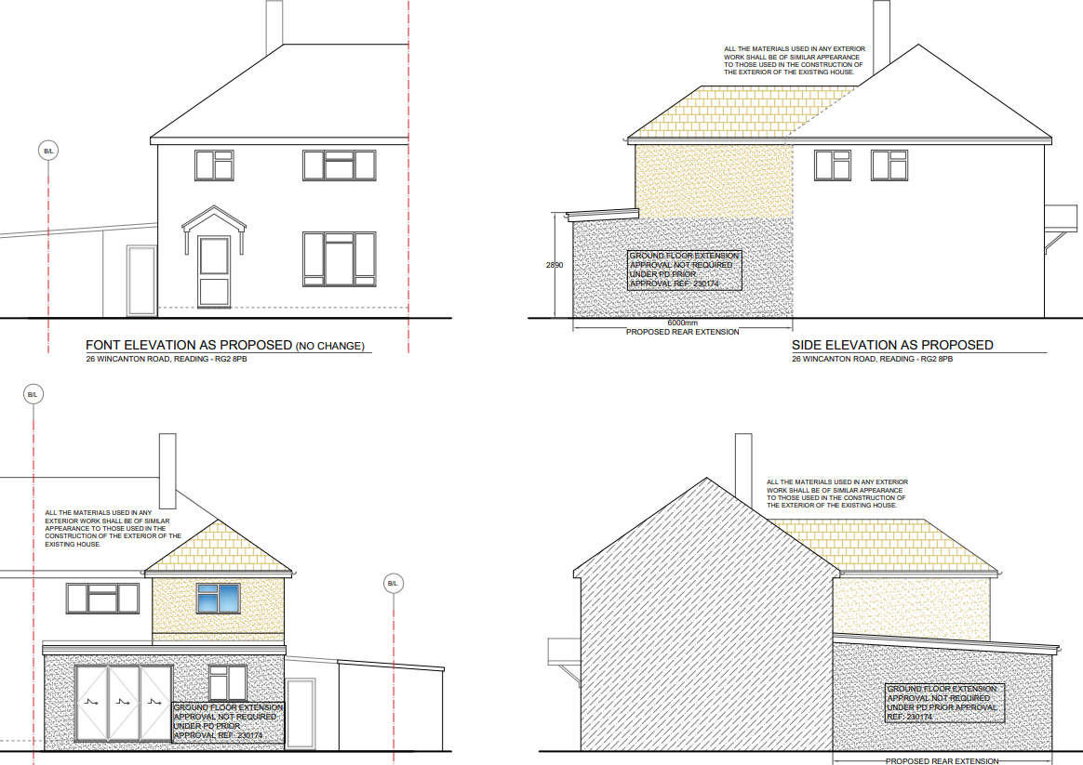
Existing Elevations Proposed Elevations

- RELEVANT PLANNING HISTORY

Application Ref: 230174
Description: Rear extension measuring 6m in depth, with a maximum height of 3m, and
2.89m in height to eaves level. Notification of the construction of an extension under class A Part 1 of Schedule 2 of the Town and Country Planning (General Permitted Development) (England) Order 2015.
Outcome: Prior Approval Not Required
Decision date: 27/3/2023

4. CONSULTATIONS

The following addresses were consulted by letter.

28 Wincanton Road, Reading, RG2 8PB
186 Whitley Wood Road, Reading, RG2 8LQ
188 Whitley Wood Road, Reading, RG2 8LQ
24 Wincanton Road, Reading, RG2 8PB

No letters of representation have been received.

Equality Act 2010:
In determining this application the Council is required to have regard to its obligations under the Equality Act 2010. However, there is no indication or evidence (including from consultation on the application) that the protected groups identified by the Act have or will have different needs, experiences, issues and priorities in relation to this particular planning application. Therefore in terms of the key equalities protected characteristics it is considered there would be no significant adverse impacts as a result of the development.

- LEGAL AND PLANNING POLICY CONTEXT

Section 38(6) of the Planning and Compulsory Purchase Act 2004 requires that proposals be determined in accordance with the development plan unless material considerations indicate otherwise. Material considerations include relevant policies in the National Planning Policy framework (NPPF) - among them the 'presumption in favour of sustainable development'. The following local and national planning policy and guidance is relevant to this application:

National Policy
National Planning Policy Framework
National Planning Practice Guidance

Reading Borough Local Plan (2019)
CC7 (Design and the Public Realm)
CC8 (Safeguarding Amenity)
H9 (House Extensions and Ancillary Accommodation)

SPD
Design Guide to House Extensions 2021

6. APPRAISAL
Character and Appearance

Policy H9 states that an extension to a house will be acceptable where it respects the character of the house in terms of scale, location, materials and design and respects the character and pattern of neighbouring properties and the street as a whole in terms of scale, location, materials and design, and any important existing building line. Policy CC7 also sets out relevant considerations for design.

The extension proposed in this application is for a pitched and hipped roof, gable ended first floor extension, extending 4m to the rear, closest to the boundary with No 28 Wincanton Road. The extension is limited to 3.5m in width, stepped back from the boundary with No 24 by approximately 3.5m. There is a separation of approximately 5m between the dwelling in this proposal and No. 28. There is a side bathroom window proposed facing No 28. The ridge line of the proposed extension is stepped down from the original dwelling.

The applicant has secured prior approval for a ground floor extension (not yet implemented), and this is a material consideration when assessing the suitability of the proposed first floor extension. Although cumulatively the scale would be relatively large, it is considered that the application site is of sufficient size to accommodate the approved ground floor extension along with the proposed first floor. The design of the first floor is considered acceptable and it is sited appropriately being considerably set away from the attached semi (no. 24) and amply separated from the neighbouring property (not. 28)

All aspects of the proposal are to the rear and the materials would be in keeping with the existing materials. It is therefore not considered that the proposal would alter the character of the existing dwelling to a degree that would be unacceptable.

Residential Amenity

Policy H9 states that an extension will be acceptable where it does not result in an overbearing impact on neighbours. Policy H10 seeks to ensure that the amenity of gardens and other outdoor areas are not compromised. Policy CC8 states an extension to a house will be acceptable where it will not cause a significant detrimental impact to the living environment of existing or new residential properties.

As has been stated in this report, the first floor extension is pulled back from the dwellings on both sides of the site. The side window presented is a bathroom window which ordinarily would be obscure glazed.

The 45 degree assessment demonstrates that the first floor aspect would not cause any detrimental impact on the access to daylight and sunlight for either of the adjacent properties. A combination of the limited depth and distances from the adjoining properties on both sides also mitigates any overbearing impacts as a result of this extension and subject to conditions ensuring the proposed window would be obscure glazed and to remove permitted development rights for further openings it is considered that any aspect of the proposal would not impinge on the privacy of these adjoining properties as a result of overlooking.

- CONCLUSION
The proposed development has been assessed as set out above and is considered to be acceptable on that basis, subject to the following conditions.

8. RECOMMENDATION: Grant
Recommended Conditions:
AP1; Approved Plans
PD2: No New Openings
PD3: Obscure Glazing

