

DELEGATED HOUSEHOLDER APPLICATION REPORT

Ward: Coley
App Ref: 230338/HOU
Address: 89 Brunswick Street, Reading, RG1 6NY
Proposals: Erection of a single storey rear extension and insertion of two rooflights to the front roof slope
Case Officer: Chukwudi Onwudinanti
Applicant: Mr Craig Buckland
Date received (valid from): 15 March 2023
Target Decision date: 7 June 2023 (EXT)

- SITE DESCRIPTION
The proposal site is a mid-terrace Victorian dwelling on the eastern side of Brunswick Road. The building lies just outside the Downshire Square Conservation Area and not too far away from the Grade II Listed Building , Brunswick Arms which is about 100 metres away at Nos 49 -55.

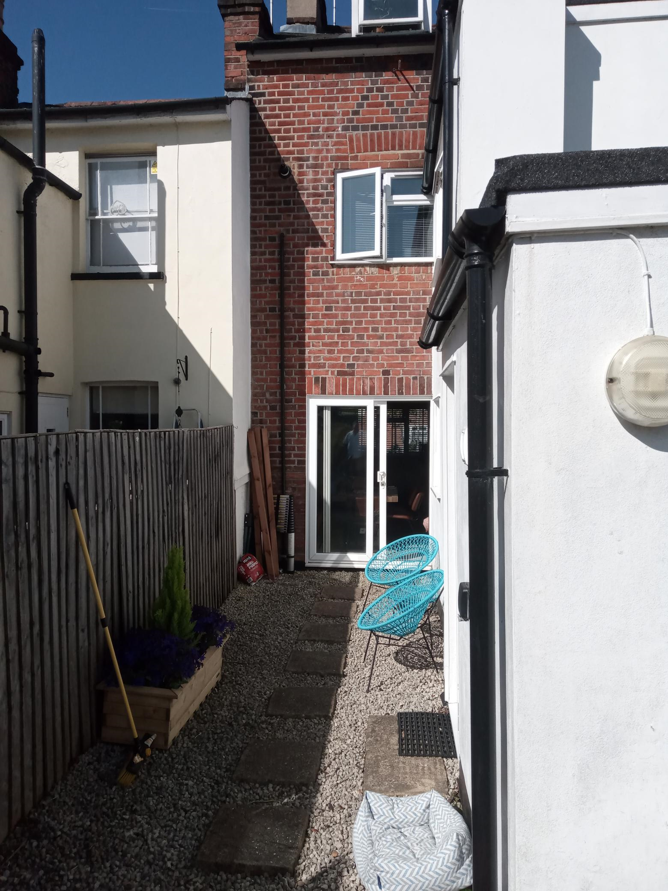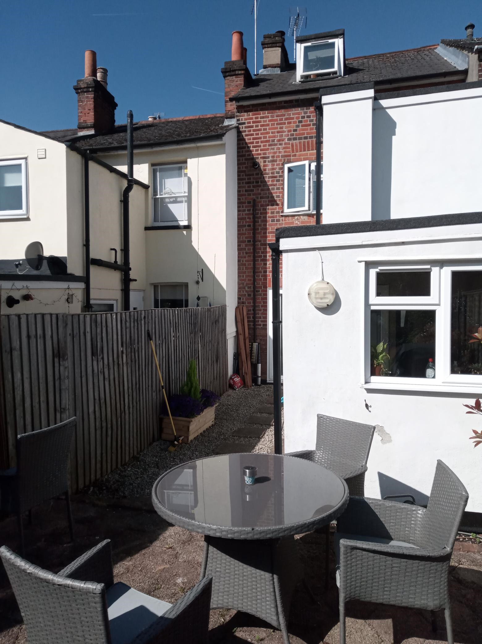

2. PROPOSAL AND SUPPORTING INFORMATION

The proposal is for the erection of a single storey rear extension measuring approximately 4m in depth and 2.5m wide (as amended), as well as insertion of two rooflights to the front roof slope.

Plans considered dated March 2023
Drawing No: P80 Rev A : Site Plan received 31/05/2023
Drawing No: P90 Rev A : Location Plan received 15/03/2023
Drawing No: P101 Rev A : Existing Elevations & Section received 15/03/2023
Drawing No: P100 Rev A : Existing Floor Plans received 15/03/2023
Drawing No: P102 Rev D : Proposed Plans received 25/05/2023
Drawing No: P103 Rev D : Proposed Elevations & Section received 25/05/2023
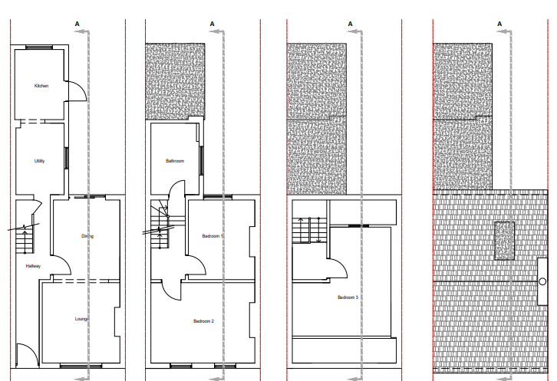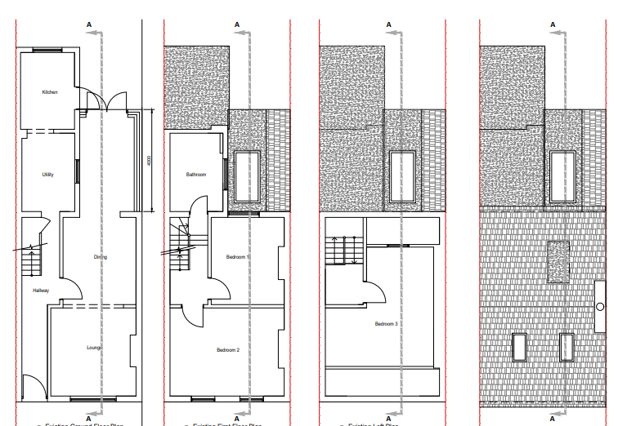
Existing Floor Plans Proposed Floor Plans

- RELEVANT PLANNING HISTORY
None

4. CONSULTATIONS

The following addresses were consulted by letter.

11 Downshire Square, Reading, RG1 6NJ
91 Brunswick Street, Reading, RG1 6NY
87 Brunswick Street, Reading, RG1 6NY
13 Downshire Square, Reading, RG1 6NJ

No letters of representation have been received.

Equality Act 2010:
In determining this application the Council is required to have regard to its obligations under the Equality Act 2010. However, there is no indication or evidence (including from consultation on the application) that the protected groups identified by the Act have or will have different needs, experiences, issues and priorities in relation to this particular planning application. Therefore in terms of the key equalities protected characteristics it is considered there would be no significant adverse impacts as a result of the development.

- LEGAL AND PLANNING POLICY CONTEXT

Section 38(6) of the Planning and Compulsory Purchase Act 2004 requires that proposals be determined in accordance with the development plan unless material considerations indicate otherwise. Material considerations include relevant policies in the National Planning Policy framework (NPPF) - among them the 'presumption in favour of sustainable development'. The following local and national planning policy and guidance is relevant to this application:

National Policy
National Planning Policy Framework
National Planning Practice Guidance

Reading Borough Local Plan (2019)
CC7 (Design and the Public Realm)
CC8 (Safeguarding Amenity)
H9 (House Extensions and Ancillary Accommodation)

SPD
Design Guide to House Extensions 2021

6. APPRAISAL
Character and Appearance

Policy H9 states that an extension to a house will be acceptable where it respects the character of the house in terms of scale, location, materials and design and respects the character and pattern of neighbouring properties and the street as a whole in terms of scale, location, materials and design, and any important existing building line. Policy CC7 also sets out relevant considerations for design.

All aspects of the extension presented by this proposal is to the rear of the property and not visible from the street scene. The original plans proposed were to extend approximately 7m to the rear from the existing recessed part, effectively extending the existing outrigger by approximately 2m. On the advice of the LPA, the extension has been limited to 4m deep from the recessed back line, without any increase to the depth of the outrigger. The height of the extension is limited to 2.4m, ground to eave, on the line of the boundary with the neighbours at No 91. All materials are to match existing.

With these amendments, it is considered that the proposed development respects the character of the house in terms of scale, location, materials and design, and does not alter in any significant way, the character and pattern of neighbouring properties as no part of the extension is visible from the street scene.

Residential Amenity

Policy H9 states that an extension will be acceptable where it does not result in an overbearing impact on neighbours. Policy H10 seeks to ensure that the amenity of gardens and other outdoor areas are not compromised. Policy CC8 states an extension to a house will be acceptable where it will not cause a significant detrimental impact to the living environment of existing or new residential properties.

As noted above, the height of the extension is limited to 2.4m and the amendment sought and achieved reduces the blank wall presented to the neighbouring property at No 91 to 4m, a little above the fence line. There are no side windows presented.

As a result of the limited height of the eaves to the extension, it is considered that there would not be overbearing impacts on the neighbours on both sides as a result. There are also no overlooking issues as the extension is limited to the ground floor level. Conditions would be used to ensure that no windows are installed on the side of the extension in the future.

There would not be a significant detrimental effect on daylight and sunlight to the adjoining neighbours

- CONCLUSION
The proposed development has been assessed as set out above and is considered to be acceptable on that basis, subject to the following conditions.

8. RECOMMENDATION

Recommended Conditions:
AP1: Approved Plans
TL1: Time Limit Standards
M1: Materials to Match Existing
PD2: No New Openings to the sides.

