

DELEGATED HOUSEHOLDER APPLICATION REPORT

Ward: Church
App Ref: 230900/HOU
Address: 188 Hartland Road, Reading, RG2 8DR
Proposals: Proposed single storey rear and side extensions. Proposed front Entrance porch alterations to front fenestration.
Case Officer: Chukwudi Onwudinanti
Applicant: Mr Jaspal Sandul
Date received (valid from): 27 June 2023
Target Decision date: 6 November 2023 (Ext)

1. SITE DESCRIPTION
The site is a semi-detached two storey dwelling on the south-western side of Hartland Road, in a predominantly residential area. The dwellings on the same side of the road are largely of same style and size, with a different style of buildings on the opposite side, creating a range of styles on the road.

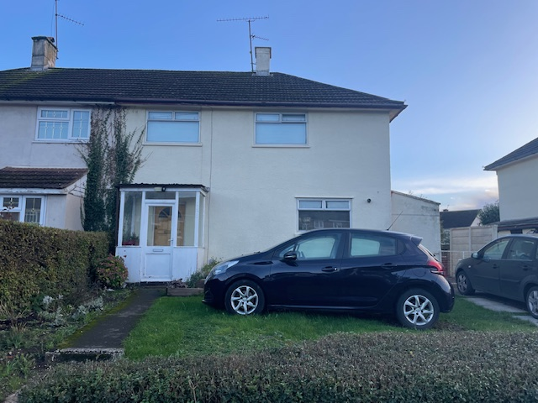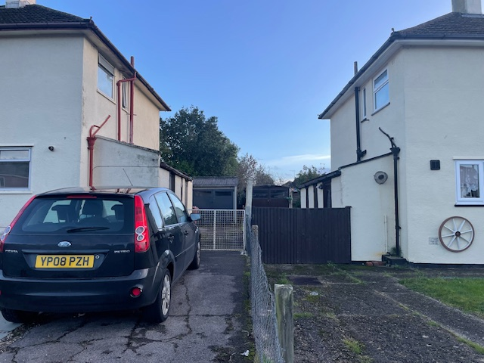

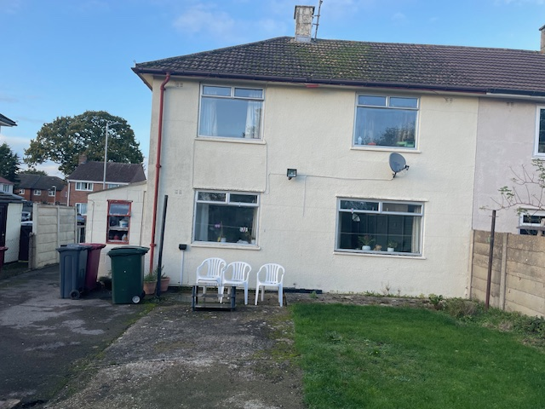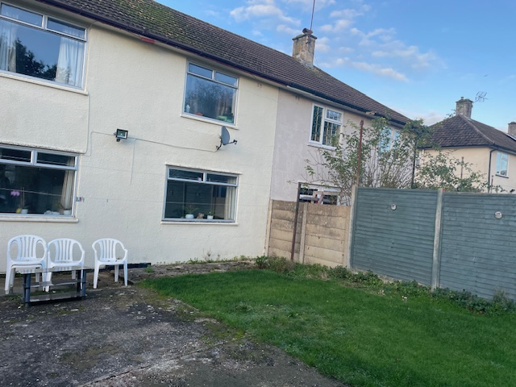

2. PROPOSAL AND SUPPORTING INFORMATION
Proposed are single storey rear and side extensions, which would essentially create a wrap-around extension. The side extension would be 3.4m in width with a flat roof at 3m high, to replace a 1.4m wide mono-pitched projection at a maximum height of 2.7m. The proposed side extension would be set back by 1m from the front elevation. The rear extension would be 3.6m deep with a flat roof.

Also proposed is a porch to the right hand side of the front elevation, removing the existing porch and creating a window in the location of the existing entrance door.

Plans considered
Drawing No 2023-04-05 Rev B: Location Plan dated 26/06/2023, received 07/09/2023
Drawing No 2023-04-05 Rev A: Existing Floor Layouts and Elevations dated 15/01/2023 received 28/06/2023
Drawing No 2023-04-04 Rev B: Block Plan received 07/09/2023
Drawing No 2023-04-02 Rev B: Proposed Floor Layouts dated 15/01/2023, received 07/09/2023
Drawing No 2023-04-03 Rev B: Proposed Elevations dated 15/01/2023, received 07/09/2023

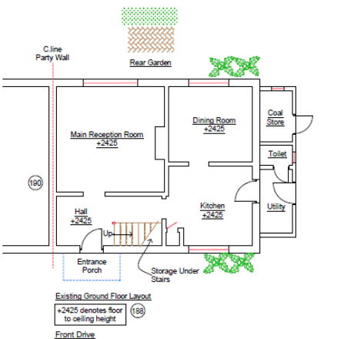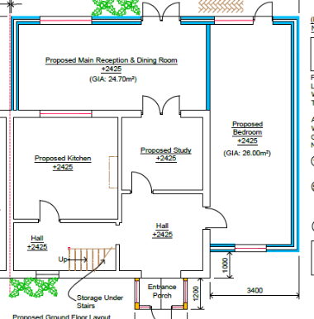
Existing Ground Floor Plan Proposed Ground Floor Plan

- RELEVANT PLANNING HISTORY
None

4. CONSULTATIONS

The following addresses were consulted by letter.

186 Hartland Road, Reading, Berkshire
43 Foxhays Road, Reading, Berkshire, RG2 8ND
62 Whitley Wood Road, Reading, RG2 8JE
64 Whitley Wood Road, Reading, RG2 8JE
190 Hartland Road, Reading, RG2 8DR

Letters of representation have been received as follows:
Letter of support from No 64 Whitley Wood Road

Equality Act 2010:
In determining this application the Council is required to have regard to its obligations under the Equality Act 2010. However, there is no indication or evidence (including from consultation on the application) that the protected groups identified by the Act have or will have different needs, experiences, issues and priorities in relation to this particular planning application. Therefore in terms of the key equalities protected characteristics it is considered there would be no significant adverse impacts as a result of the development.

- LEGAL AND PLANNING POLICY CONTEXT

Section 38(6) of the Planning and Compulsory Purchase Act 2004 requires that proposals be determined in accordance with the development plan unless material considerations indicate otherwise. Material considerations include relevant policies in the National Planning Policy framework (NPPF) - among them the 'presumption in favour of sustainable development'. The following local and national planning policy and guidance is relevant to this application:

National Policy
National Planning Policy Framework
National Planning Practice Guidance

Reading Borough Local Plan (2019)
CC7 (Design and the Public Realm)
CC8 (Safeguarding Amenity)
H9 (House Extensions and Ancillary Accommodation)

SPD
Design Guide to House Extensions 2021

Discussions with agent.
The original submission by the agent had the side extension pushed to the same line as the existing front façade, thereby moving the line of the existing side outrigger forward. The LPA advised the agent to revise the drawings to step the side extension back from the principal elevation. The agent has subsequently revised the design.

6. APPRAISAL
Character and Appearance

Policy H9 states that an extension to a house will be acceptable where it respects the character of the house in terms of scale, location, materials and design and respects the character and pattern of neighbouring properties and the street as a whole in terms of scale, location, materials and design, and any important existing building line. Policy CC7 also sets out relevant considerations for design.

The proposal presents an extension to the rear of this property of 3.6m with a flat roof and a maximum ground to eave height of 3m. There is a proposed flat roofed side extension aspect of 3.4m with the same maximum ground to eave height as the rear extension. All materials to be used externally are to match the existing materials.

The design of the proposal creates a wraparound development around the right side and the rear of the existing dwelling, with the side extension aspect stepped back approximately 1m from the line of the Principal Elevation. This wraparound effect creates a relatively large increase in footprint of the existing dwelling, however, it is considered that this would be acceptable due to being single storey in nature, set back to the front and with sufficient overall plot space to accommodate the scale of the proposal.

The rear aspect of the wraparound increases the depth to the rear by 3.6m, which is within the 4m guidance as set out in the SPD.

In moving the front porch to the side, there is a departure from the existing rhythm and character of the dwellings on the same side of the street, with the dwellings having pairs of the front porches sitting side by side on the dwellings on that side. However, these porches are not original to the street and there is a variety of front design treatments within the overall area such that it is not considered that this change would have such impact on the character of the street scene as to be deemed unacceptable.

Residential Amenity

Policy H9 states that an extension will be acceptable where it does not result in an overbearing impact on neighbours. Policy H10 seeks to ensure that the amenity of gardens and other outdoor areas are not compromised. Policy CC8 states an extension to a house will be acceptable where it will not cause a significant detrimental impact to the living environment of existing or new residential properties.

The side extension proposed is an increase to the existing built form. The roof would be flat and the height would be limited to 3m and would have no side facing windows. The adjacent property at no. 186 has side facing windows, but these are believed to serve a utility area. There would be some limited differing effects with regard to daylight and sunlight to these windows as the proposed side extension would be closer to the boundary and slightly higher, but it is not considered that this would be so detrimental to warrant refusal on this basis and these windows, it is believed, serve non- habitable rooms. It is not considered that the overall height would create overbearing effects on no. 186.

The depth of the rear extension is 3.6m. It is not considered that there would be a detrimental effect on the daylight and sunlight to no. 190 when assessed against the 60 degree line from the centre of the rear French window of that property.

Overall it is considered that the limited height of the extension, combined with the flat roof mitigates any overbearing effects, privacy and overlooking issues.

- CONCLUSION
The proposed development has been assessed as set out above and is considered to be acceptable on that basis, subject to the following conditions.

8. RECOMMENDATION: Grant
Recommended Conditions:
AP1: Approved Plans
TL1: Time Limit Standards
M1: Materials to Match Existing

