

DELEGATED HOUSEHOLDER APPLICATION REPORT

Ward: Park
App Ref: 221838/HOU
Address: 59c Cholmeley Road, Reading, RG1 3NB
Proposals: Proposed First Floor Front Extension and Side Dormer Plus Internal Alterations
Case Officer: Chukwudi Onwudinanti
Applicant: Mr Hussaini
Date received (valid from): 8 December 2022
Target Decision date: 17 March 2023 (EXT)

1. SITE DESCRIPTION
The proposal site is a semi-detached chalet style bungalow on the western side of Cholmeley Road. It is a counterpoint on the road as it is the only bungalow within the context of the street scene and surrounding area. The site is bounded on both sides by private roads leading into a block of flats on one side and private garages on the other.

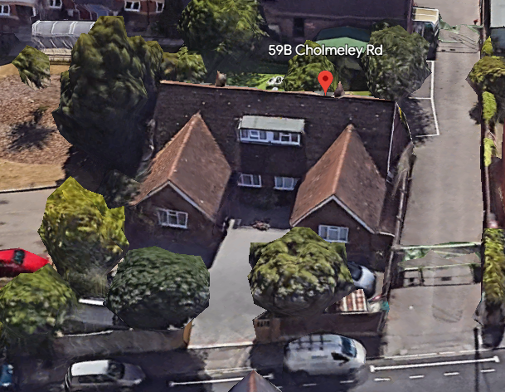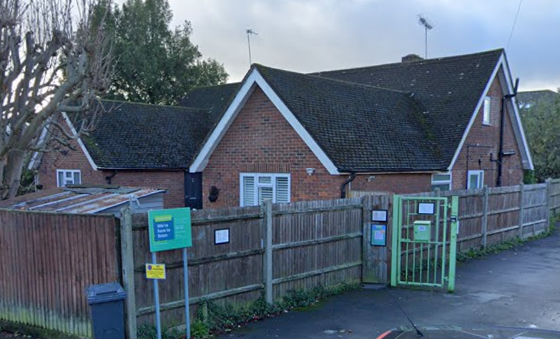

2. PROPOSAL AND SUPPORTING INFORMATION
Proposed First Floor Front Extension increasing the height of the front pitch roof by 1.1m and a Side Dormer measuring 5.75m wide and 1.2m high, plus Internal Alterations.

Plans considered dated May 2021, received 8th December 2022
Drawing No: 21054.B.PP-01: Existing Ground Floor Plan
Drawing No: 21054.B.PP-02: Existing First Floor Plan
Drawing No: 21054.B.PP-03: Existing Elevations
Drawing No: 21054.B.PP-04: Proposed First Floor Plan
Drawing No: 21054.B.PP-05: Proposed Elevations
Drawing No: 21054.S.PP-06: Location Plan
Drawing No: 21054.S.PP-07: Block Plan

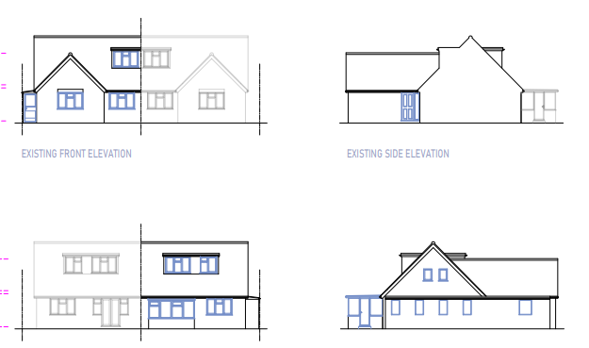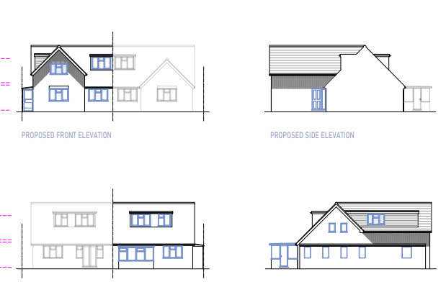
Existing Elevations Proposed Elevations

- RELEVANT PLANNING HISTORY

App Ref: 221835/HOU
Address: 59b Cholmeley Road, Reading, RG1 3NB
Proposals: Proposed First Floor Front Extension and Side Dormer Plus Internal Alterations
Outcome: Pending

4. CONSULTATIONS

The following addresses were consulted by letter.

59a Cholmeley Road, Reading, RG1 3NB
12 Eastgate Court, Reading, RG1 3NF
59c Cholmeley Road, Reading, RG1 3NB

No letters of representation have been received.

Equality Act 2010:
In determining this application the Council is required to have regard to its obligations under the Equality Act 2010. However, there is no indication or evidence (including from consultation on the application) that the protected groups identified by the Act have or will have different needs, experiences, issues and priorities in relation to this particular planning application. Therefore in terms of the key equalities protected characteristics it is considered there would be no significant adverse impacts as a result of the development.

- LEGAL AND PLANNING POLICY CONTEXT

Section 38(6) of the Planning and Compulsory Purchase Act 2004 requires that proposals be determined in accordance with the development plan unless material considerations indicate otherwise. Material considerations include relevant policies in the National Planning Policy framework (NPPF) - among them the 'presumption in favour of sustainable development'. The following local and national planning policy and guidance is relevant to this application:

National Policy
National Planning Policy Framework
National Planning Practice Guidance

Reading Borough Local Plan (2019)
CC7 (Design and the Public Realm)
CC8 (Safeguarding Amenity)
H9 (House Extensions and Ancillary Accommodation)

SPD
Design Guide to House Extensions 2021

6. APPRAISAL
Character and Appearance

Policy H9 states that an extension to a house will be acceptable where it respects the character of the house in terms of scale, location, materials and design and respects the character and pattern of neighbouring properties and the street as a whole in terms of scale, location, materials and design, and any important existing building line. Policy CC7 also sets out relevant considerations for design.

The proposal site is the only bungalow within the area it is located. Although the proposed flat roof dormer extension to the side of the existing gable ended projection would be large in terms of its overall length, it would be set down and set in within the roofscape. It is not considered that there would be a detrimental impact on the overall character and pattern of the dwelling, and there is an identical proposal for the adjoining semi-detached dwelling. The original materials are to be matched in the extensions. The roof lights to be installed would not add any impacts to the existing dwelling.

It is therefore considered that the proposal is sympathetic in scale and design to the existing dwelling, neighbouring properties and the street scene as a whole.

Residential Amenity

Policy H9 states that an extension will be acceptable where it does not result in an overbearing impact on neighbours. Policy H10 seeks to ensure that the amenity of gardens and other outdoor areas are not compromised. Policy CC8 states an extension to a house will be acceptable where it will not cause a significant detrimental impact to the living environment of existing or new residential properties.

As stated above in this report, all aspects of this proposal are done on both sides of the semi-detached dwelling. There are also no properties on the immediate side boundaries to the property. There are therefore no privacy and overlooking issues and no overbearing effects as the upward developments are done in tandem on both sides of the building. There are no sunlight or daylight issues.

- CONCLUSION
The proposed development has been assessed as set out above and is considered to be acceptable on that basis, subject to the following conditions.

8. RECOMMENDATION
Recommended Conditions:
AP1: Approved Plans
TL1: Time Limit Standards
M1: Materials to Match Existing

