

DELEGATED HOUSEHOLDER APPLICATION REPORT

Ward: Kentwood
App Ref: 230902/HOU
Address: 17 Wardle Avenue, Tilehurst, Reading, RG31 6JR
Proposals: Proposed single storey flat roof rear extension with bifold doors and roof lanterns.
Case Officer: Chukwudi Onwudinanti
Applicant: Mrs Victoria Hattam
Date received (valid from): 28 June 2023
Target Decision date: 8 September 2023 (EXT)

1. SITE DESCRIPTION
The proposed site is a semi-detached two storey dwelling on the western side of Wardle Avenue which connects Armour Rd on the south and Armour Hill to the North. The road is characterised by deep green tree cover and dwellings of various styles and sizes with deep, long rear gardens. The trees are subject to TPOs.
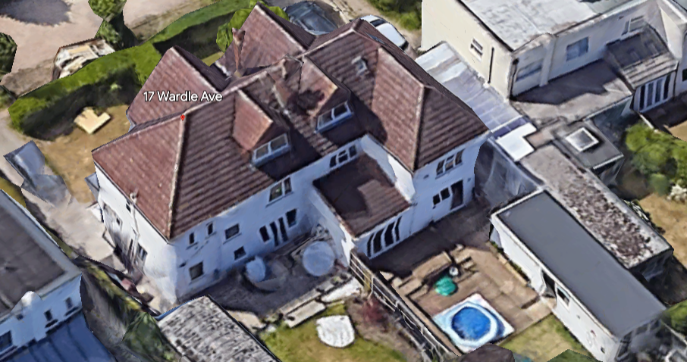

2. PROPOSAL AND SUPPORTING INFORMATION
Proposed is a single storey flat roof rear extension measuring 4m deep and running the full width of the existing dwelling, with the installation of bifold doors and roof lanterns.

Plans considered received 28/6/2023
Location Plan
HATTAM-0523-01: Existing Ground Floor Plan
HATTAM-0523-02: Existing Elevations
HATTAM-0523-03 Rev A: Proposed Ground Floor Plan
HATTAM-0523-04 Rev A: Proposed Elevations
HATTAM-0523-05 Rev A: Proposed Section A-A
HATTAM-0523-06: Location Plan
HATTAM-0523-07: Block Plan

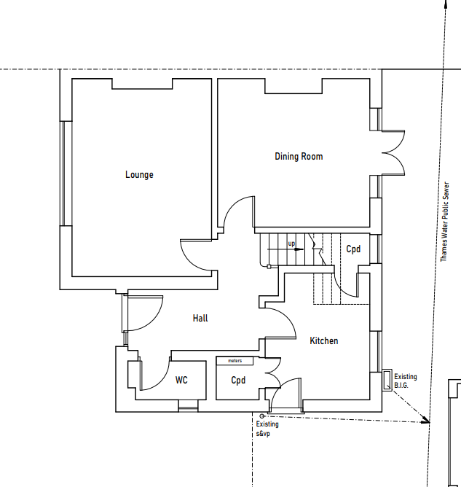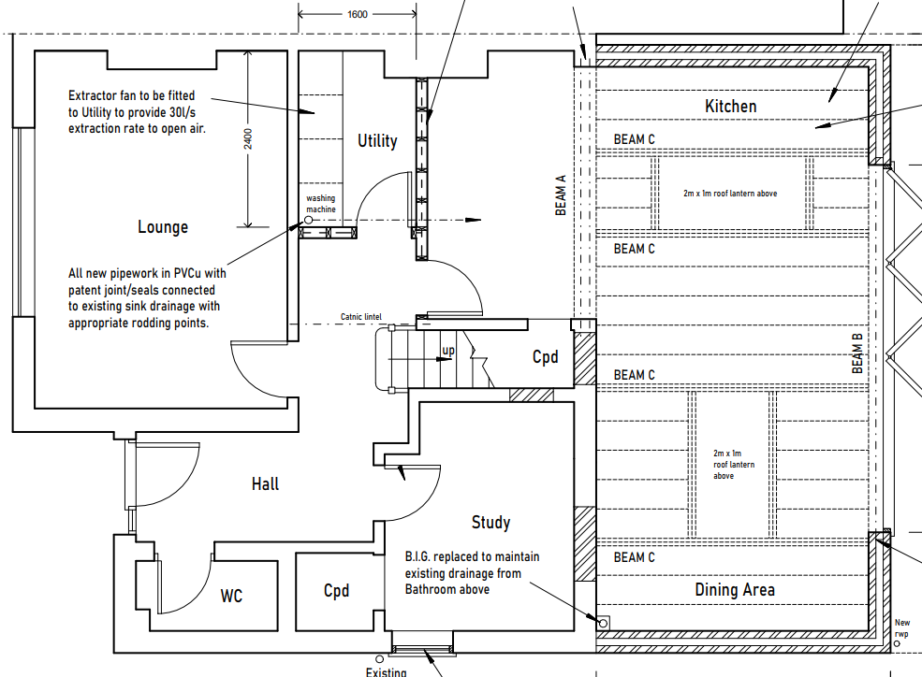

Existing Ground Floor Plan Proposed Ground Floor Plan

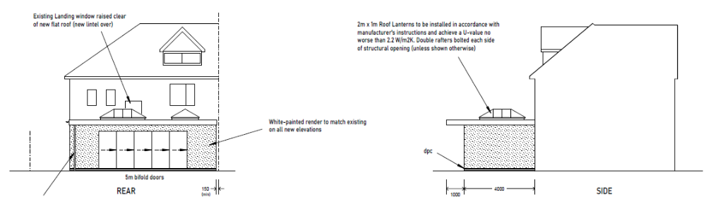

Proposed Elevations

- RELEVANT PLANNING HISTORY
None

4. CONSULTATIONS

The following addresses were consulted by letter.

38 Newbery Close, Tilehurst, Reading, Berkshire, RG31 6JN
15 Wardle Avenue, Reading
19 Wardle Avenue, Tilehurst, Reading, RG31 6JR
40 Newbery Close, Tilehurst, RG31 6JN

Consultation was undertaken with Trees:

Trees
I have no objections. However all the street trees are subject to a TPO hence the following 2 Informatives would be prudent:

I15 Advice about TPO.d trees and trees in Conservation Areas
You are advised that no tree works are approved by virtue of this consent. Any works to trees subject to a Tree Preservation Order or to Conservation Area status will require submission of a tree works application or Section 211 Notice respectively.

I24/17 Do not damage the verge
You are advised to avoid the use of the grass verges for development related activity, e.g. storage of materials, due to the resulting potential harm to important street trees.

Equality Act 2010:
In determining this application the Council is required to have regard to its obligations under the Equality Act 2010. However, there is no indication or evidence (including from consultation on the application) that the protected groups identified by the Act have or will have different needs, experiences, issues and priorities in relation to this particular planning application. Therefore in terms of the key equalities protected characteristics it is considered there would be no significant adverse impacts as a result of the development.

- LEGAL AND PLANNING POLICY CONTEXT

Section 38(6) of the Planning and Compulsory Purchase Act 2004 requires that proposals be determined in accordance with the development plan unless material considerations indicate otherwise. Material considerations include relevant policies in the National Planning Policy framework (NPPF) - among them the 'presumption in favour of sustainable development'. The following local and national planning policy and guidance is relevant to this application:

National Policy
National Planning Policy Framework
National Planning Practice Guidance

Reading Borough Local Plan (2019)
CC7 (Design and the Public Realm)
CC8 (Safeguarding Amenity)
H9 (House Extensions and Ancillary Accommodation)
EN12 (Biodiversity and the Green Network)
EN14 (Trees, Hedges and Woodlands)

SPD
Design Guide to House Extensions SPD, 2021

6. APPRAISAL
Character and Appearance

Policy H9 states that an extension to a house will be acceptable where it respects the character of the house in terms of scale, location, materials and design and respects the character and pattern of neighbouring properties and the street as a whole in terms of scale, location, materials and design, and any important existing building line. Policy CC7 also sets out relevant considerations for design.

All aspects of this proposal are to the rear of the property, limited to a depth of 4m and height of approximately 2.8m. Materials are to match existing and as a result of the location of the extension, no part of it would be visible from the street.

It is considered that the character of the house in terms of scale, location, materials and design is respected by the particulars of this proposal.

Residential Amenity

Policy H9 states that an extension will be acceptable where it does not result in an overbearing impact on neighbours. Policy H10 seeks to ensure that the amenity of gardens and other outdoor areas are not compromised. Policy CC8 states an extension to a house will be acceptable where it will not cause a significant detrimental impact to the living environment of existing or new residential properties.

The rear extension only extends to the line of the existing extension on the neighbouring property at No 15. There is an existing outbuilding to the boundary with No19 which is to be removed to make way for the proposed extension.

Therefore, there would not be any significant additional impact brought on by this proposal to the neighbouring properties in terms of privacy, overlooking, overbearing effects or their access to sunlight and daylight.

The roof lights proposed are not positioned in any way that would give rise to overlooking from the properties on both sides.

- CONCLUSION
The proposed development has been assessed as set out above and is considered to be acceptable on that basis, subject to the following conditions.

8. RECOMMENDATION: Grant
Recommended Conditions:
AP1: Approved Plans
TL1: Time Limit Standards
M1: Materials to Match Existing
I15: Advice about TPO.d trees and trees in Conservation Areas
I24/17: Do not damage the verge

