

DELEGATED HOUSEHOLDER APPLICATION REPORT

Ward: Tilehurst
App Ref: 221923/VAR
Address: 111 Chapel Hill, Tilehurst, Reading, RG31 5DD
Proposals: Removal of existing rear extension and replacement with new front single storey extension and alterations to front porch without complying with condition 2 (Application No 191977) to change to a flat roof over the front porch and other changes as proposed in Application No 221923.

Case Officer: Chukwudi Onwudinanti
Applicant: Mr & Mrs Mackim
Date received (valid from): 7 March 2023
Target Decision date: 16 June 2023 (EXT)

1. SITE DESCRIPTION

111 Chapel Hill is located at the trough between the crest of two hills on a suburban street with moderate levels of traffic. Dwellings within the wider context are typically large detached single-family dwellings on large plots. The front garden has been converted to hard surfacing for parking vehicles. The site is not within a conservation area and there are no protected trees on site.

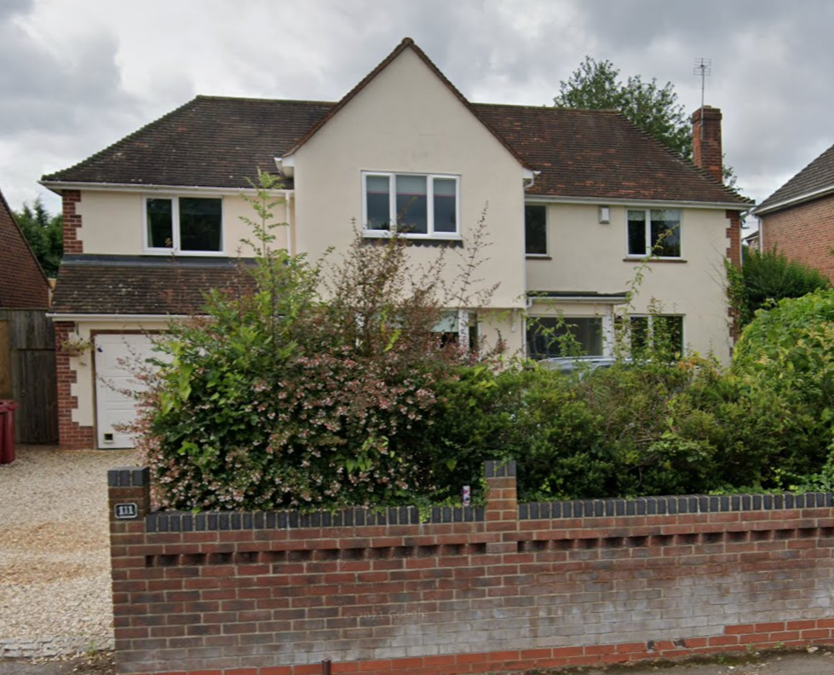

2. PROPOSAL AND SUPPORTING INFORMATION
Application for removal or variation of a condition 2 following grant of planning permission. (Application No 191977)
Plans Considered
Drawing No: 22011.S.BC-10 Rev A: Location Plan received 24th May 2023
Drawing No: 22011.S.BC-10: Proposed Ground Floor Plan received 12th June 2023
Drawing No: 22011.S.BC-11 Rev A: Block Plan received 24th May 2023
Drawing No: 2201.S.BC-07: Proposal Elevations received 3rd January 2023

The following changes to the previously permitted (Application No 191977) are sought :

- Approved rear parapet wall to a flat roof
- Rear elevation to include more glazing
- Front mono pitched roof over garage & porch to be flat roof
- Cladding to front and rear extensions

- RELEVANT PLANNING HISTORY

Application Ref: 191977
Description: Removal of existing rear extension and replacement with new. Front single storey extension and alterations to front porch.
Outcome: Permitted
Decision Date: 20/3/2020

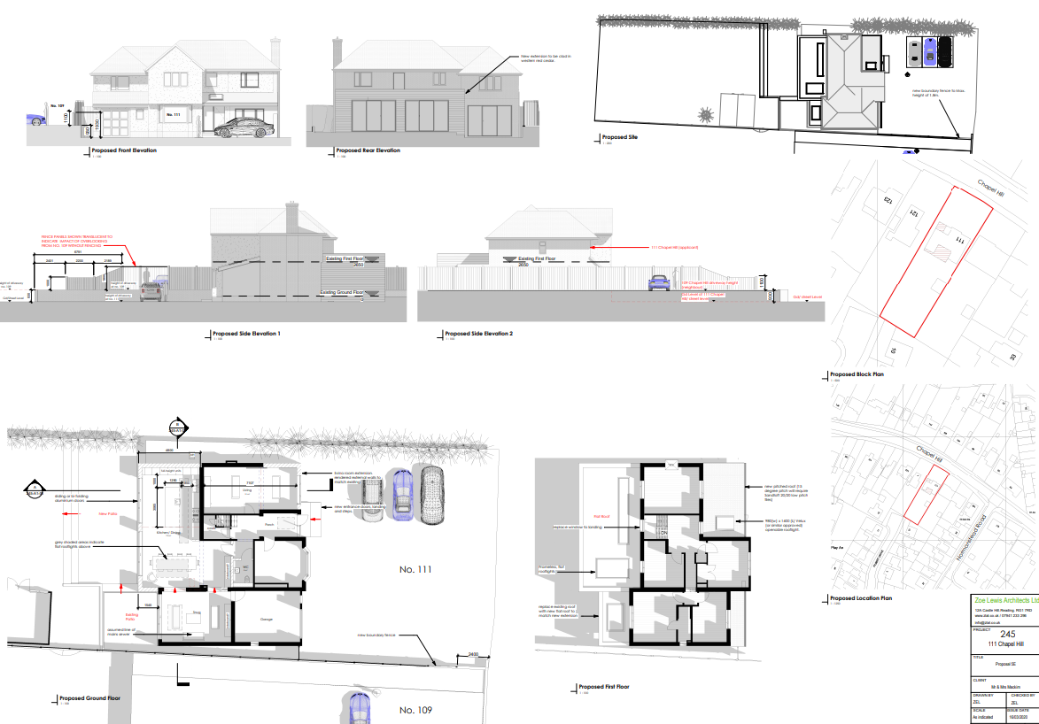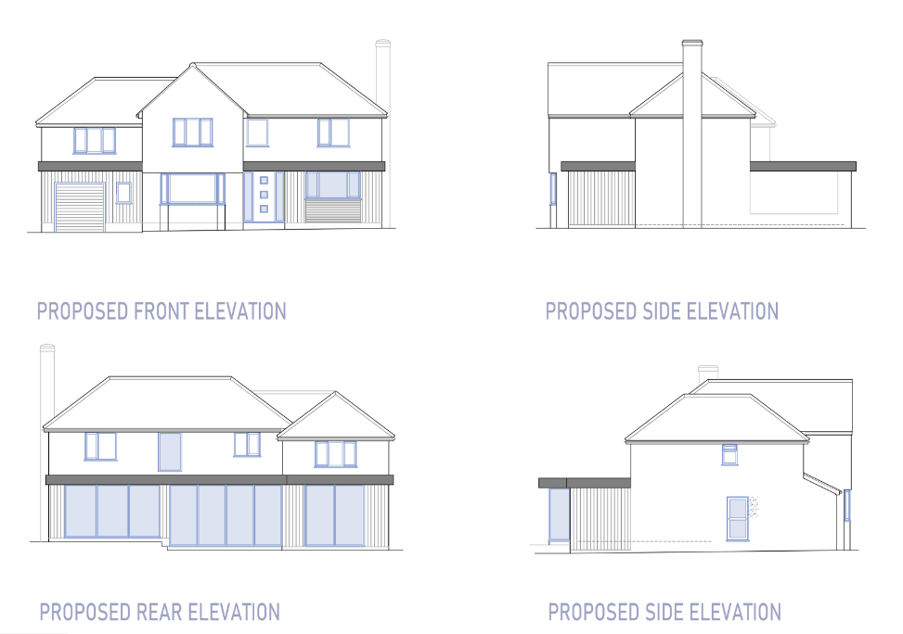
Previously Permitted Plans and Elevations VAR Elevations

CONDITIONS TO VARY
- The development hereby permitted shall ONLY be carried out in accordance with the following approved plans:
Drawing No. 245-A1-07D Proposal 5E
Drawing No. 245-A1-09 Proposal 5E Images
As received 16 March 2020
REASON: For the avoidance of doubt and to ensure that the development is carried out and adhered to in accordance with the application form and associated details hereby approved.

REVISED CONDITION
2. The development hereby permitted shall ONLY be carried out in accordance with the following approved plans:

Drawing No: 22011.S.BC-10: Proposed Ground Floor Plan received 12th June 2023
Drawing No: 22011.S.BC-07: Proposed Elevations received 3rd January 2022
Drawing No: 22011.S.BC-11 Rev A: Block Plan received 24th May 2023

REASON: For the avoidance of doubt and to ensure that the development is carried out and adhered to in accordance with the application form and associated details hereby approved.

4. CONSULTATIONS
No letters of representation have been received as follows:

Equality Act 2010:
In determining this application the Council is required to have regard to its obligations under the Equality Act 2010. However, there is no indication or evidence (including from consultation on the application) that the protected groups identified by the Act have or will have different needs, experiences, issues and priorities in relation to this particular planning application. Therefore in terms of the key equalities protected characteristics it is considered there would be no significant adverse impacts as a result of the development.

- LEGAL AND PLANNING POLICY CONTEXT

Section 38(6) of the Planning and Compulsory Purchase Act 2004 requires that proposals be determined in accordance with the development plan unless material considerations indicate otherwise. Material considerations include relevant policies in the National Planning Policy framework (NPPF) - among them the 'presumption in favour of sustainable development'. The following local and national planning policy and guidance is relevant to this application:

National Policy
National Planning Policy Framework
National Planning Practice Guidance

Reading Borough Local Plan (2019)
CC7 (Design and the Public Realm)
CC8 (Safeguarding Amenity)

- APPRAISAL
The proposed changes to the previously approved application, as stated above in this report include :

- Approved rear parapet wall to a flat roof
- Rear elevation to include more glazing
- Front mono pitched roof over garage & porch to be flat roof
- Cladding to front and rear extensions
In assessing the above changes against policies CC7 and CC8, it has been considered that the changes to the rear would have no material impact on the character and appearance of the building as viewed from the street scene as they would be limited to the rear of the property and not visible from the street.

On the principal elevation, the front porch is to be amended to be covered by a flat roof and some cladding would be applied. While these alterations are adding new elements to the character of the building, they are not considered to be unacceptable, when viewed in the context of the overall street scene outlook, as there are varied styles and external finishes to the buildings on the street and in the surrounding areas.

Therefore, in line with NPPG, this proposal has been considered to be ‘minor material amendments’, as both individually and collectively (by virtue of scale and/or nature considerations) they are considered to result in a development which is not substantially different from the one which was originally approved.
- CONCLUSION
The proposed development has been assessed and the proposed works are considered to be in accordance with the above relevant policies and planning permission can be granted.

8. RECOMMENDATION
Grant

