

DELEGATED HOUSEHOLDER APPLICATION REPORT

Ward: Caversham Heights
App Ref: 230931/HOU
Address: 8 Gurney Close, Caversham, Reading, RG4 7LE
Proposals: Demolish the existing garage and build single-storey side extension
Case Officer: Chukwudi Onwudinanti
Applicant: Mr and Mrs Payne
Date received (valid from): 4 July 2023
Target Decision date: 13 October 2023 (EXT)

1. SITE DESCRIPTION
The site is a detached bungalow on the northern side of Gurney Close, among other bungalows of similar style and size on both sides of the street, in a predominantly residential area.

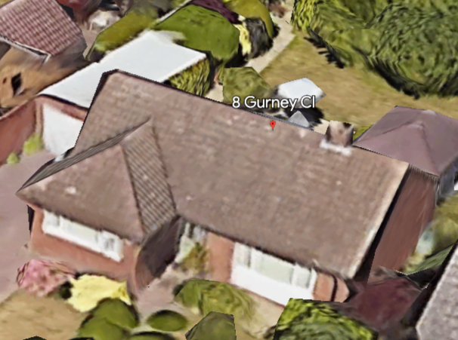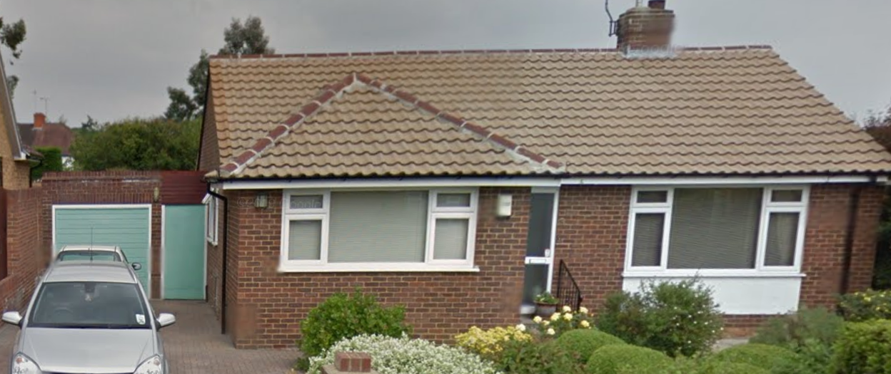
Google Photos

2. PROPOSAL AND SUPPORTING INFORMATION
The application proposes to demolish the existing detached garage (albeit the adjacent gate creates an attached link between the garage and the house) and build a single-storey side extension to the same overall width of the garage and gate, and extending forward and also to the rear. The front would be set back from the main front elevation of the house by .3m and would extend4.5m to the rear. The extension would include roof lanterns.

Plans considered dated May 2023
Site Block Plan received 05/07/2023
RDO/1/20/A/D1: Existing Plans received 05/07/2023
RDO/1/20/A/D2: Existing Elevations received 05/07/2023
RDO/1/20/D3/R4: Proposed Plan received 22/09/2023
RDO/1/20/D4/R4: Proposed Elevations 22/09/2023
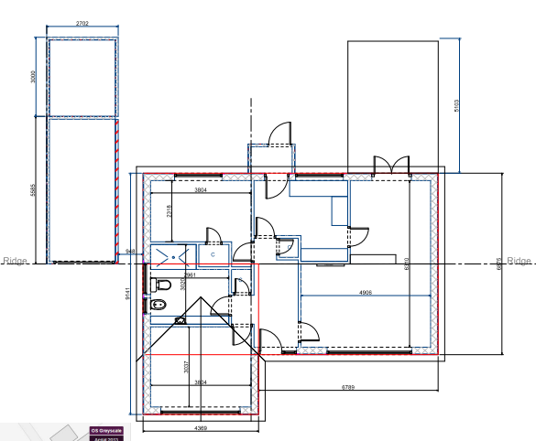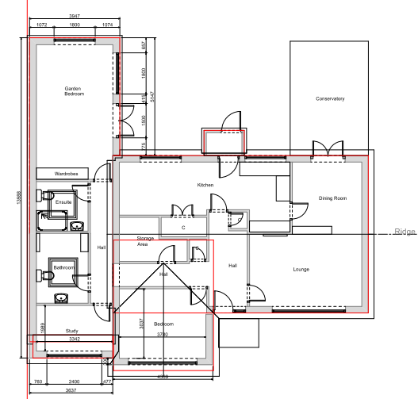
Existing Ground Floor Plan Proposed Ground Floor Plan

- RELEVANT PLANNING HISTORY

None

4. CONSULTATIONS

The following addresses were consulted by letter.

39 Woodcote Way, Caversham Heights, Reading, RG4 7HJ
6 Gurney Close, Caversham, Reading, RG4 7LE
41 Woodcote Way, Caversham, Reading, RG4 7HJ
43 Woodcote Way, Caversham, Reading, RG4 7HJ
10 Gurney Close, Caversham, Reading, RG4 7LE

No letters of representation have been received.

Equality Act 2010:
In determining this application the Council is required to have regard to its obligations under the Equality Act 2010. However, there is no indication or evidence (including from consultation on the application) that the protected groups identified by the Act have or will have different needs, experiences, issues and priorities in relation to this particular planning application. Therefore in terms of the key equalities protected characteristics it is considered there would be no significant adverse impacts as a result of the development.

- LEGAL AND PLANNING POLICY CONTEXT

Section 38(6) of the Planning and Compulsory Purchase Act 2004 requires that proposals be determined in accordance with the development plan unless material considerations indicate otherwise. Material considerations include relevant policies in the National Planning Policy framework (NPPF) - among them the 'presumption in favour of sustainable development'. The following local and national planning policy and guidance is relevant to this application:

National Policy
National Planning Policy Framework
National Planning Practice Guidance

Reading Borough Local Plan (2019)
CC7 (Design and the Public Realm)
CC8 (Safeguarding Amenity)
H9 (House Extensions and Ancillary Accommodation)

SPD
Design Guide to House Extensions 2021

6. APPRAISAL
Character and Appearance

Policy H9 states that an extension to a house will be acceptable where it respects the character of the house in terms of scale, location, materials and design and respects the character and pattern of neighbouring properties and the street as a whole in terms of scale, location, materials and design, and any important existing building line. Policy CC7 also sets out relevant considerations for design.

The proposed side extension would increase the footprint width of the existing dwelling by approximately 3.6m, and the extension would be for the full depth of the dwelling plus an additional xm beyond the rear wall of the existing house (i.e up to the extent of the footprint of the demolished garage). This side extension has been stepped back from the line of the principal elevation, on the advice of the LPA, to make the development more subservient to the existing dwelling. The roof is part gable at the front, with the ridge stepped down considerably from the ridge of the existing dwelling, and flat roofed behindthis.

The overall scale of the development and the combination of the above factors, make the proposal sympathetic and respectful of the character of the house and the street scene, in terms of location, materials and design.

Residential Amenity

Policy H9 states that an extension will be acceptable where it does not result in an overbearing impact on neighbours. Policy H10 seeks to ensure that the amenity of gardens and other outdoor areas are not compromised. Policy CC8 states an extension to a house will be acceptable where it will not cause a significant detrimental impact to the living environment of existing or new residential properties.

The walls of the side extension would be a .25m increase on the existing height (2.4m) of the garage. The limited height of the extension means it only adds minimally to the impact on the side windows on No 10.

The extension would therefore not create any additional impact on that already existing with the garage, on the neighbouring property on No 10, in terms of sunlight and daylight access. Also, the limited height would mean there would not be any overbearing effects, nor overlooking or loss of privacy.

- CONCLUSION
The proposed development has been assessed as set out above and is considered to be acceptable on that basis, subject to the following conditions.

8. RECOMMENDATION: Grant
Recommended Conditions:
AP1: Approved Plans
TL1: Time Limit Standards
M1: Materials to Match Existing

