

DELEGATED HOUSEHOLDER APPLICATION REPORT

Ward: Caversham
App Ref: 231017/HOU
Address: 90 Blenheim Road, Caversham, Reading, RG4 7RR
Proposals: Replacement single storey side extension
Case Officer: Chukwudi Onwudinanti
Applicant: Mr John McKeane
Date received (valid from): 21 July 2023
Target Decision date: 24 October 2023(ext)

- SITE DESCRIPTION
The site is a semi-detached two storey dwelling on the eastern side of Blenheim Road, within a predominantly residential area. The area is characterised by dwellings of same styled buildings on the opposite side of the road but of various styles on the same side as the proposal site.

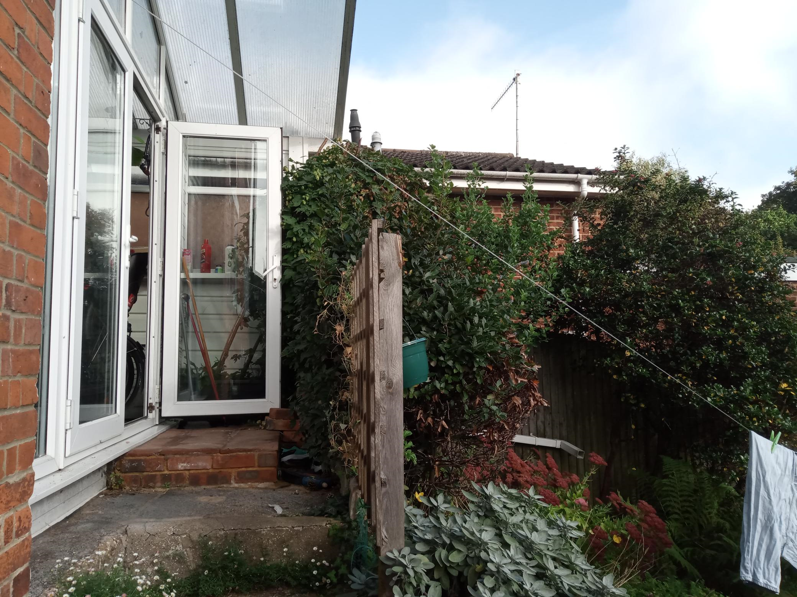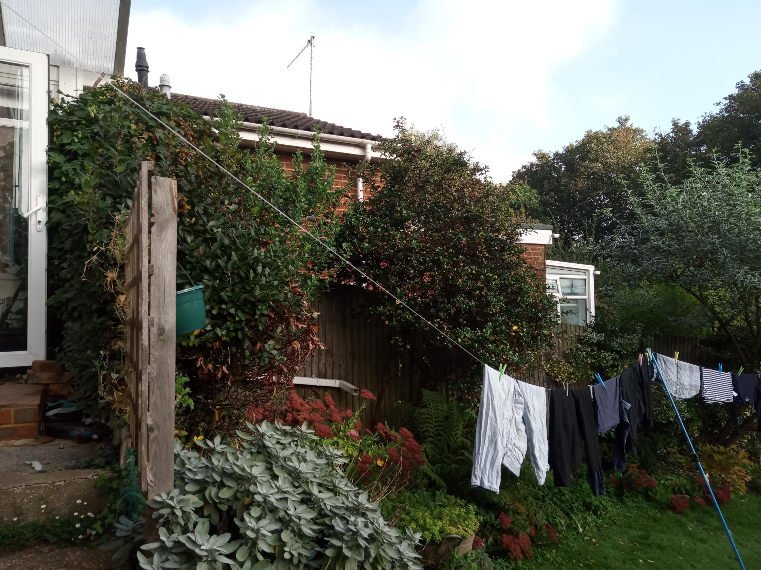

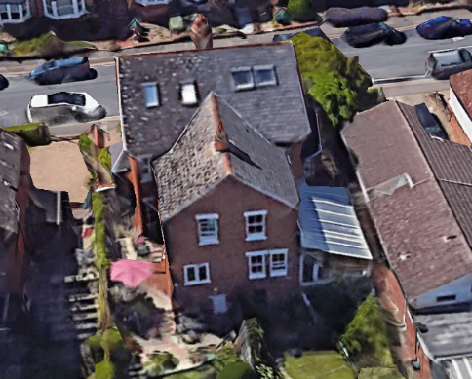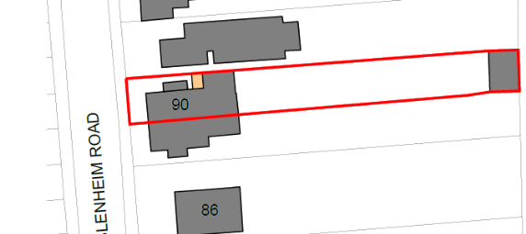
Proposed Block Plan

2. PROPOSAL AND SUPPORTING INFORMATION
Replacement of the existing side conservatory with a single storey side extension with an increased footprint of the permanent build to the side to create a dining room and study.

Plans considered dated March 2023 received 28/07/2023
Drawing No 23A013/PL12 Rev C: Proposed Elevations
Drawing No 23A013/PL11 Rev C: Proposed Floor Plan Ground and Roof
Drawing No 23A013/PL03: Existing Elevations
Drawing No 23A013/PL02 Rev A: Existing Floor Plan Ground and Roof
Drawing No 23A013/PL01 Rev A: Existing and Proposed Block Plan

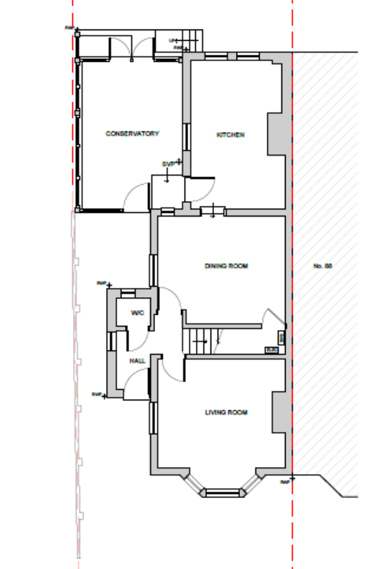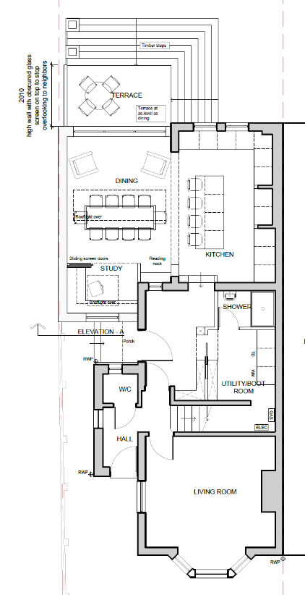
Existing Floor Plan Proposed Floor Plan

- RELEVANT PLANNING HISTORY
None

4. CONSULTATIONS

The following addresses were consulted by letter.

92 Blenheim Road, Caversham, Reading, RG4 7RR
88 Blenheim Road, Caversham, Reading, RG4 7RR

No letters of representation have been received.

Equality Act 2010:
In determining this application the Council is required to have regard to its obligations under the Equality Act 2010. However, there is no indication or evidence (including from consultation on the application) that the protected groups identified by the Act have or will have different needs, experiences, issues and priorities in relation to this particular planning application. Therefore in terms of the key equalities protected characteristics it is considered there would be no significant adverse impacts as a result of the development.

- LEGAL AND PLANNING POLICY CONTEXT

Section 38(6) of the Planning and Compulsory Purchase Act 2004 requires that proposals be determined in accordance with the development plan unless material considerations indicate otherwise. Material considerations include relevant policies in the National Planning Policy framework (NPPF) - among them the 'presumption in favour of sustainable development'. The following local and national planning policy and guidance is relevant to this application:

National Policy
National Planning Policy Framework
National Planning Practice Guidance

Reading Borough Local Plan (2019)
CC7 (Design and the Public Realm)
CC8 (Safeguarding Amenity)
H9 (House Extensions and Ancillary Accommodation)

SPD
Design Guide to House Extensions 2021

6. APPRAISAL
Character and Appearance

Policy H9 states that an extension to a house will be acceptable where it respects the character of the house in terms of scale, location, materials and design and respects the character and pattern of neighbouring properties and the street as a whole in terms of scale, location, materials and design, and any important existing building line. Policy CC7 also sets out relevant considerations for design.

All aspects of the extensions proposed in this application are to the side and rear and would make no significant impact on the size of the footprint of the existing dwelling. The impact on the street scene by the small side extension would be very limited.

The proposed material would match existing.

Residential Amenity

Policy H9 states that an extension will be acceptable where it does not result in an overbearing impact on neighbours. Policy H10 seeks to ensure that the amenity of gardens and other outdoor areas are not compromised. Policy CC8 states an extension to a house will be acceptable where it will not cause a significant detrimental impact to the living environment of existing or new residential properties.

The site is on a raised ground level, higher than the level on the neighbouring property on the side of the extension. There is an existing conservatory leading out to a small platform (ca 0.9m deep) with steps down to the garden level. A terrace is proposed which would extend 2.01m from the rear of the new single storey side extension with timber wrap-around steps down to the garden level. It is proposed that the terrace would have a wall with obscure glazed screen on top to a total height of 1.7m. The existing conservatory walls would be replaced by solid walls and the terrace would be increased to the rear by approximately 1.2m. It is therefore considered that the developments as proposed would not create any significant additional impacts in terms of overbearing effects and access to sunlight and daylight for the neighbouring properties.

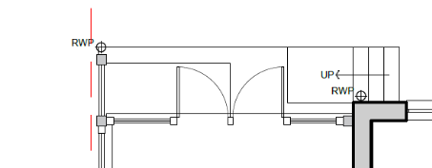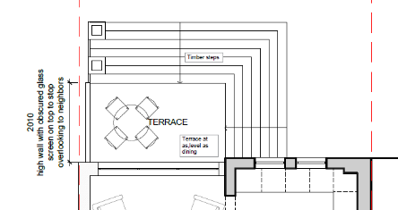
Existing rear platform and steps Proposed terrace with wraparound steps
down to the garden

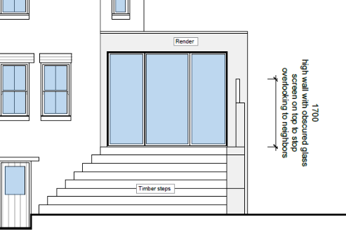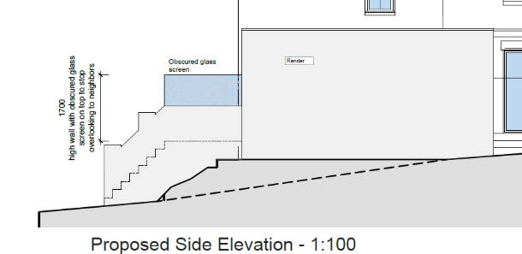
Proposed rear (extract)

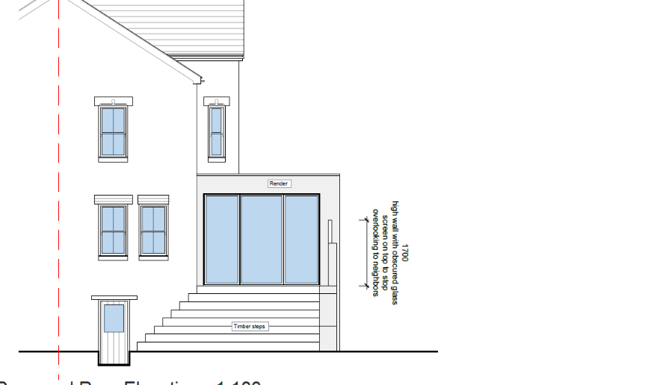

There are no side windows on the neighbouring property in direct line of sight the existing conservatory, the proposed extension to replace the conservatory, and the proposed extended deck. As demonstrated on site the elevated levels of the side steps proposed would not present any significant added overlooking impacts on the property at No 91as the effect diminishes with the descent of the steps towards the rear garden. As there is no significant increase in impact, it has been considered that the screen at the height of 1.7m will adequately mitigate any perception of overlooking. This screen is proposed to be obscured glazing.

- CONCLUSION
The proposed development has been assessed as set out above and is considered to be acceptable on that basis, subject to the following conditions.

8. RECOMMENDATION
Recommended Conditions:
Ap1: Approved Plans
TL1: Time Limit Standards
M1: Materials to Match Existing

