

DELEGATED HOUSEHOLDER APPLICATION REPORT

Ward: Park
App Ref: 231073/CLP
Address: 66 St Peters Road, Reading, RG6 1PH
Proposals: Hip to gable roof extension with rear dormer loft conversion, installation of new gable end window and front roof lights
Case Officer: Chukwudi Onwudinanti
Applicant: Mr and Mrs Miller
Date received (valid from): 31 July 2023
Target Decision date: 14 November 2023 (EXT)

INTRODUCTION
The application site is a semi-detached two storey property on the western side of St Peters Road in a predominantly residential area.

The application site is not a listed building nor located in a conservation area. It is not in an area subject to any Article 4 restrictions.

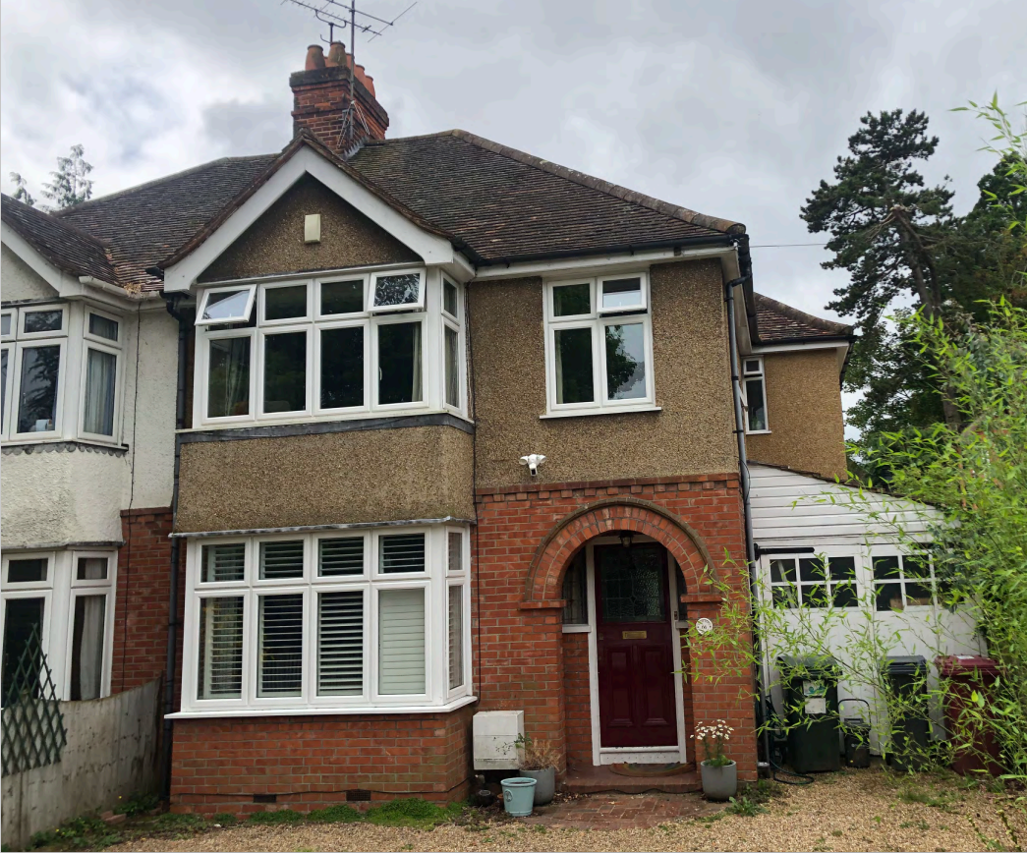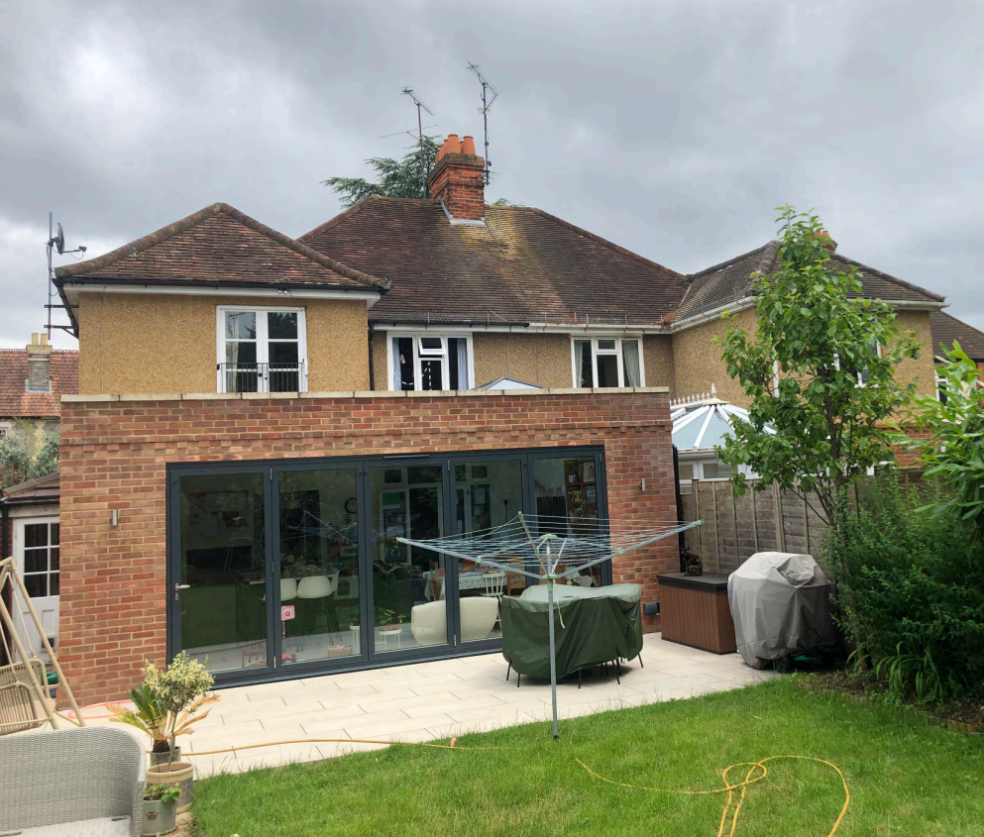

PROPOSAL AND SUPPORTING INFORMATION
This proposal is for a Certificate of Lawfulness for various works to the dwellinghouse. The proposals include:

- Hip to gable rear dormer loft conversion
- installation of new gable end window
- two front roof lights

Plans and Documents Considered dated 27/07/2023 received 31/07/2023
LR_23_66STPETERSRd_col_00: Site Location Plan
LR_23_66STPETERSRd_col_03 Rev B: Proposed Floor Plans
LR_23_66STPETERSRd_col_01 Rev B: Existing Floor Plans
LR_23_66STPETERSRd_col_04 Rev B: Proposed Elevations
LR_23_66STPETERSRd_col_02 Rev B: Existing Elevations
LR_23_66STPETERSRd_col_05 Rev B: Existing & Proposed Section A-A and Volume Calculations

RELEVANT PLANNING HISTORY
Application No: 170010
Proposal: Erect single storey rear extension following demolition of existing conservatory.
Decision: Permitted
Decision Date: 20/2/2017

Application NO: 231074/HOU
Proposal: Hip to gable rear dormer loft conversion, installation of new gable end window and front roof lights.
Decision: Pending

CONSULTATIONS
No consultations required for this type of application.

Equality Act 2010:
In determining this application the Council is required to have regard to its obligations under the Equality Act 2010. However, there is no indication or evidence (including from consultation on the application) that the protected groups identified by the Act have or will have different needs, experiences, issues and priorities in relation to this particular planning application. Therefore in terms of the key equalities protected characteristics it is considered there would be no significant adverse impacts as a result of the development.

Relevant Planning Policy and Guidance
National Planning Practice Guidance
The Town and Country Planning (General Permitted Development) (England) Order 2015 (GPDO)
Permitted development rights for householders – Technical Guidance September 2019

The proposal must be assessed to ensure it complies with the conditions of and Class A, Class B and Class C, Part 1, Schedule 2 of the Town and Country Planning (General Permitted Development) (England) Order 2015 (as amended).

ASSESSMENT UNDER CLASS A
A Certificate of Lawfulness for a Proposed Development has been submitted as the applicant considers the proposal falls within the permitted development rights of the property.

The proposal must be assessed to ensure that it complies with the conditions Class A, , which relates to ‘The enlargement, improvement or other alteration of a dwellinghouse’, Class B additions etc to the roof of a dwellinghouse’ and Class C ‘other alterations to the roof of a dwellinghouse’, Part 1, Schedule 2 of the Town and Country Planning (General Permitted Development) (England) Order 2015 (as amended.

A.1 Development is not permitted by Class A if:

A.1 (a) permission to use the dwellinghouse as a dwellinghouse has been granted only by virtue of Class M, N, P or Q of Part 3 of this Schedule (changes of use) Complies
A.1 (b) as a result of the works, the total area of ground covered by buildings within the curtilage of the dwellinghouse (other than the original dwellinghouse) would exceed 50% of the total area of the curtilage (excluding the ground area of the original dwellinghouse) Complies
A.1 (c) the height of the part of the dwellinghouse enlarged, improved or altered would exceed the height of the highest part of the roof of the existing dwellinghouse Complies
A.1 (d) the height of the eaves of the part of the dwellinghouse enlarged, improved or altered would exceed the height of the eaves of the existing dwellinghouse Complies –
A.1 (e) the enlarged part of the dwellinghouse would extend beyond a wall which (i) forms the principal elevation of the original dwellinghouse; or (ii) fronts a highway and forms a side elevation of the original dwellinghouse Complies
A.1 (f) subject to paragraph (g), the enlarged part of the dwellinghouse would have a single storey and – (i) extend beyond the rear wall of the original dwellinghouse by more than 4 metres in the case of a detached dwellinghouse, or 3 metres in the case of any other dwellinghouse, (ii) exceed 4 metres in height Complies
A.1 (g) for a dwellinghouse not on article 2(3) land nor on a site of special scientific interest, the enlarged part of the dwellinghouse would have a single storey and – (i) extend beyond the rear wall of the original dwellinghouse by more than 8 metres in the case of a detached dwellinghouse, or 6 metres in the case of any other dwellinghouse, or (ii) exceed 4 metres in height Complies
A.1 (h) the enlarged part of the dwellinghouse would have more than a single storey and – (i) extend beyond the rear wall of the original dwellinghouse by more than 3 metres, or (ii) be within 7 metres of any boundary of the curtilage of the dwellinghouse opposite the rear wall of the dwellinghouse N/A
A.1 (i) the enlarged part of the dwellinghouse would be within 2 metres of the boundary of the curtilage of the dwellinghouse, and the height of the eaves of the enlarged part would exceed 3 metres N/A
A.1 (j) the enlarged part of the dwellinghouse would extend beyond a wall forming a side elevation of the original dwellinghouse, and would – (i) exceed 4 metres in height, (ii) have more than a single storey, or (iii) have a width greater than half the width of the original dwellinghouse N/A
A.1 (k) it would consist of or include – (i) the construction or provision of a verandah, balcony or raised platform (ii) the installation, alteration or replacement of a microwave antenna, (iii) the installation, alteration or replacement of a chimney, flue or soil and vent pipe, or (iv) an alteration to any part of the roof of the dwellinghouse N/A
A.2 In the case of a dwellinghouse on article 2(3) land, development is not permitted by Class A if: N/A
A.2 (a) it would consist of or include the cladding of any part of the exterior of the dwellinghouse with stone, artificial stone, pebble dash, render, timber, plastic or tiles N/A
A.2 (b) the enlarged part of the dwellinghouse would extend beyond a wall forming a side elevation of the original dwellinghouse N/A
A.2 (c) the enlarged part of the dwellinghouse would have more than a single storey and extend beyond the rear wall of the original dwellinghouse N/A
CONDITIONS UNDER CLASS A
Development is permitted by Class A subject to the following conditions:

A.3 (a) the materials used in any exterior work (other than materials used in the construction of a conservatory) must be of a similar appearance to those used in the construction of the exterior of the dwellinghouse Complies, as per Drawing No LR_23_66STPETERSRd_col_04 Rev B: Proposed Elevations
A.3 (b) any upper-floor window located in a wall or roof slope forming a side elevation of the dwellinghouse must be (i) obscure-glazed, and (ii) non-opening unless the parts of the window which can be opened are more than 1.7 metres above the floor of the room in which the window is installed Complies as per Drawing No LR_23_66STPETERSRd_col_04 Rev B: Proposed Elevations

A.3 (c) where the enlarged part of the dwellinghouse has more than a single storey, or forms an upper storey on an existing enlargement of the original dwellinghouse, the roof pitch of the enlarged part must, so far as practicable, be the same as the roof pitch of the original dwellinghouse N/A

ASSESSMENT UNDER CLASS B
B.1 Development is not permitted by Class B if:
B.1 (a) permission to use the dwellinghouse as a dwellinghouse has been granted only by virtue of Class M, N, P or Q of Part 3 of this Schedule (changes of use); complies
B.1 (b) any part of the dwellinghouse would, as a result of the works, exceed the height of the highest part of the existing roof; complies
B.1 (c) any part of the dwellinghouse would, as a result of the works, extend beyond the plane of any existing roof slope which forms the principal elevation of the dwellinghouse and fronts a highway; complies
B.1 (d) the cubic content of the resulting roof space would exceed the cubic content of the original roof space by more than
(i) 40 cubic metres in the case of a terrace house:
(ii) 50 cubic metres in any other case
Complies, as the cubic content of the resulting roof space would exceed the cubic content of the original roof space by 48.8 cubic metres ( using the calculation for the volume of a roof dormer with H = 4.1m; Width = 7.0m; Depth = 3.3m)
B.1 (e) it would consist of or include (i) the construction or provision of a veranda, balcony or raised platform, complies or
(ii) the installation, alteration or replacement of a chimney, flue or soil and vent pipe; Complies
B.1 (f) the dwellinghouse is on article 2(3) land. N/AConditions
B.2 Development is permitted by Class B subject to the following conditions:
B.2 (a) the materials used in any exterior work must be of a similar appearance to those used in the construction of the exterior of the existing dwellinghouse; complies, as stated above

B.2 (b) the enlargement must be constructed so that (i) other than in the case of a hip-to-gable enlargement or an enlargement which joins the original roof to the roof of a rear or side extension (aa) the eaves of the original roof are maintained or reinstated; N/A as a hip-to gable enlargement and (bb) the edge of the enlargement closest to the eaves of the original roof is, so far as practicable, not less than 0.2 metres from the eaves, measured along the roof slope from the outside edge of the eaves; complies and (ii) other than in the case of an enlargement which joins the original roof to the roof of a rear or side extension, no part of the enlargement extends beyond the outside face of any external wall of the original dwellinghouse; complies and
B.2 (c) any window inserted on a wall or roof slope forming a side elevation of the dwellinghouse must be (i) obscure-glazed, complies and (ii) non-opening unless the parts of the window which can be opened are more than 1.7 metres above the floor of the room in which the window is installed, N/A / complies
C.1 Development is not permitted by Class C if:
C.1 (a) permission to use the dwellinghouse as a dwellinghouse has been granted only by virtue of Class M, N, P or Q of Part 3 of this Schedule (changes of use); complies
C.1 (b) the alteration would protrude more than 0.15 metres beyond the plane of the slope of the original roof when measured from the perpendicular with the external surface of the original roof; complies (front rooflights are 0.10m)
C.1 (c) it would result in the highest part of the alteration being higher than the highest part of the original roof; complies or
C.1 (d) it would consist of or include (i) the installation, alteration, or replacement of a chimney, flue or soil and vent pipe, complies or (ii) the installation, alteration or replacement of solar photovoltaics or solar thermal equipment, N/A / complies
Conditions
C.2 Development is permitted by Class C subject to the condition that any window located on a roof slope forming a side elevation of the dwellinghouse must be:
C.2 (a) obscure-glazed; N/A and
C.2 (b) non-opening unless the parts of the window which can be opened are more than 1.7 metres above the floor of the room in which the window is installed, N/A
OVERALL RECOMMENDATION
Sufficient evidence has been provided to demonstrate that a Certificate of Lawfulness should be granted for the proposed hip to gable roof extension and rear dormer loft conversion, installation of new gable end window and two front roof lights.

The proposal has been assessed against the Town and Country Planning Act 1990 (as amended) and Class A, Class B and Class C, Part 1, Schedule 2 of the Town and Country Planning (General Permitted Development) (England) Order 2015 (as amended). It can be confirmed that the proposed operations would be lawful for planning purposes on the basis of the following:
LR_23_66STPETERSRd_col_00: Site Location Plan
LR_23_66STPETERSRd_col_03 Rev B: Proposed Floor Plans
LR_23_66STPETERSRd_col_01 Rev B: Existing Floor Plans
LR_23_66STPETERSRd_col_04 Rev B: Proposed Elevations
LR_23_66STPETERSRd_col_02 Rev B: Existing Elevations
LR_23_66STPETERSRd_col_05 Rev B: Existing & Proposed Section A-A and Volume Calculations

Therefore the Local Planning Authority can issue the applicant with a Certificate of Lawfulness for the proposed development.
Informatives
Building Regulations
Construction and Demolition
Encroachment and Party Wall Act

