January 2023 Bellway Homes Limited (Thames Valley)
Open Space Statement
Former Dee Road Fire Station, Reading

January 2023

Contents
1. Introduction 1
2. Planning Policy Background 2
3. Proposed Development Open Space Considerations 3
4. Conclusion 5

- Introduction

  - This Open Space Statement has been prepared on behalf of Bellway Homes Limited (Thames Valley) and supports a planning application for the development of 54 homes, at the former Royal Berkshire Fire & Rescue Station, Dee Road, Reading (“the site”).
  - The proposed development comprises:
Redevelopment of former fire station to provide 54 dwellings, including affordable housing, together with associated access, parking and landscaping.

  - The purpose of this statement is to identify and consider open space provision associated with the proposed development and updates the Statement provided with the original planning submission, dated July 2022 . This statement has been written with regard to the Reading Borough Local Plan (2019).

- Planning Policy Background

  - Section 38(6) of the Planning and Compulsory Purchase Act 2004 provides that all planning decisions must be made in accordance with the Development Plan unless material considerations indicate otherwise. In this particular case the Development Plan comprises the adopted Reading Borough Local Plan and accompanying Proposals Map (November 2019). Other material considerations include guidance contained within the National Planning Policy Framework (‘the NPPF’), updated in July 2021.
  - The following Reading Local Plan policies are relevant to the consideration of public open space provision for the proposed development:
- Policy EN7: Local Green Space and Public Open Space
- Policy EN9: Provision of Open Space.

  - Policy EN7 confirms the areas of Local Green Space and Public Open Space in the Borough and confirms these areas will be protected from development.
  - Policy EN9 requires new development to make provision for appropriate open space based on the needs to the development, which can be achieved through on or off-site provision, contribution toward provision or improvement of existing leisure or recreational facilities. The policy confirms that on sites of 50 or more dwellings, new provision will be sought where the availability and quality of existing open space has been identified as deficient.
  - An Open Spaces Strategy for Reading was published in March 2007 and was amended by an Update Note in January 2018. The key objectives of the Open Spaces Strategy is to:
- ‘Safeguard Reading’s environmental endowment
- Ensure that there is no net loss of recreational POS
- Secure additional open space where opportunities arise.’

  - The Strategy confirms that the amount of open space in Reading is adequate, but there are issues in regard to access, quality and green links to existing public open space.
  - NPPF Paragraph 98 states that access to a network of high quality open spaces is important for the health and well-being of communities and can deliver wider benefits for the nature and support efforts to address climate change.

- Proposed Development Open Space Considerations

  - The proposed development originally submitted proposed 63 dwellings and incorporated areas of public open space adjacent to Spey Road and Dee Road.
  - Comments from Reading Borough Council were received which requested a reduction in the number of dwellings and increase in the quantum of public open space within the development.
  - The application plans have been revised to respond to the Council’s comments, reducing the number of dwellings to 54 and significantly increasing the amount of public open space on the western edge of the site, fronting onto Spey Road.
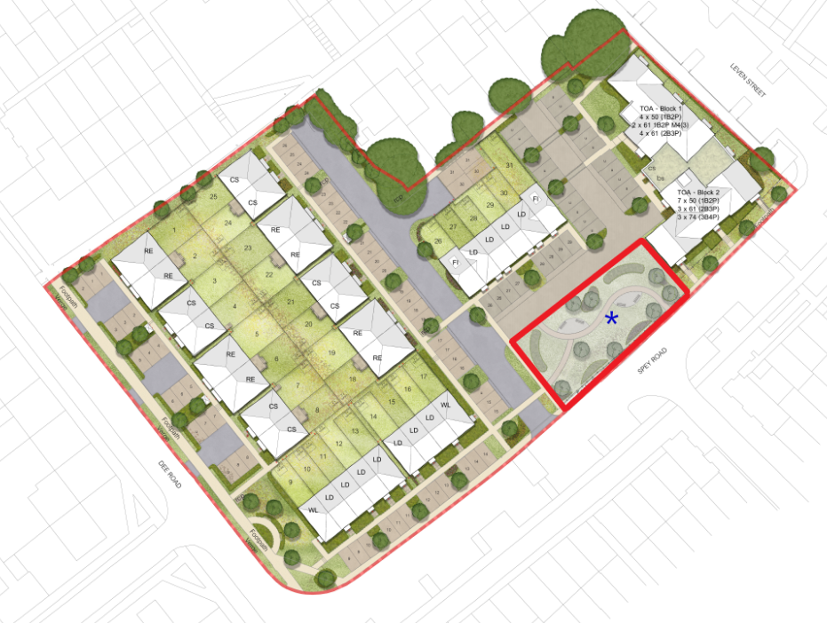

Figure 1: Proposed Site Layout showing Increased Open Amenity Space fronting Spey Road

  - The public open space provision is in the form of a formal garden which will be accessible to future occupiers of the proposed development and existing residents in the area.
  - The on-site public open space provision is considered to be suitable based on the scale of development proposed and would comply with Local Plan Policies EN7 and EN9 and Reading Borough Council’s Open Space Strategy.
Section 106 Agreement

  - In accordance with Reading Borough Council Planning Obligations under Section 106 Supplementary Planning Document, the delivery of the Open Space and its future ongoing maintenance under a Management Company can be secured.

- Conclusion

  - The statement has identified that the proposed development provides adequate and accessible on-site public open space provision for use by future occupiers of the development and existing residents in the vicinity of the site.
  - The delivery of the open space and its future management by a Management Company can be secured via a Section 106 Agreement pursuant to any planning permission.
  - It is considered that the proposed on-site provision of open space would meet the requirement of the Local Plan in this regard.

 | James Walker | Tom Ryan
 | Associate | Planner
 | +44 (0) 1189 520 511  +44 (0) 7929 661 123  James.o.walker@savills.com | +44 (0) 1189 520 504  +44 (0) 7870 999 306  Tom.ryan@savills.com

