

DELEGATED HOUSEHOLDER APPLICATION REPORT

Ward: Redlands
App Ref: 220668/HOU & 220669/LBC
Address: 30 Eldon Road, Reading, RG1 4DL
Proposals: Enclosure of existing rear parking bays with new gates
Case Officer: Chukwudi Onwudinanti
Applicant: Mr Pascal Felix
Date received (valid from): 6 May 2022
Target Decision date: 28 January 2023

1. SITE DESCRIPTION

The application site is a Grade II Listed neoclassical semi-attached property located on Eldon Road backing onto Eldon Place at the rear with vehicular access to the site. The property is located within the Eldon Road conservation area. The rear of 30 Eldon Road is located opposite the front of 26 Eldon Place.

The description of the site extracted from the Heritage Statement by M. D. Howlett states:

Nos.28 and 30 are listed Grade II for their special architectural or historical interest, and the appraisal of the building by Historic England observes that they were probably designed by Henry or Nathaniel Brunt, and finished in Bath stone ashlar “with hipped slate roofing and 2 central chimneys”. Apart from the flat eaves, all of the principal architectural features that contributed to the listing occur on its exterior at the front, namely:-

“Flat eaves, obscured in front by wide break with coved cornice in which are 2 small attic windows with marginal glazing; gulloche panels below, 2 ranges of glazing bar sash windows, triparte arch-headed on ground floor with stone balcony and cast-iron rails. Band over ground floor. Ground floor of break channelled. Recessed round-headed porches on either side. Front garden walls project and have Eldon Square-type piers; polygonal with crested capping.” (Website: Historic England)

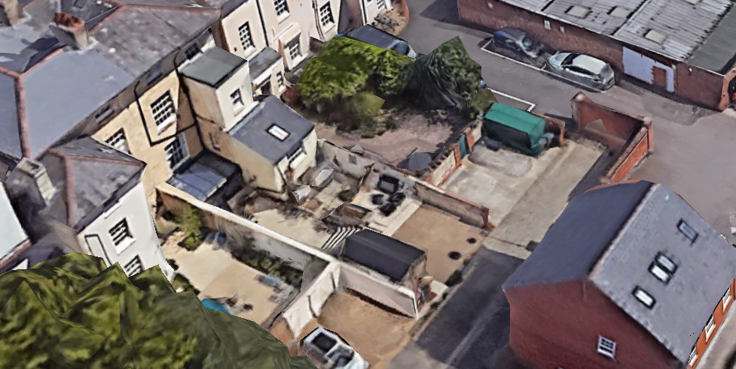

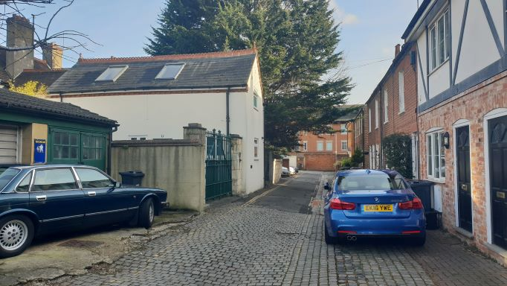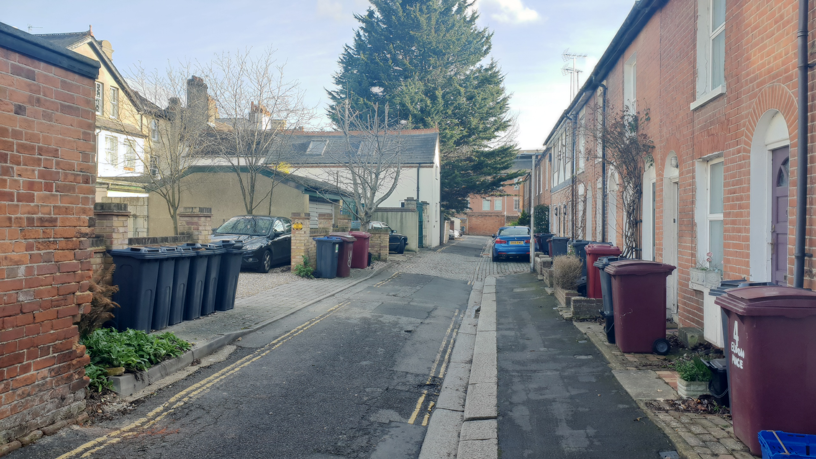

2. PROPOSAL AND SUPPORTING INFORMATION
Enclosure of existing rear parking bays with new side collapsible gates of height 1.35m.

Plans considered
Location Plan
Proposed Block Plan dated February 2020 and received 6th May 2022
Floor Plans dated January 2022 and received 6th May 2022

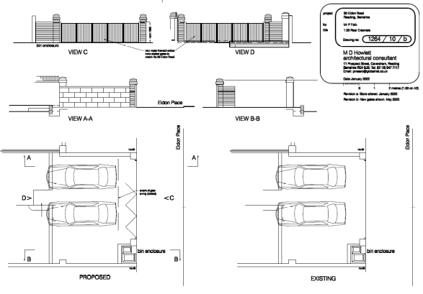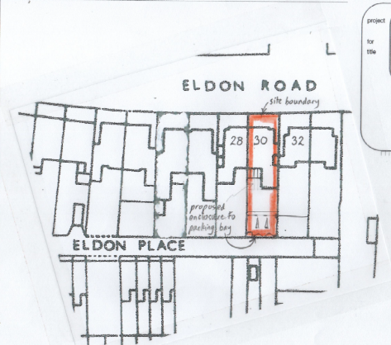
Existing and Proposed Plans and Elevations Proposed Block Plan

- RELEVANT PLANNING HISTORY

Application Ref: 220050/FUL
Application Description: Extension and part enclosure of existing rear parking bays and formation of partial bin enclosure
Decision: Permitted
Decision Date: 28th March 2022

Application Ref: 220051/LBC
Application Description: Extension and part enclosure of existing rear parking bays and formation of partial bin enclosure
Decision: Consented
Decision Date: 30th March 2022

4. CONSULTATIONS

The following addresses were consulted by letter.

Flat 3, 28 Eldon Road, Reading, RG1 4DL
Flat 2, 28 Eldon Road, Reading, RG1 4DL
Flat 1, 28 Eldon Road, Reading, RG1 4DL
32 Eldon Road, Reading, RG1 4DL
26 Eldon Place, Reading, RG1 4ED

Letter of representation have been received in support of the application from No 26.

Comment Type: Support
Comment: Now that the original cross wall has been removed, the installation of the proposed gates would restore privacy between our two properties at ground floor level. Mr Felix has discussed with us the revised height and design of the gates. We would support the application.”

Previous Transport Comments (Application No 220050)
“Transport and access
The proposed gates were considered a danger to road pedestrians and other users and the access should conform to Highway specification. It is required that any gates should be set back by a minimum of 5m from the carriageway edge to ensure that vehicles do not obstruct the highway. Eldon Place is a narrow lane with limited pavement, the is at the end of the lane with limited room for manoeuvre. Amended plans removed the proposed gates from the householder application 220050, this has addressed prior concerns and is considered acceptable in relation to TR3 Access Traffic and highway related matters and TR5 Car and Cycle Parking and electric vehicle charging.”

Current Transport Comments
“This application proposes to introduce low level folding gates (1.35m) along the boundary line at the rear of the property fronting Eldon Place. Given location of the site at the end of a cul de sac, there would be little scope for a car waiting to enter or exit the site creating an obstruction. Taking this in to consideration, in this instance only Transport can accept the proposal.”

Heritage Comments.
“There are no objections to the revised scheme to lower the height of the proposed gates. The proposed scheme is considered to have a neutral impact of the adjacent listed building and the conservation area in which it is located.
As such it is recommended for Approval, subject to confirmation of the colour of the fence being either dark green or black.

Reason: The proposed works will not harm the character and setting of the listed building or the conservation area as defined in Section 16 of the NPPF. Also, it is considered to comply with Section 16(2) and Section 72 (1) of the Planning (Listed Buildings and Conservation Areas) Act 1990, as well as Council’s Local Plan policies: EN1, EN3, EN4

Equality Act 2010:
In determining this application the Council is required to have regard to its obligations under the Equality Act 2010. However, there is no indication or evidence (including from consultation on the application) that the protected groups identified by the Act have or will have different needs, experiences, issues and priorities in relation to this particular planning application. Therefore in terms of the key equalities protected characteristics it is considered there would be no significant adverse impacts as a result of the development.

- LEGAL AND PLANNING POLICY CONTEXT

Section 38(6) of the Planning and Compulsory Purchase Act 2004 requires that proposals be determined in accordance with the development plan unless material considerations indicate otherwise. Material considerations include relevant policies in the National Planning Policy framework (NPPF) - among them the 'presumption in favour of sustainable development'. The following local and national planning policy and guidance is relevant to this application:

Section 16(2) of the Planning (Listed Buildings and Conservation Areas) Act 1990 requires the local planning authority to have special regard to the desirability of preserving a listed building or its setting or any features of special interest which it possesses.

Section 72 (1) of the Planning (Listed Buildings and Conservation Areas) Act 1990 requires the local planning authority in the exercise of its functions to pay special attention to the desirability of preserving or enhancing the character or appearance of a conservation area.

Planning (Listed Buildings and Conservation Areas) Act 1990
- Grade II, Listed Building in a Conservation Area.
- Section 16(2) requires the local planning authority to have special regard to the desirability of preserving the listed building or its setting or any features of special interest which it possesses.
- Section 72 (1) requires the local planning authority in the exercise of its functions to pay special attention to the desirability of preserving or enhancing the character or appearance of a conservation area.

National Planning Policy and Guidance
- National Planning Policy Framework (NPPF) - Section 16
- National Planning Practice Guidance

Reading Borough Council – Local Plan 2019
• Conservation Area: Castle Street/Russell Street/Oxford Road
• Policy EN1: Protection and Enhancement of the Historic Environment
• Policy EN3: Enhancement of Conservation Areas
• Policy EN4: Locally Important Heritage Assets
• Policy EN6: New Development in a Historic Context

Other guidance
• Historic England Good Practice Guide Note Number 2: managing significance in decision-taking.
• Principles of Conservation (Historic England, 2008)
• Guide to the Conservation of Historic Buildings
(British Standards Publication BS 7913:2013, 2015)

Relevance of NPPF in assessing application
https://www.gov.uk/guidance/conserving-and-enhancing-the-historic-environment

Where changes are proposed, the National Planning Policy Framework sets out a clear framework for both plan-making and decision-making in respect of applications for planning permission and listed building consent to ensure that heritage assets are conserved, and where appropriate enhanced, in a manner that is consistent with their significance and thereby achieving sustainable development.

6. APPRAISAL

- Principle of Development
The principle of improvements and repairs to a listed building are acceptable in principle in accordance with Policy EN1 and Section 16 of the NPPF, subject to the works protecting and where possible enhancing the significance of the Listed Building including its setting, the historic character and local distinctiveness of the area in which it is located and will not have an adverse impact on those elements which contribute to their special architectural or historic interest.

- Effect on Heritage Asset

In assessing this application, it is noted that the application seeks to introduce new elements to the conservation area, and alters the setting of the listed building. However, the proposed works do not seek to alter the character or the architectural distinctiveness of the listed building or any of its listed elements. The setting is not unduly harmed with the proposed good quality boundary treatment on the historic boundary line.

In previous applications (220050 and 220051), these gates were not permitted owing to their height and appearance. However, in this current application, the height has been reduced to 1.35m, making it less visible above the fence line. It is also considered prudent to attach a condition of painting the gate in dark colours, as advised by the Heritage Consultant, to reduce its effect on the public realm and the settings of the conservation area. These viewpoints have been supported by both the Transport and Highways Consultees and The heritage Consultant.

Highway Safety
The proposal seeks to enclose the rear of the property with a folding gate. The gate will be of a design that will not swing onto the road, so will not present any impediments on the road or alter the use of the road to an unacceptable degree.

- CONCLUSION
Therefore, it is considered that these works, if carried out as now proposed, with the conditions attached, would not be of significant impact to the features of this listed building and its setting, subject to other appropriate conditions for Listed Building Consent and Full Approval.

8. RECOMMENDATION: Give Consent and Permission
Recommended Conditions for Permission:
AP1: Approved Drawings
TL1: Time Limit Standard

Recommended Conditions for Consent:
LB1: TIME LIMIT LISTED BUILDING (WORKS)
LB2: LISTED BUILDING (WORKS SPECIFICATION)
MLB2: LISTED BUILDINGS MATERIALS (TO BE APPROVED)

