

DELEGATED HOUSEHOLDER APPLICATION REPORT

Ward: Redlands
App Ref: 231035/HOU
Address: 20 Lancaster Close, Reading, RG1 5HB
Proposals: Proposed garage conversion , fenestration changes at ground floor and first floor ensuite and changes to existing driveway.
Case Officer: Chukwudi Onwudinanti
Applicant: Mr Rajiv Kumar Varma
Date received (valid from): 24 July 2023
Target Decision date: 23 November 2023 (EXT)

- SITE DESCRIPTION
The site is a two storey detached dwelling on the southern side of Lancaster Close, on the intersection with Whitby Drive. The area is characterised by dwellings of various styles and sizes, a mix of two storey detached dwellings and bungalows, in a predominantly residential area with a lot of trees and vegetation cover. The area is between The Mount Conservation Area and Christchurch Conservation Area. The tree within the site to the front is subject to a TPO.

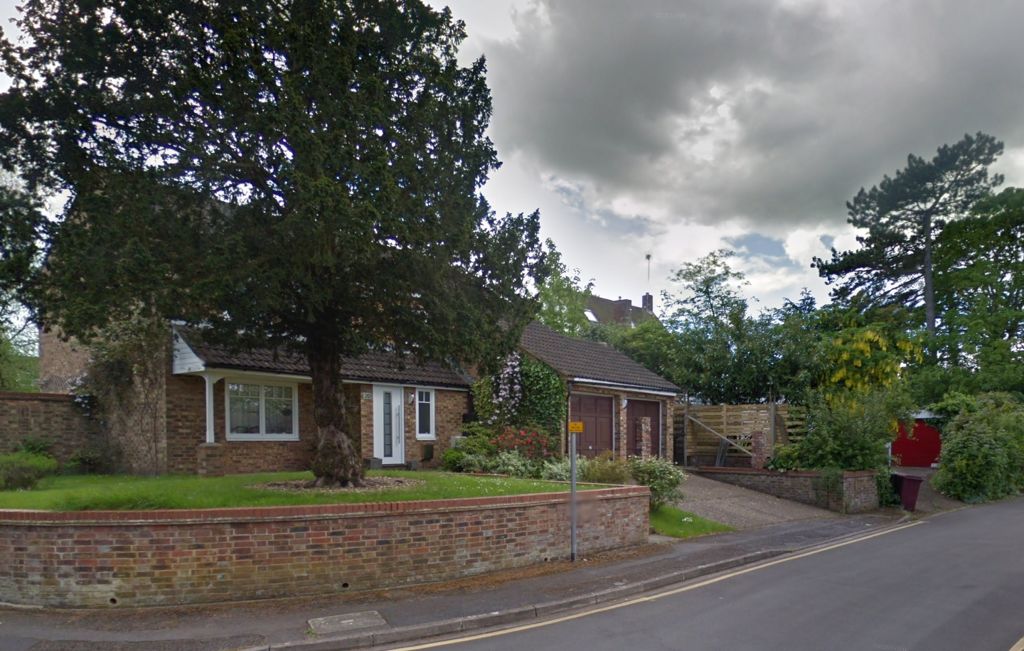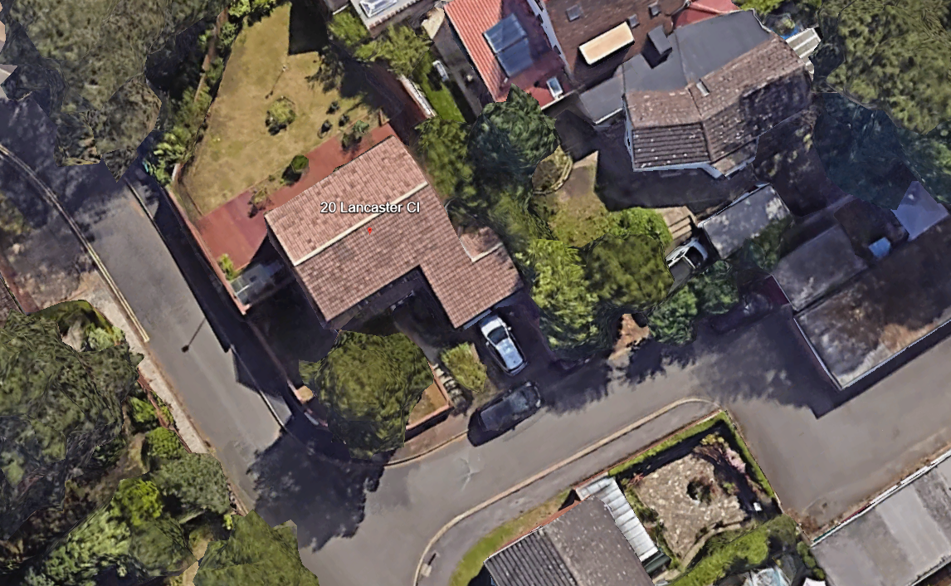
Google Photos
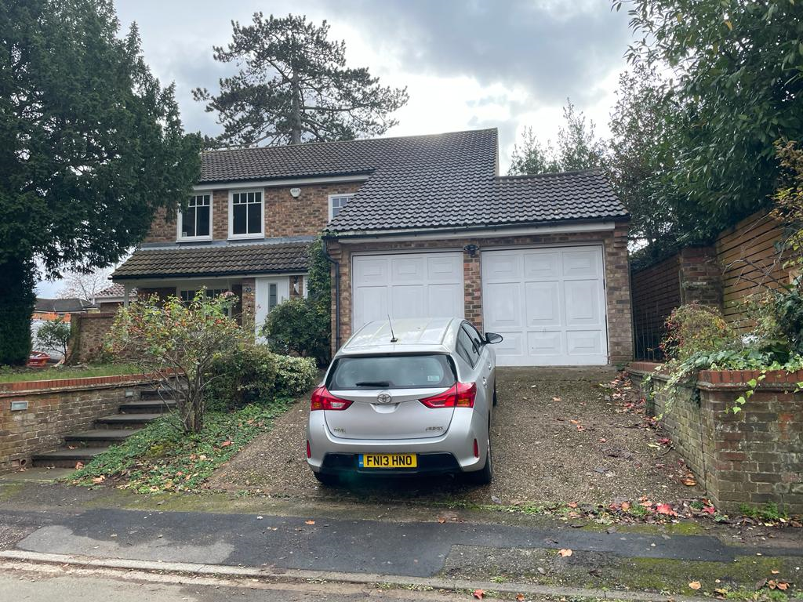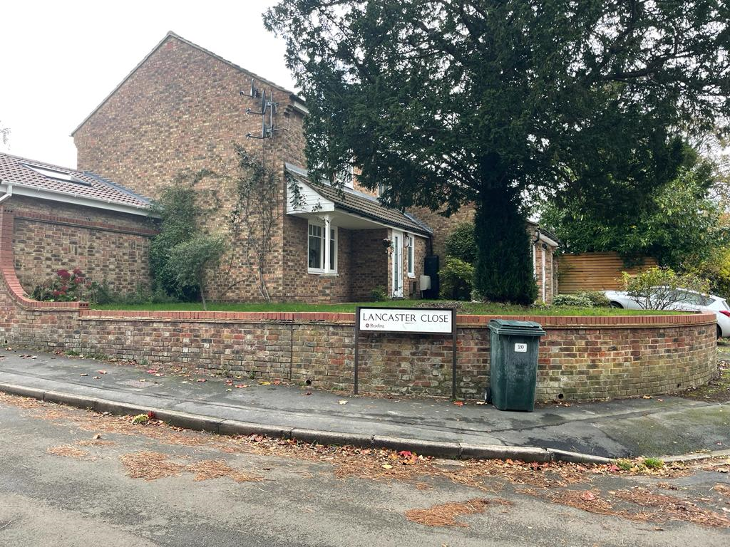
Site photos

2. PROPOSAL AND SUPPORTING INFORMATION
The proposal is to convert the garage into an ensuite bedroom with storage. The sloping drive would be levelled and there would be a new pair of retaining walls on both sides of the new bedroom. There would be two front facing windows in place of the garage doors, a front facing obscure glazed window on the first floor and safety guard rail at the level of the front door.

Plans considered received 25/07/2023
Location Plan dated 24/07/2023
Drawing No PP-102: Existing Floor and Roof Plans dated 07/07/2023
Drawing No PP-103: Existing Elevations dated 07/07/2023
Drawing No PP-101: Site Location/ Block Plan dated 07/07/2023
Drawing No PP-104: Proposed Floor and Roof Plans dated 07/07/2023
Drawing No PP-105: Proposed Elevations dated 07/07/2023

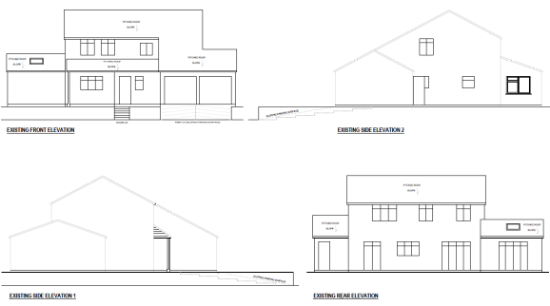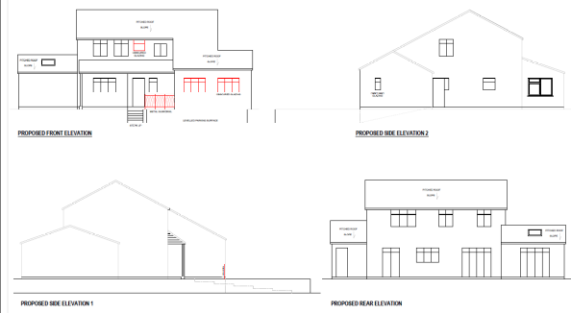
Existing Elevations Proposed Elevations

- RELEVANT PLANNING HISTORY
Application Ref: 220292
Description: Single storey side and rear extension
Outcome: Application Permitted
Decision Date: 14/6/2022

4. CONSULTATIONS
The following addresses were consulted by letter.

1 Whitby Drive, Reading, Berkshire, RG1 5HW
19 Lancaster Close, Reading, RG1 5HB
The Cottage, White Gables, Sutherlands Avenue, Reading, RG2 7AS
White Gables, Sutherland Avenue, Reading, RG2 7AS

No letters of representation have been received.

Transport Comments
The loss of the double garage will result in the loss of parking. Submitted proposed ground floor plan illustrates parking within the curtilage of the site which is in accordance with Councils current parking standards.

There are no Transport objections to this application, subject to condition:

DC1 VEHICLE PARKING (AS SPECIFIED)

Natural Environment Comments

I’ve now looked at the proposals and can confirm that I’ve no objections subject to the condition (L7) you suggested – this would primarily be to ensure protection of the TPO Yew on the frontage from any construction related activity.
I note that in terms of ground works, this is limited to levelling the currently ramped driveway. As I would not expect the roots of the Yew to extend into here due to the ground conditions and retaining wall, this is acceptable.

Equality Act 2010:
In determining this application the Council is required to have regard to its obligations under the Equality Act 2010. However, there is no indication or evidence (including from consultation on the application) that the protected groups identified by the Act have or will have different needs, experiences, issues and priorities in relation to this particular planning application. Therefore in terms of the key equalities protected characteristics it is considered there would be no significant adverse impacts as a result of the development.

- LEGAL AND PLANNING POLICY CONTEXT
Section 38(6) of the Planning and Compulsory Purchase Act 2004 requires that proposals be determined in accordance with the development plan unless material considerations indicate otherwise. Material considerations include relevant policies in the National Planning Policy framework (NPPF) - among them the 'presumption in favour of sustainable development'. The following local and national planning policy and guidance is relevant to this application:

National Policy
National Planning Policy Framework
National Planning Practice Guidance

Reading Borough Local Plan (2019)
CC7 (Design and the Public Realm)
CC8 (Safeguarding Amenity)
H9 (House Extensions and Ancillary Accommodation)
TR3 (Access Traffic and Highway-related Matters)
TR5 (Car and Cycle Parking)
EN14 (Trees, Hedges and Woodlands)

SPD
Design Guide to House Extensions 2021
Revised Parking Standards and Design SPD 2011

6. APPRAISAL
Character and Appearance

Policy H9 states that an extension to a house will be acceptable where it respects the character of the house in terms of scale, location, materials and design and respects the character and pattern of neighbouring properties and the street as a whole in terms of scale, location, materials and design, and any important existing building line.

Policy CC7 of the Reading Borough Local Plan requires all development to be of high quality design and maintain and enhance the character and appearance of the surrounding area. In this specific case, this concerns the following components:

- Layout
- Landscape
- Architectural detail and material

The proposal seeks to convert the existing garage into an ensuite bedroom, with attached storage. This conversion would be achieved largely by internal changes and modifications and would not increase the footprint of the dwelling.

Also to be added by this proposal are two windows on the ground floor to replace the garage doors and an obscure glaze bathroom window on the first floor, all on the Principal Elevation.

The existing sloped driveway would be made flat and retaining walls erected on both sides of the new three car parking space to be created. A ramp is to be developed on the side of the property, on the boundary with No 1a Whitby Drive. A metal guardrail is to be installed on the raised terrace in front of the dwelling. Materials used externally to make good any fillings after the insertion of the windows are to match existing materials on the dwelling.

As highlighted above, the proposed development would not change the footprint of the existing dwelling and the changes to be made to the driveway would not create any new visually dominant features, and the new retaining walls would not be of heights that would bring any new dominant features who would detrimentally affect the street scene.

Regarding the materials, the areas to be made good are to match existing materials on the dwelling. This would be ensured by conditions in the interest of visual amenity and ensuring that the change in fenestration responds positively to the local context and character in accordance with Policies CC7 and H9 of the Reading Borough Local Plan 2019.

The addition of windows and change of fenestration to the front façade would alter the appearance of the dwelling, however as these alterations are not considerably extensive and as the dwelling is a detached dwelling with dwellings of various styles on all sides of the dwelling, these changes would not be such that they would significantly alter the character and pattern of the street and the dwellings on the street.

Overall, the proposed development is considered in accordance with Policies H9 and CC7 of the Reading Borough Local Plan. The proposed development is considered to respect the character and appearance of 20 Lancaster Close and the surrounding area. The proposed development is also not considered harmful to the character and appearance of the nearby Conservation Areas due to the scale of the proposed development.

Residential Amenity

Policy H9 states that an extension will be acceptable where it does not result in an overbearing impact on neighbours. Policy H10 seeks to ensure that the amenity of gardens and other outdoor areas are not compromised. Policy CC8 states an extension to a house will be acceptable where it will not cause a significant detrimental impact to the living environment of existing or new residential properties.

In their response to consultation on this proposal, Transport has stated that the three car space provided within the proposal would be adequate to counter the loss of the garages in the existing dwelling. There are no new side windows to be created and there are no new walls to be erected externally, apart from the retaining walls that would not exceed the ground levels.

It is therefore considered that no aspect of this proposal would create adverse amenity issues in terms of privacy and overlooking, overbearing effects, and loss of sunlight and daylight hitherto accessible to neighbouring properties.

Trees
Policy EN14 states that: Individual trees, groups of trees, hedges and woodlands will be protected from damage or removal where they are of importance, and Reading’s vegetation cover will be extended. The quality of waterside vegetation will be maintained or enhanced.

There is a TPO tree within the site of this proposal. There is no aspect of this proposal that would be within close proximity of this tree, however condition would be attached in the decisionnotice to ensure that the development process would not have any adverse impact on this tree or any trees within close proximity. This position is supported by the Natural Environment Consultee advice.

- CONCLUSION
The proposed development has been assessed as set out above and is considered to be acceptable on that basis, subject to the following conditions.

8. RECOMMENDATION: Grant
Recommended Conditions:
TL1: Time Limit (Standard)
AP1: Approved Plans
M1: Materials (To Match)

Standard Informative
I15 Advice about TPO.d trees and trees in Conservation Areas
You are advised that no tree works are approved by virtue of this consent. Any works to trees subject to a Tree Preservation Order will require submission of a tree works application.

