

DELEGATED HOUSEHOLDER APPLICATION REPORT

Ward: Church
App Ref: 230735/HOU
Address: 82 Kingsbridge Road, Reading, RG2 7RQ
Proposals: Proposed part-two part-single storey rear and side extensions with loft conversion and rear dormer extension.
Case Officer: Chukwudi Onwudinanti
Applicant: Mr F Otoo
Date received (valid from): 28 May 2023
Target Decision date: 20 December 2023(EXT)

1. SITE DESCRIPTION
The site is a semi-detached two storey dwelling on the west side of Kingsbridge Road, close to the Brixham Road junction. The area is predominantly residential with a mix of buildings of similar styles and size and terraced dwellings on both sides of the road

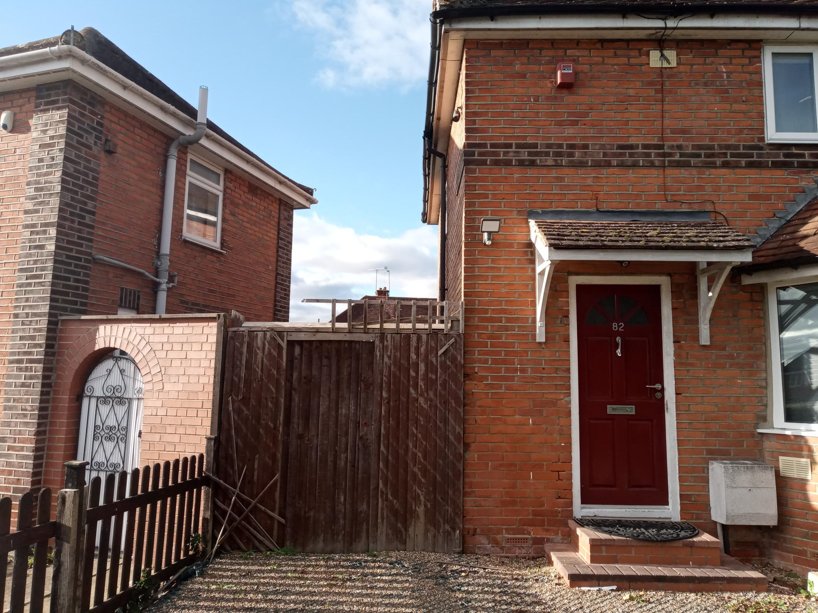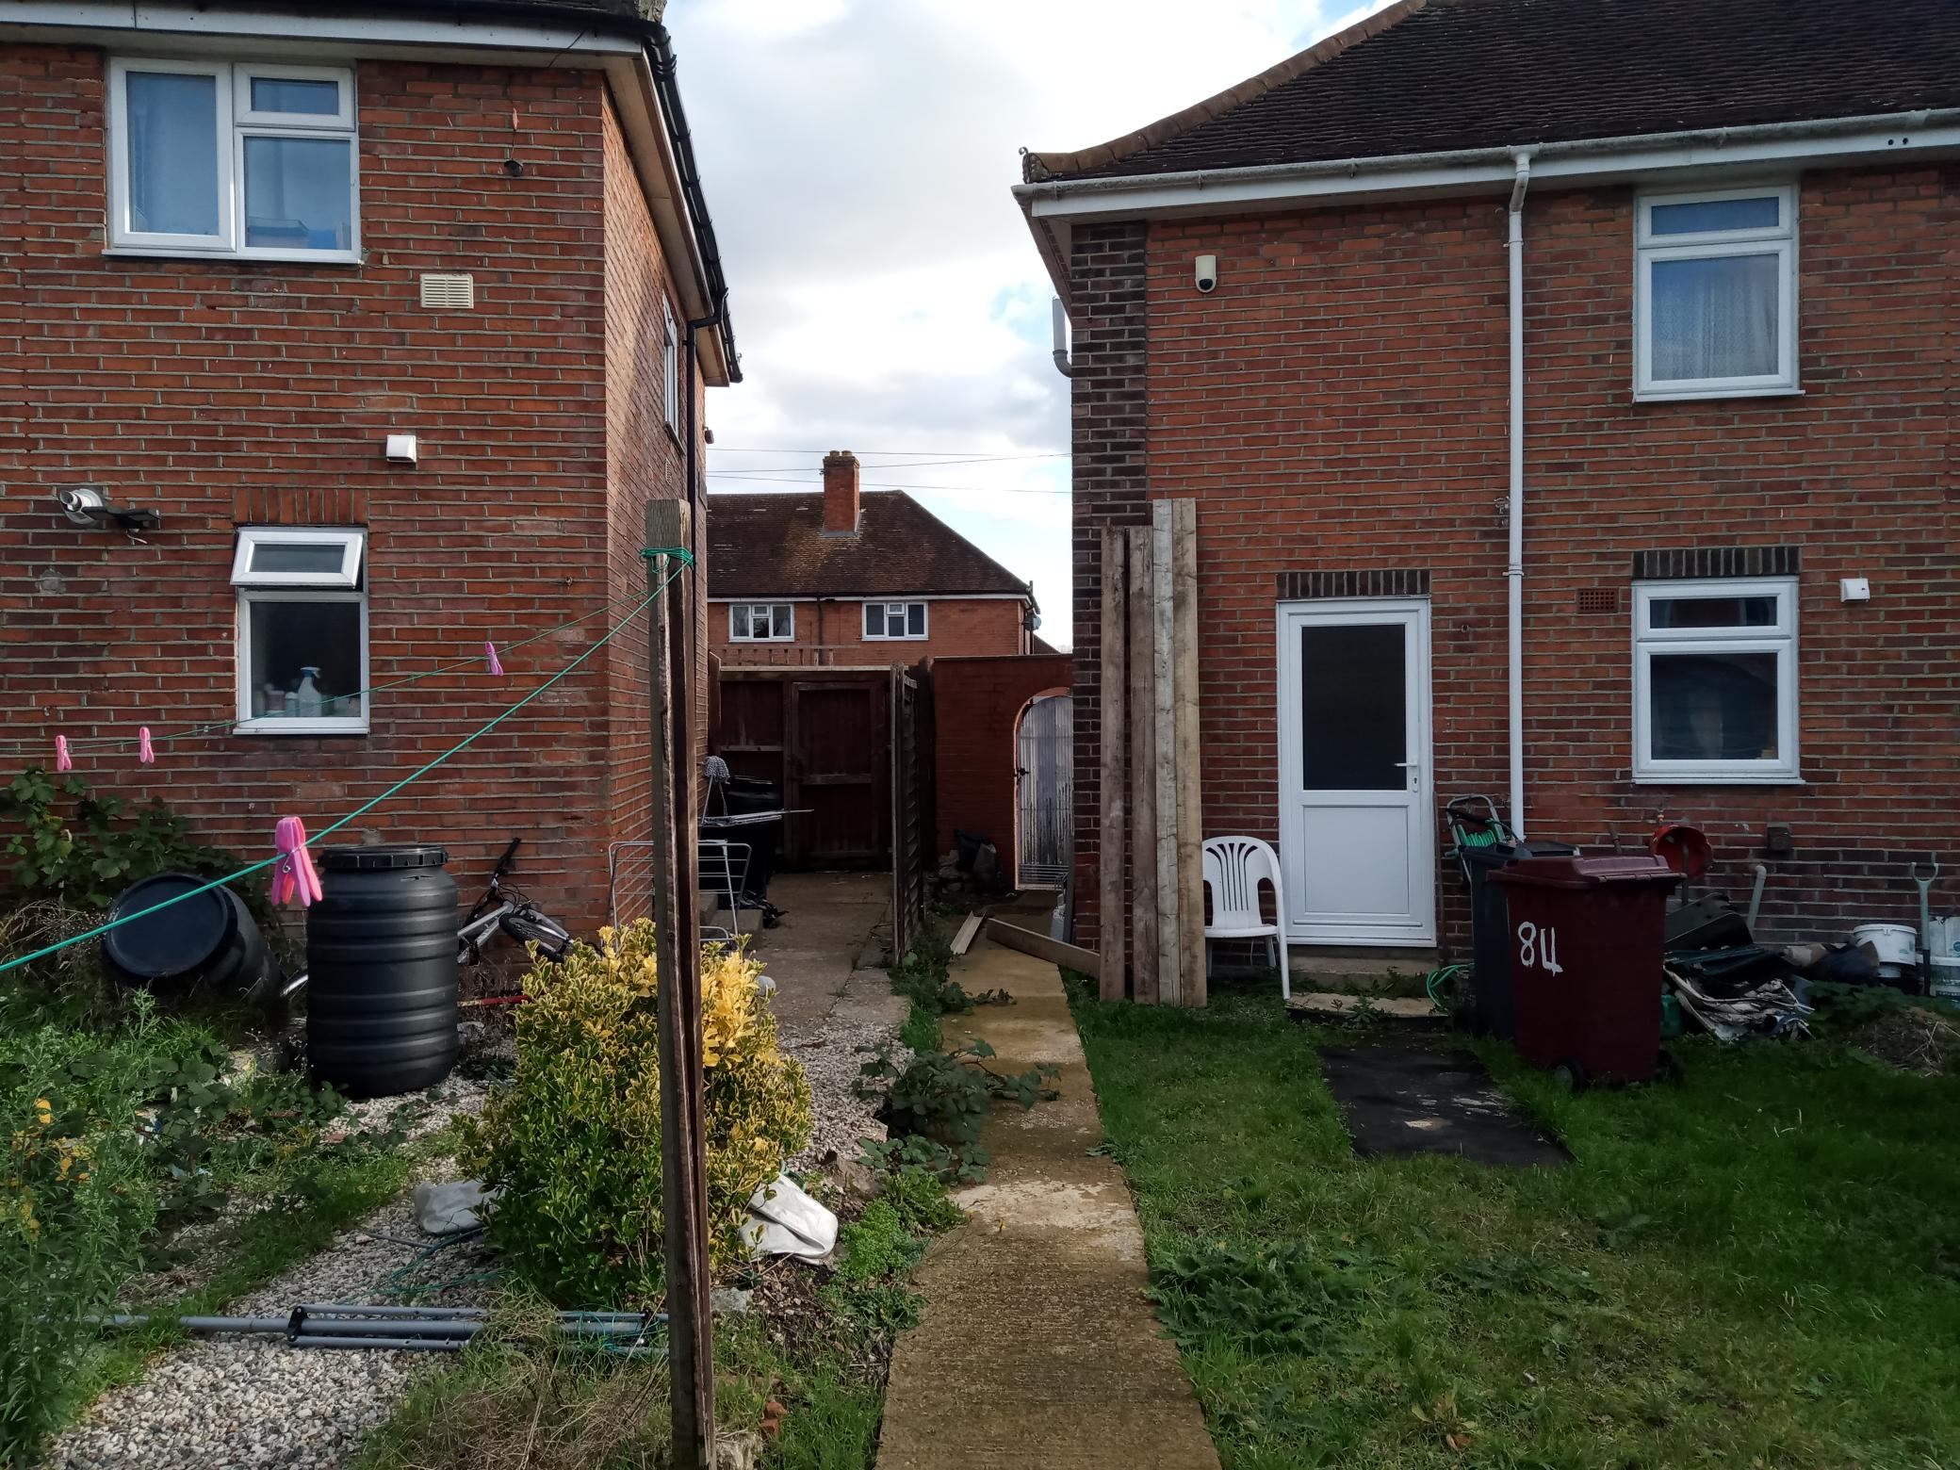
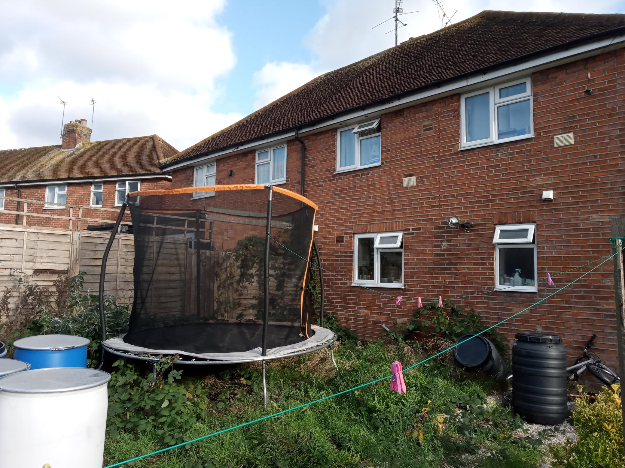
Site photos.

2. PROPOSAL AND SUPPORTING INFORMATION
Proposed is a part-two part-single storey rear and side extensions with loft conversion and rear dormer extension. The side extension aspect is on the ground floor level, extending approximately 2m to the side on the left side elevation, with the rear aspect extending 4m and the full width to the rear of the existing property while the first floor aspect is stepped back from the right side elevation, spanning just 2m of the width of the existing property. Also proposed, is a rear dormer measuring approximately 4m by 3m.
Plans considered
Drawing No 00: Location Plan dated Apr 2023 received 30/05/2023
Drawing No 10: Existing Floor Plans dated Apr 2023 received 30/05/2023
Drawing No 11: Existing Elevations dated Apr 2023 received 30/05/2023
Drawing No 12: Existing Block Plan dated Apr 2023 received 30/05/2023
Drawing No 01 Rev B: Proposed Floor Plans dated Nov 2023 received 15/12/2023
Drawing No 02 Rev B: Proposed Second Floor and Roof Plans dated Nov 2023 received 1/12/2023
Drawing No 11 Rev B: Proposed Elevations dated Nov 2023 received 1/12/2023
Drawing No 04 Rev B: Proposed Site Plan dated Nov 2023 received 14/12/2023

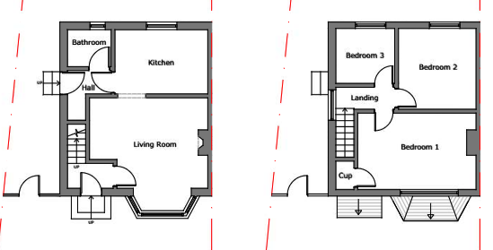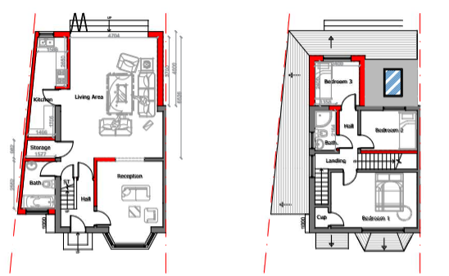
Existing Floor Plans Proposed Floor Plans
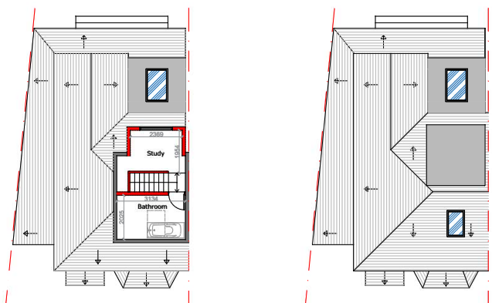

Proposed Loft and Roof Plans

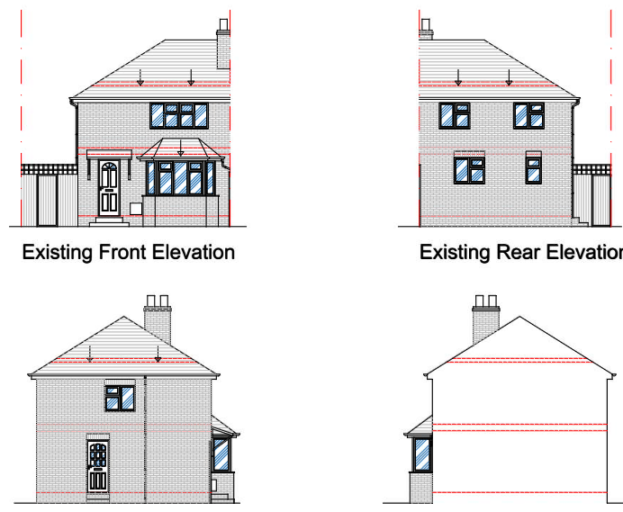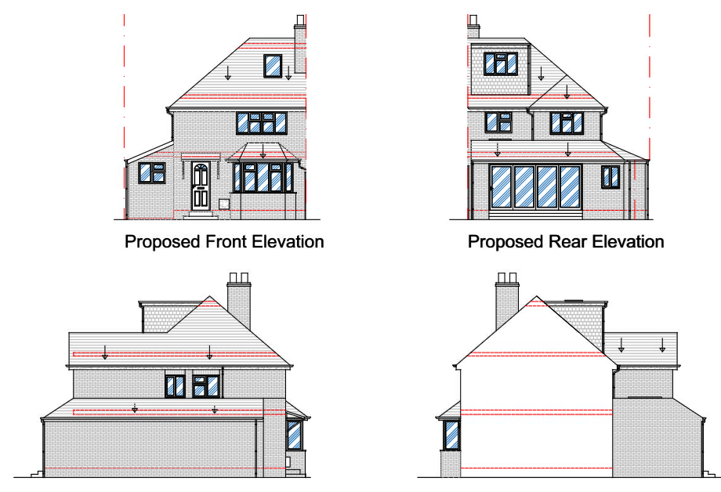

Existing Elevations Proposed Elevations

- RELEVANT PLANNING HISTORY
None

4. CONSULTATIONS

The following addresses were consulted by letter.

107 Brixham Road, Reading, Berkshire, RG2 7RB
80 Kingsbridge Road, Reading, Berkshire, RG2 7RQ
84 Kingsbridge Road, Reading, RG2 7RQ
109 Brixham Road, Reading, RG2 7RB

No letters of representation have been received.

Equality Act 2010:
In determining this application the Council is required to have regard to its obligations under the Equality Act 2010. However, there is no indication or evidence (including from consultation on the application) that the protected groups identified by the Act have or will have different needs, experiences, issues and priorities in relation to this particular planning application. Therefore in terms of the key equalities protected characteristics it is considered there would be no significant adverse impacts as a result of the development.

- LEGAL AND PLANNING POLICY CONTEXT

Section 38(6) of the Planning and Compulsory Purchase Act 2004 requires that proposals be determined in accordance with the development plan unless material considerations indicate otherwise. Material considerations include relevant policies in the National Planning Policy framework (NPPF) - among them the 'presumption in favour of sustainable development'. The following local and national planning policy and guidance is relevant to this application:

National Policy
National Planning Policy Framework
National Planning Practice Guidance

Reading Borough Local Plan (2019)
CC7 (Design and the Public Realm)
CC8 (Safeguarding Amenity)
H9 (House Extensions and Ancillary Accommodation)

SPD
Design Guide to House Extensions SPD (2021)
Revised Parking Standards and Design SPD 2011

6. APPRAISAL
Character and Appearance

Policy H9 states that an extension to a house will be acceptable where it respects the character of the house in terms of scale, location, materials and design and respects the character and pattern of neighbouring properties and the street as a whole in terms of scale, location, materials and design, and any important existing building line. Policy CC7 also sets out relevant considerations for design.

The side extension aspect of this proposal is limited to the ground floor, at a maximum height of 2.7m, ground to eave and 3.5m ground to the hip of the mono pitch roof over the ground floor. The ground floor extension creates a wrap-around effect on the existing dwelling, stretching out 4m to the rear and along the full width of the dwelling.

The first floor aspect is pulled back from the side elevation on one side, is limited to a depth of 2.4m, and does not extend to the boundary as the side extension. The hip of the gable roof over the first floor extension is stepped down from the main hip of the existing dwelling, while the dormer to create the loft conversion is of a flat roof and to the rear of the property.

In all aspects of the proposal, materials are proposed to match the existing materials used externally on the site.

Officer’s Note.
In the original submissions, the side extension aspect of this application was proposed to be on the same line as the Principal Elevation. This was considered by the LPA as not being subservient to the existing dwelling and the agent was advised accordingly. The plans being assessed here have been revised to reflect this advice, stepping the side extension back from the existing frontline by 1m.

Considering the proposal overall, the combination of the revisions made to the line of the side extension, the stepped down level of the hip on the roof of the first floor extension, as well as the limitations to the extensions to the side of the first floor aspect, are deemed to diminish any negative impacts the proposal would have on the character of the existing dwelling and the dwellings in close proximity. This proposal would therefore be acceptable as it respects the character of the house in terms of scale, location, materials and design and respects the character and pattern of neighbouring properties and the street as a whole in terms of scale, location, materials and design, and the existing line of the Principal Elevation.

Residential Amenity

Policy H9 states that an extension will be acceptable where it does not result in an overbearing impact on neighbours. Policy H10 seeks to ensure that the amenity of gardens and other outdoor areas are not compromised. Policy CC8 states an extension to a house will be acceptable where it will not cause a significant detrimental impact to the living environment of existing or new residential properties.

The side extension on the ground floor introduces a new building line of blank wall of approximately 9m on the boundary line with No 84. This wall would be of a height of approximately 2.7m. However, the effective difference in building line to the rear between the two properties would in effect be limited to just under 4m (as determined on site visit).

The first floor aspect is limited to a depth of 2.4m, stepped back from the boundary with No 84 and stepped back approximately 2.8m from the line of the side elevation facing No 80. The new rear dormer would have windows facing the rear of the property, and the new window to be installed on the elevation facing No 84 would be a bathroom window placed beside an existing stairway landing window on that elevation. The rooflights to be installed on the front first floor roofslope and on the ground floor roof to the rear do not project from the slope of the roofs, so would not present any overlooking vantage points.

As is demonstrated by the photos from the site visit, there are no existing windows to habitable rooms on the rear wall of the property on No 84 that could be impaired in terms of access to daylight and sunlight and the first floor extension is adequately stepped back from No 80.

All aspects of this proposal are therefore considered to be acceptable as they would not present any privacy and overlooking issues, would have no overbearing effects and would not limit or impair access to sunlight daylight to the properties on both sides of the site.

- CONCLUSION
The proposed development has been assessed as set out above and is considered to be acceptable on that basis, subject to the following conditions.

8. RECOMMENDATION
Recommended Conditions:
AP1: Approved Plans
M1: Materials to Match Existing
TL1: Time Limit Standards

