

DELEGATED HOUSEHOLDER APPLICATION REPORT

Ward: Battle
App Ref: 230733/HOU
Address: 65 Belmont Road, Reading, RG30 2UT
Proposals: Front extension to form a porch area following removal of existing detached porch and extension of bay roof over the extension
Case Officer: Chukwudi Onwudinanti
Applicant: Terry Davies
Date received (valid from): 27 May 2023
Target Decision date: 13 September 2023(EXT)

1. SITE DESCRIPTION
The proposal site is a mid-terrace two storey dwelling on the eastern side of Belmont Road, in a predominantly residential area. The road is characterised by two lines of terraces running the full lengths of both sides of the road.
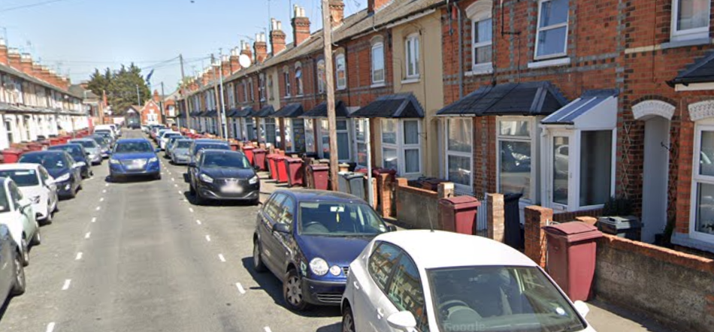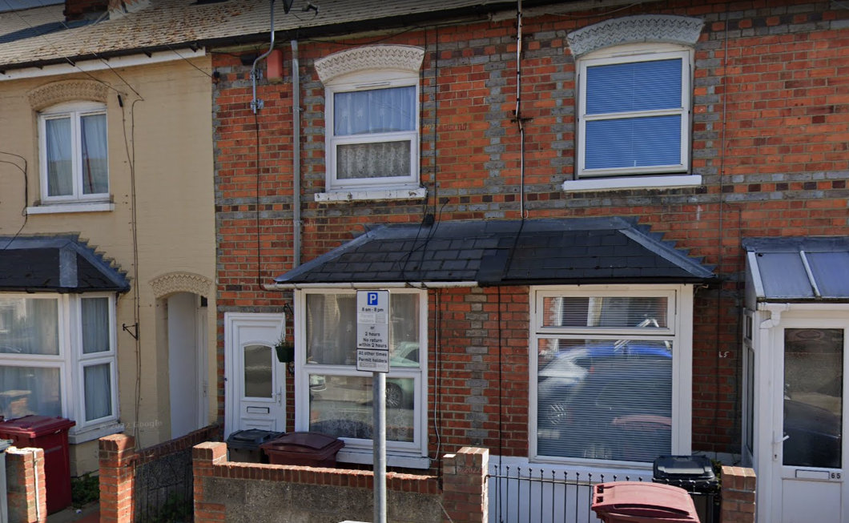

2. PROPOSAL AND SUPPORTING INFORMATION
The amended proposal is to marginally increase the size of the existing porch following removal of existing porch and integrating the roof over the porch with the cover over the existing bay windows.

Plans considered dated 26/05/2023
ND/BR/00: Location Plan
ND/BR/02: Existing Ground Floor Plan
ND/BR/03: Existing Roof Plan
ND/BR/04: Existing Front and Side Elevations
ND/BR/05: Existing Rear and Side Elevations
ND/BR/14 Rev A: Proposed Ground Floor Plan
ND/BR/15 Rev A: Proposed Roof Plan
ND/BR/16 Rev B: Proposed Front and Side Elevations
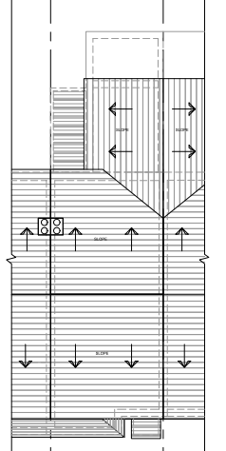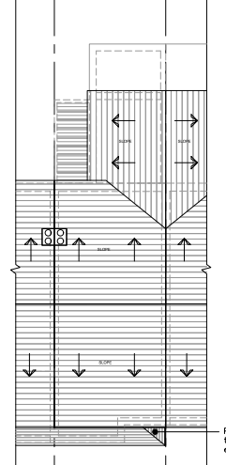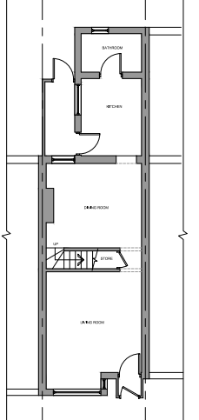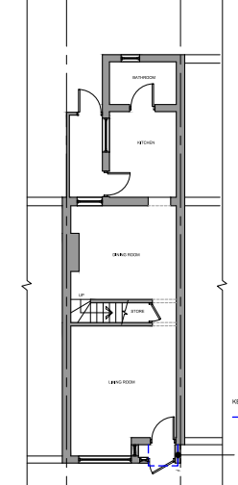

Existing and Proposed Roof Plans Existing and Proposed Floor Plans

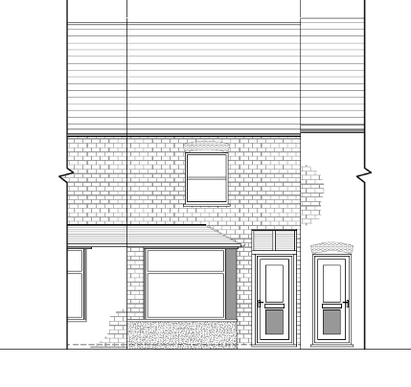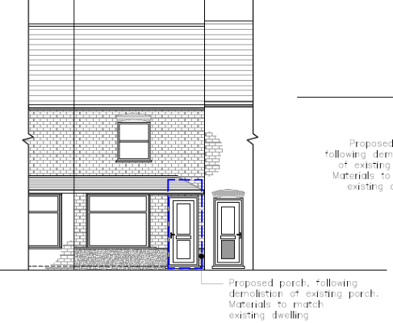
Existing Elevation Proposed Elevation

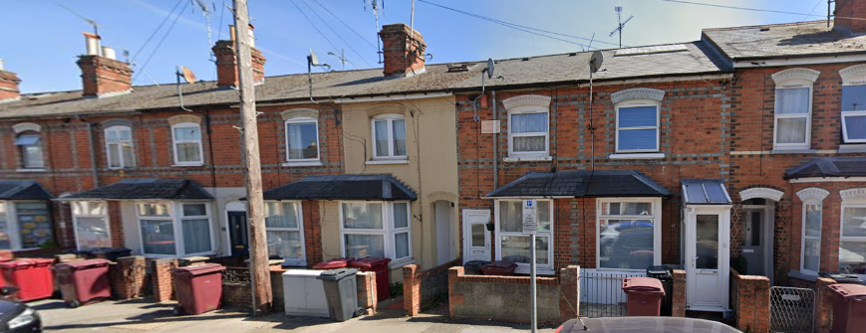
Google Street View 2021 Application site

- RELEVANT PLANNING HISTORY
991731
Alterations and extensions to the rear and erection of front porch
Permitted
17/9/1999

4. CONSULTATIONS

The following addresses were consulted by letter.

60 Elm Park Road, Reading, RG30 2TN
67 Belmont Road, Reading, RG30 2UT
62 Elm Park Road, Reading, RG30 2TN
63 Belmont Road, Reading, RG30 2UT

Letters of representation have been received as follows:

Address: 62 Elm Park Road
I have a new-born daughter and back onto the property and I'm concerned about the noise implications of this project.

Planning Officer Note: The proposal for the development of a front porch is unlikely to create significant noise issues during construction and it is considered that the impact would be even less for properties which back onto the rear of the property.

Transport Comments:
There are no transport objections to the proposed new porch.

Discussion with agent:
The agent has taken the advice of the LPA and revised the plans. The size of the original porch has been reduced, and the bay window roofing has been extended to cover the porch.

Equality Act 2010:
In determining this application the Council is required to have regard to its obligations under the Equality Act 2010. However, there is no indication or evidence (including from consultation on the application) that the protected groups identified by the Act have or will have different needs, experiences, issues and priorities in relation to this particular planning application. Therefore in terms of the key equalities protected characteristics it is considered there would be no significant adverse impacts as a result of the development.

- LEGAL AND PLANNING POLICY CONTEXT

Section 38(6) of the Planning and Compulsory Purchase Act 2004 requires that proposals be determined in accordance with the development plan unless material considerations indicate otherwise. Material considerations include relevant policies in the National Planning Policy framework (NPPF) - among them the 'presumption in favour of sustainable development'. The following local and national planning policy and guidance is relevant to this application:

National Policy
National Planning Policy Framework
National Planning Practice Guidance

Reading Borough Local Plan (2019)
CC7 (Design and the Public Realm)
CC8 (Safeguarding Amenity)
H9 (House Extensions and Ancillary Accommodation)

SPD
Design Guide to House Extensions SPD 2021

6. APPRAISAL

Character and Appearance
Policy H9 states that an extension to a house will be acceptable where it respects the character of the house in terms of scale, location, materials and design and respects the character and pattern of neighbouring properties and the street as a whole in terms of scale, location, materials and design, and any important existing building line. Policy CC7 also sets out relevant considerations for design.

The proposal seeks to extend the property to the front to create a larger porch area in line with and attached to the existing bay and to integrate the roof with the roof over the existing bay windows. This would be a marginal increase in footprint.

The character and appearance of the street, apart from nos. 1 & 3 Belmont Road (no planning history has been established), is consistent and largely unaltered along this side of the street with the entrance door either recessed or at the same plane as the front wall and distinct and separate from the projecting front bay. The application site itself, however, has already been altered with the addition of a projecting detached porch deeper than the bay (approved in 1999), which alters its appearance as part of the wider street scene.

With the revisions agreed by the agent, it is considered that the current proposal, as amended, would be a slight improvement on the existing porch extension, previously permitted. The gap between dwellings on the terrace would still be maintained.

It is considered, therefore, that the proposed change to the front of the property, which would essentially create a wider bay and extended roof over, would not create such significant harm to the character and appearance such that a refusal would be warranted in this instance and has been weighed against the impact on character from the current approved porch and the small improvement with respect to a reduced depth front projection that the proposal would create.

Residential Amenity
Policy H9 states that an extension will be acceptable where it does not result in an overbearing impact on neighbours. Policy H10 seeks to ensure that the amenity of gardens and other outdoor areas are not compromised. Policy CC8 states an extension to a house will be acceptable where it will not cause a significant detrimental impact to the living environment of existing or new residential properties.

As stated above, the extension to the porch is limited and is still largely within the envelope of the existing dwelling. Therefore, there would not be any resultant impact on any of the neighbours on both sides.

- CONCLUSION
The proposed development has been assessed as set out above and is considered to be acceptable on that basis, subject to the following conditions.

8. RECOMMENDATION
Recommended Conditions:
AP1: Approved Plans
TL!: Time Limit Standards
M1: Materials to Match Existing

