

DELEGATED HOUSEHOLDER APPLICATION REPORT

Ward: Church
App Ref: 221935/HOU
Address: 10 Windermere Road, Reading, RG2 7HP
Proposals: Demolition of existing outbuilding/storage to the rear of the property and proposed erection of a single storey side and rear extension.
Case Officer: Chukwudi Onwudinanti
Applicant: Mr Wei
Date received (valid from): 28 December 2022
Target Decision date: 22 February 2023

1. SITE DESCRIPTION
The proposal site is a semi-detached two storey dwelling on the western side of Windermere Road, in a purely residential area, among dwellings of similar styles and patterns. The dwelling has existing extensions to the rear and an outbuilding to the rear. Buildings on the street scene are characterised by side attached garages and a mixture of bricks and rendering to the external walls.

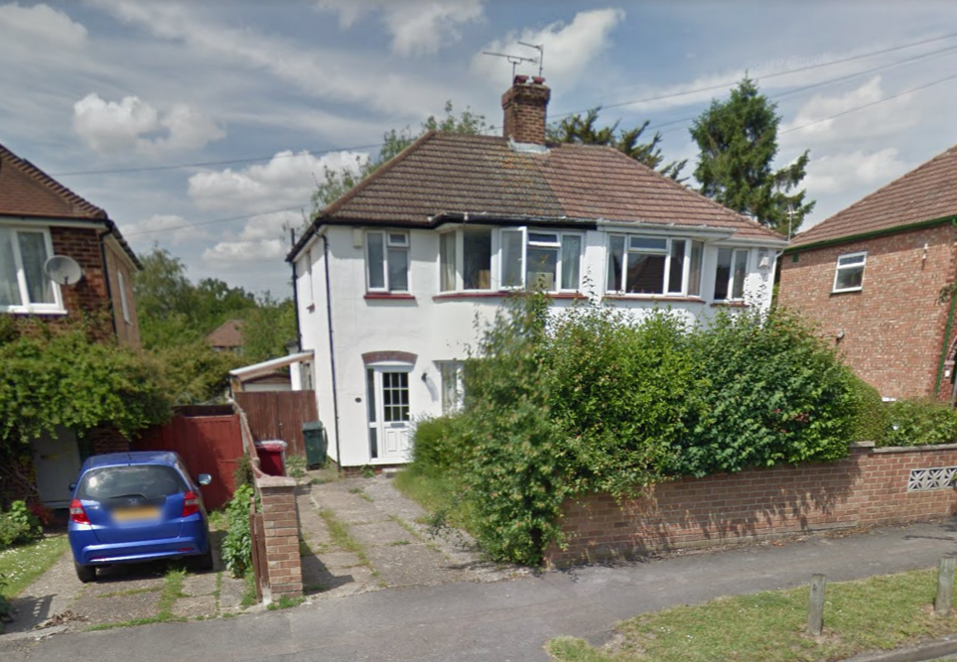

2. PROPOSAL AND SUPPORTING INFORMATION
The application proposes demolition of existing outbuilding/storage to the rear of the property and erection of a single storey side and rear extension, mostly using the footprints of the existing side extension and outbuilding to the rear. The height of the side and rear extension is approximately 1.8m.

Plans considered dated 28/12/2022 received 12/05/2023
Drawing No PL200 Rev D: Existing and Proposed Front & Rear Elevations
Drawing No PL201 Rev D: Existing and Proposed Left & Right Elevations
Drawing No PL100 Rev C: Existing and Proposed Floor Plans
Drawing No PL002 Rev C: Location Plan

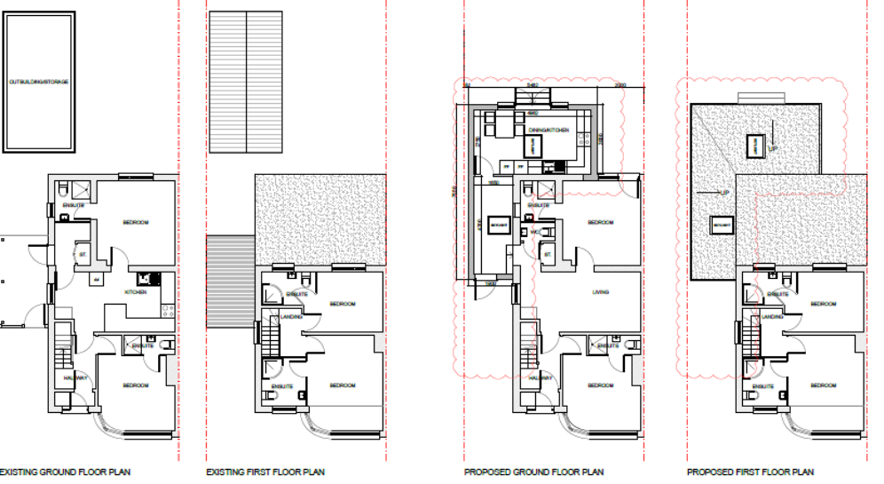
Existing Floor Plans Proposed Floor Plans

- RELEVANT PLANNING HISTORY

None

4. CONSULTATIONS

The following addresses were consulted by letter.

12 Windermere Road, Reading, RG2 7HP
31 Stanhope Road, Reading, RG2 7HW
8 Windermere Road, Reading, RG2 7HP
29 Stanhope Road, Reading, RG2 7HW
29A Stanhope Road, Reading, RG2 7HW

No letters of representation have been received.
The agent has extensively reduced the size of the originally submitted scheme, on advice from the LPA.
Equality Act 2010:
In determining this application the Council is required to have regard to its obligations under the Equality Act 2010. However, there is no indication or evidence (including from consultation on the application) that the protected groups identified by the Act have or will have different needs, experiences, issues and priorities in relation to this particular planning application. Therefore in terms of the key equalities protected characteristics it is considered there would be no significant adverse impacts as a result of the development.

- LEGAL AND PLANNING POLICY CONTEXT

Section 38(6) of the Planning and Compulsory Purchase Act 2004 requires that proposals be determined in accordance with the development plan unless material considerations indicate otherwise. Material considerations include relevant policies in the National Planning Policy framework (NPPF) - among them the 'presumption in favour of sustainable development'. The following local and national planning policy and guidance is relevant to this application:

National Policy
National Planning Policy Framework
National Planning Practice Guidance

Reading Borough Local Plan (2019)
CC7 (Design and the Public Realm)
CC8 (Safeguarding Amenity)
H9 (House Extensions and Ancillary Accommodation)

SPD
Design Guide to House Extensions (2021)
Revised Parking Standards and Design SPD 2011

6. APPRAISAL
Character and Appearance

Policy H9 states that an extension to a house will be acceptable where it respects the character of the house in terms of scale, location, materials and design and respects the character and pattern of neighbouring properties and the street as a whole in terms of scale, location, materials and design, and any important existing building line. Policy CC7 also sets out relevant considerations for design.

This proposal would create a long continuous wall on the boundary with the neighbouring property at No 12. However, this effect already largely exists as a result of the existing side structure and the outbuilding to the rear. The effect is further mitigated by the modest height of the extension (2.8m) which would be hardly visible above the dividing fence between the two properties.

Following the advice of the LPA, the agent has massively reduced the scale of the originally submitted application, bringing the effective rear depth of the extension from 6.4m to 3m.

It is therefore considered that the scale, location, materials and design of the proposal are sympathetic to the existing dwelling and its surrounding environment.

Residential Amenity

Policy H9 states that an extension will be acceptable where it does not result in an overbearing impact on neighbours. Policy H10 seeks to ensure that the amenity of gardens and other outdoor areas are not compromised. Policy CC8 states an extension to a house will be acceptable where it will not cause a significant detrimental impact to the living environment of existing or new residential properties.

As stated above in this report, the extension proposed would be on the existing footprint of the outbuilding and the garage to the side. The height is limited to 2.8m, ground to eaves. There are no side windows presented. Initial concerns raised by the LPA with the original submission regarding the prospective living conditions have been allayed by the revised submissions. The side wall visible to the neighbours have also been reduced to 7m, with the limited height.

The proposal is not considered to present any additional sunlight/daylight assess impact to the property at No 12 and the limited height ensures that there is no overbearing effect or overlooking presented by the long continuous wall on the boundary.

- CONCLUSION
The proposed development has been assessed as set out above and is considered to be acceptable on that basis, subject to the following conditions.

8. RECOMMENDATION

Recommended Conditions:
AP1: Approved Plans
TL1: Time Limit Standards
M1:Materials to Match Existing
PD6: Ancillary Domestic Use

