

DELEGATED HOUSEHOLDER APPLICATION REPORT

Ward: Katesgrove
App Ref: 230718/HOU
Address: 22 Swainstone Road, Reading, RG2 0DX
Proposals: Rebuild of the existing rear extension with eaves raised to match neighbouring property.
Case Officer: Chukwudi Onwudinanti
Applicant: Mrs Despoina Metochianaki
Date received (valid from): 24 May 2023
Target Decision date: 9 August 2023(EXT)

1. SITE DESCRIPTION
The proposal site is a mid-terrace dwelling on the southern side of Swainstone Road, in a predominantly residential area. The area is characterised by terraces on both sides of the road.

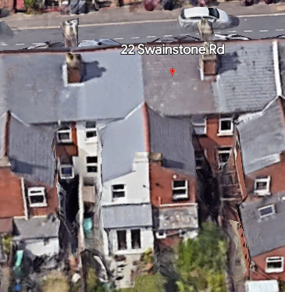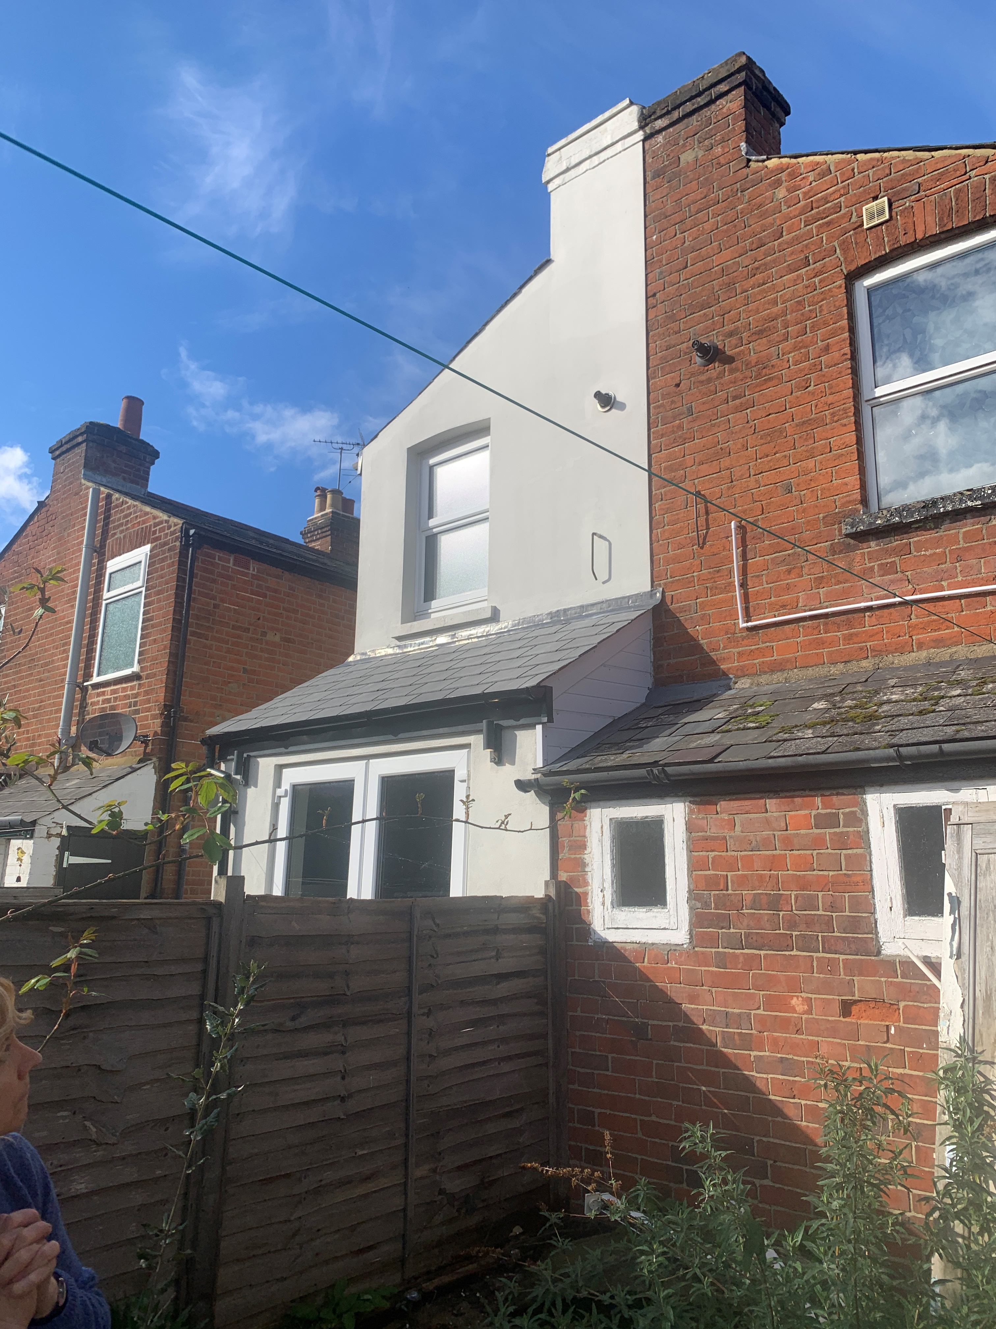

2. PROPOSAL AND SUPPORTING INFORMATION
Rebuild of the existing rear extension on same footprints with eaves raised to match neighbouring property.

Plans considered dated March 2023 received 25/5/2023
Drawing No P101 Rev A: Existing Elevations
Drawing No P100 Rev A: Existing Floor Plans
Drawing No P90 Rev A: Site Plan
Drawing No P80 Rev A: Location Plan
Drawing No P102 Rev A: Proposed Plans
Drawing No P103 Rev A: Proposed Elevations

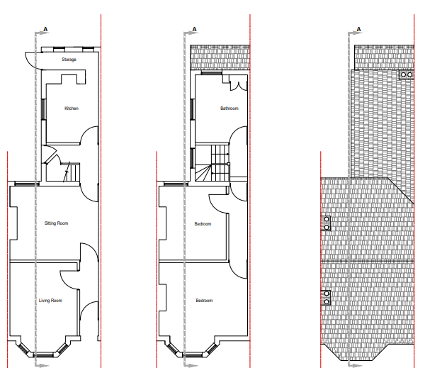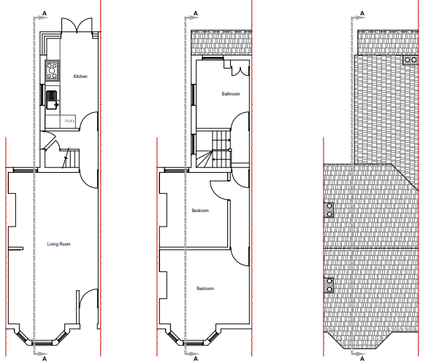

Existing Plans Proposed Plans

- RELEVANT PLANNING HISTORY
Application Reference: 230426/CLP
Description: Rebuild of the existing rear storage area with the raise of eaves.
Storage area to be incorporated into the kitchen
Outcome: Withdrawn
Date of Withdrawal: 30/5/2023

4. CONSULTATIONS

The following addresses were consulted by letter.

10 Bourne Avenue, Reading, RG2 0DU
22 Swainstone Road, Reading, RG2 0DX
24 Swainstone Road, Reading, RG2 0DX

No letters of representation have been received.

Equality Act 2010:
In determining this application the Council is required to have regard to its obligations under the Equality Act 2010. However, there is no indication or evidence (including from consultation on the application) that the protected groups identified by the Act have or will have different needs, experiences, issues and priorities in relation to this particular planning application. Therefore in terms of the key equalities protected characteristics it is considered there would be no significant adverse impacts as a result of the development.

- LEGAL AND PLANNING POLICY CONTEXT

Section 38(6) of the Planning and Compulsory Purchase Act 2004 requires that proposals be determined in accordance with the development plan unless material considerations indicate otherwise. Material considerations include relevant policies in the National Planning Policy framework (NPPF) - among them the 'presumption in favour of sustainable development'. The following local and national planning policy and guidance is relevant to this application:

National Policy
National Planning Policy Framework
National Planning Practice Guidance

Reading Borough Local Plan (2019)
CC7 (Design and the Public Realm)
CC8 (Safeguarding Amenity)
H9 (House Extensions and Ancillary Accommodation)

SPD
Design Guide to House Extensions SPD (2021)

6. APPRAISAL
Character and Appearance

Policy H9 states that an extension to a house will be acceptable where it respects the character of the house in terms of scale, location, materials and design and respects the character and pattern of neighbouring properties and the street as a whole in terms of scale, location, materials and design, and any important existing building line. Policy CC7 also sets out relevant considerations for design.

The proposal presents an upward extension of the existing rear extension, bringing the roof to the level of the extension on the adjoining property. This development is not considered to add any significant impact on the character of the existing dwelling in terms of scale and design.

Residential Amenity

Policy H9 states that an extension will be acceptable where it does not result in an overbearing impact on neighbours. Policy H10 seeks to ensure that the amenity of gardens and other outdoor areas are not compromised. Policy CC8 states an extension to a house will be acceptable where it will not cause a significant detrimental impact to the living environment of existing or new residential properties.

The extension is not proposed to extend to the rear more than the existing footprint of the extension at the rear of the property. The increase in height would match the height of the extension on the adjoining property and there are no proposed new windows to the side of the extension.

It is therefore considered that the development as proposed would not present any additional detrimental impacts on the neighbours on both sides of the property.

- CONCLUSION
The proposed development has been assessed as set out above and is considered to be acceptable on that basis, subject to the following conditions.

8. RECOMMENDATION: Grant
Recommended Conditions:
AP1: Approved Plans
M1: Materials to Match Existing
TL1: Time Limit Standards

